AGAINST "SUSTAINABILITY"
Ted Everett
Philosophy colloquium 5/2/2014

1. Preamble
Let me begin with a few words about why I am giving this talk (together with the preserved head of Richard Feynman), and why I do this sort of thing so often. There are several reasons. First, I am constantly puzzled by the deep disagreements that I so often have with friends and colleagues whom I see as intellectual peers. We all have access to about the same pool of public information about issues like this, yet I seem always to interpret that information differently from most of my friends. That can be awkward for the friendships, but it's also just perplexing in itself. Working on talks like this helps me to understand these disagreements.
The second main reason I like to give these talks is that it seems to me that far too many of our students here at Geneseo, as at most colleges and universities these days, only ever hear one side of these important issues carefully articulated, and receive only caricatures, if that, of the views of people who seriously disagree, together with attacks on the dissenters themselves as unreasonable if not wicked people. So, I make an effort to present dissenting views on topics like this where it seems to me that the moral consensus is making public disagreement difficult, so that interested students can at least hear something from the other side before they make their minds up for good. Most other people who are skeptical of mainstream views, students especially, have more to lose if they say things that other people disapprove of in today's ideological and, I fear, increasingly authoritarian environment. But I can say whatever I like with little real risk since I have tenure, and at this point in my career it doesn't really matter whether people think I'm full of shit.
So, today I want to criticize the theory and practice of what's called sustainability, and this will involve a lot of talk about the issue of climate change. I want to acknowledge up front that I am not any kind of climate scientist, and don't want to pose as one, so I am not going to challenge the expertise of anybody in that field or to question their methods, their data, or their good faith. I will, however, be posing as a philosopher of science, because I want to make some arguments about what constitutes rational belief in scientific propositions, both for the lay consumers of science and for scientists themselves. Because I'm posing as a philosopher, and because I really do respect the views of people on the other side, and because I promised my critical thinking students that I would be perfectly reasonable, I will try not to indulge in the kind of snarkasm that this topic typically inspires on the internet.
By the way, my partner for tonight Dr. Feynman has made a lot of famous remarks about science, and one of them that I get teased about sometimes by scientists is this one, that

“Philosophy of science is about as useful to scientists as ornithology is to birds.”

I am happy to agree this is generally true under normal scientific circumstances – for example, scientists don't need philosophers telling them how to sample and interpret tree-rings, any more than birds need ornithologists to tell them how flap their wings. But birds can benefit from ornithology when it turns out, as it occasionally does, that an entire flock of birds has caught the Avian Flu. And Feynman actually knows this very well, as something of an expert ornithologist himself, as we shall see.

2. Some basic problems with sustainability
Here are my three main problems with sustainability as a concept and as a crusade. It isn't what we usually think it is. First, we should recognize that sustainability is a political concept, not just a neutral sort of value like safety or good health. Here for illustration is Geneseo's official "Sustainability Statement":

“SUNY Geneseo calls upon all members of our community to embrace sustainability as a core value, including a commitment to its constitutive principles of ecological, social, and economic justice…The college understands that sustainability is a process of building support for societal and intergenerational equity and a shared sense of responsibility for the ethical stewardship of our social and natural environment.”

Right off the bat we can see that sustainability as Geneseo understands it, is about much more than recycling, saving energy, and things like that. It is also about social and economic justice, and about getting people to support these goals so that our society as well as our environment can be managed in an ethical way. Now, social and economic justice may be fine concepts, but they are certainly also political concepts, and ones associated only with the political left. (The political right does, of course, have its own conception of justice, but it's one in which justice in the social and economic realms is defined as whatever follows from respecting the rights of individuals, not social or economic groups. That's why they almost never talk about social justice or economic justice per se: they're not separate concepts on the right.
Second, I want to stress that the practice of sustainability, even just within the sphere of strictly environmental projects, has potential and actual bad consequences. For one thing, this stuff is expensive. SUNY, for example, has spent a great deal of money – facilities planning says they can't tell me how much – on sustainability measures for all of the new building and renovation projects on our campus over the last few years, including solar panels, rain recyclers and hundreds of geothermal wells to help with heating. Where do you suppose this money comes from? If we hadn't spent it on greening our campuses couldn't it have been spent on something else that was perhaps more useful? One way to have spent it differently could have been not borrowing it in the first place. Because NYS is currently $300b in debt, which comes to about $15,000 for every man, woman, and child in a state that already has the highest taxes in the country. Do you suppose that nobody has to pay this money back, with interest? Most of the people who borrowed it will die before it has to be paid back, but you guys will not. Even if the solar and geothermal devices end up saving energy and other expenses, up to the point of recouping the initial investment over the next generation or so, they won't have "paid for themselves" unless they also recoup of all the interest on the debt that we've incurred funding these up-front expenses, and we will never get back the opportunity not to have borrowed the money in the first place, or to have borrowed it and spent it more productive ways.
Besides being expensive, sustainability initiatives are sometimes merely symbolic, and don't really do anything other than to advertise sustainability. Bear in mind, for example, when you see these clean, green, electric vehicles that we have all around the campus now, that electricity is not actually a source of power – the electricity that nice places like Geneseo get to use comes primarily from burning fossil fuels, more coal than anything else, followed by gas that's being tapped in other states where fracking is permitted, and the bulk of the remainder is from nuclear plants. So when you see these little electric wagons, try to imagine that the coal and gas was being burned for that electricity here on campus rather than some other place discretely out of sight. Worse, these big hand-drying machines we have in almost all the restrooms now; it's not at all clear that these things save any energy at all compared to paper towels. But they do make people really angry because they are incredibly loud, especially in the basement men's room in Wadsworth, which is a tiny space. [My little fantasy every time I'm in there is to yank the damn thing off the wall, strap it to my back, and fly over to Doty where they still have paper towels.]
Moreover, these sustainability initiatives can have serious harmful effects on people and society, beyond just driving people nuts who have to use them. Arguably, these hand dryers, are not just unpleasant but positively unhealthy also because they take such a long time to use that a lot of people just wipe their hands off on their pants, or don't even wash them at all. Moreover, studies have shown that these blowers actually scatter germs all over the room rather than letting them get collected and disposed of in a biodegradable brown-paper towel. That's on the little local scale. Large-scale sustainability measures can do serious economic damage. California now has a law requiring that 33% of electricity come from renewable sources by 2020. This may be a nice sounding idea; but the problem is that renewable sources are far more expensive than fossil fuels, so the price of electricity is expected to increase by a third to a half over the same six years. People like us with nice jobs and educations can probably afford the extra 500$ a year, but that can be a real burden on people making low-end wages. And there is a limit to how much taxes can be increased to subsidize the people who are most harmed by such expensive mandates. After a certain point higher taxes start bringing in less rather than more revenue, because they slow down the activities that generate that money in the first place. There is evidence that taxes in California (and New York) have already exceeded that point, after which the equity issues can only be resolved through more forceful kinds of intervention.
Sustainability also depends on what I take to be some dubious presuppositions It seems that what justifies all this expense, trouble, interference, and coercive behavior in the minds of people who promote the value of sustainability is the belief that we are acting in the face of critical environmental problems that have not just local but planetary scope – a belief that has been circulating in the West in one form or another for many decades, at least, but that is currently anchored to a particular apocalyptic theory about climate change which I don't find very plausible, backed by a supposedly strong consensus among scientists for which I don't see very convincing evidence despite the frequent use of the number 97%, and enforced by formal and informal measures against dissenters, often called "deniers" or "denialists" and spoken of as "anti-science", that are a travesty of scientific ethics. All-in-all, this climate crisis theory, if it is science at all, strikes me as closer in spirit to medieval authoritarian science than to the modern science of the twentieth century. Here again is SUNY's official statement on sustainability:

“We endorse the broad scientific consensus that human demands on the planet threaten the ecological, social and economic resources upon which our global society depends…”

Okay – but this is a lot to endorse, and extraordinary claims require extraordinary evidence.
Here are the questions that I think we need to ask about this stuff – not as scientific experts or as professional philosophers, but merely as people who think critically about what they are being told. First, is there, in fact, a broad scientific consensus about this environmental (and apparently also social and economic) crisis? What, exactly, is the content of this consensus? What is the evidence for this consensus? Is it rational for us, given the evidence available, to mandate further intrusive "sustainability", much of which is very expensive, much of which appears to be mainly symbolic, and much of which is patently harmful to the interests of ordinary people, in order to try to resolve this crisis of climate change, assuming it can be resolved by human actions at all? If it is rational, what are the reasons? Are they reasons that ordinary people ought to share, or are they reasons that only experts can appreciate and that other people will just have to accept on the experts' authority? If the latter, then we may need to add democracy to the list of things we're giving up, at least in part, in order to promote sustainability.
My own current, tentative guess about this stuff is that climate crisis theory is very probably false, that the total evidence available right now rationally justifies very little in the way of further institutional or governmental interference in our personal or economic lives, and that many of the efforts to enforce this supposed consensus in the face of disagreement are unwarranted, unscientific, and in some cases truly egregious. In my view, most reasonable people (and I do only mean most reasonable people) ought to be skeptics.

3. The public disagreement about climate change
Here is a very concise statement of what scientists supposedly agree about, based on a recent survey of scientific literature.
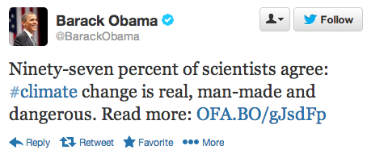
Let's compare this with how non-scientists seem to thinking about climate change right now. Here is a Gallup poll from a few weeks ago, asking people how much they worry about each of 15 problems of current political interest.
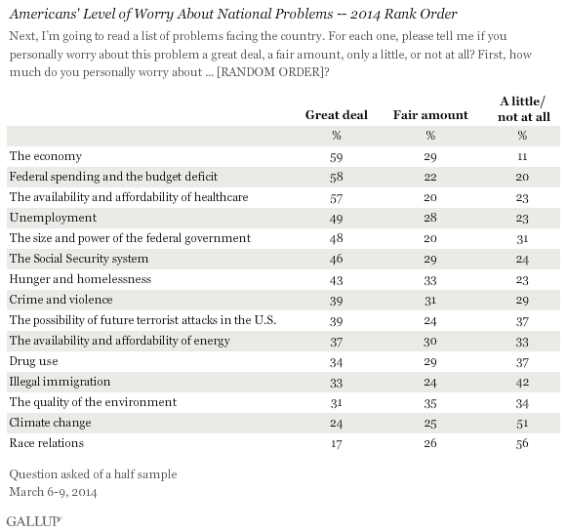
The economy comes first – no big surprise there. What might be surprising is that climate change ranks near the bottom, and the environment in general not much higher. Even among Democrats, climate change only rises to 11th out of the 15 problems, still below things like federal spending, drugs, and crime:
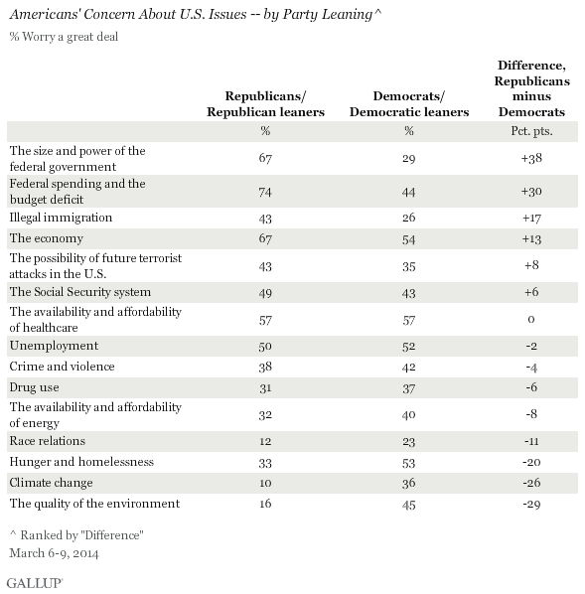

The environment ranks higher among Democrats as well as the general public, but it's still less than a majority who say they're greatly worried. In general, according to a series of these Gallup polls, strong concern about the environment is now at its lowest level ever, having dropped 12 points in the last seven years:
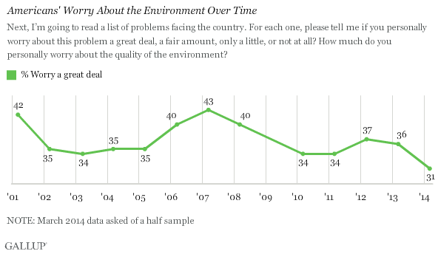
So, there's considerable tension here, between what SUNY Geneseo and the federal government think is a critical problem, and what ordinary people think. In fact, it looks like most people don't even believe that the scientific consensus that's behind this theory even exists. According to the popular climate website skepticalscience.com and its companion website theconsensusproject.com, the median view of the general public is that 55% of scientists agree on global warming, while in fact it's 97%:

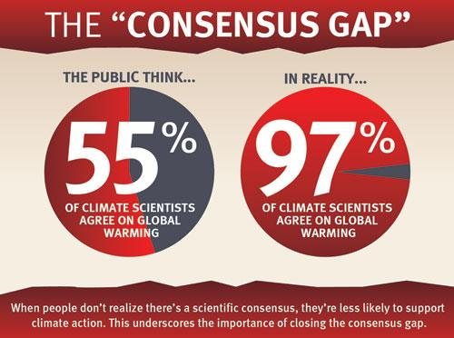
How can ordinary people get it all so wrong? There seem to be two popular theories that attempt to diagnose this "consensus gap" in the perception of objective facts. The first diagnosis is that there is something wrong psychologically with people who don't believe that we are facing a crisis in climate change. Here is the psychologist Stephan Lewandowski in a controversial but widely publicized and celebrated article from last year:

Among American conservatives, but not liberals, trust in science has been declining since the 1970's...There are also growing indications that rejection of science is suffused by conspiracist ideation, that is the general tendency to endorse conspiracy theories including the specific beliefs that inconvenient scientific findings constitute a “hoax”.
Stephan Lewandowski, et al “NASA Faked the Moon Landing--Therefore, (Climate) Science Is a Hoax: An Anatomy of the Motivated Rejection of Science”, Psychological Science 24(5) 2013

This study really struck a chord with journalists and people in the climate change community. But I doubt that many of them really believe that most "deniers", as they call them, are literally crazy – there are just too many of them if, as seems to be the case, something like half the American public just don't believe we're having an environmental crisis.
The other major diagnosis of the so-called consensus gap is that much of the general public is not crazy, exactly, but rather gullible – to the point that media sources like Rush Limbaugh and Fox News are able to essentially brainwash them into denying the facts that 97% of climate scientists agree about, and even deny the that scientists agree. Since a small handful of scientists are willing to go against the consensus in exchange for corporate support or for other self-interested reasons, Fox News can amplify their voices by having them appear on O'Reilly and Hannity all the time and make it look like there is genuine debate, when in fact science has spoken and the essential question has been settled. People get angry at these corporate and other right-wing organizations for deliberately misleading everybody in the same way that cigarette companies used to lie about tobacco causing cancer, and put a lot of pressure on academic journals and respectable newspapers like the LA Times not to encourage this illusion that basic questions are still open one by including the views of denialists. Some people have been going
further than this, including RFK Jr, who shouted from stage at an environmental concert:

This is treason. And we need to start treating them as traitors.
Robert F. Kennedy Jr., “Live Earth” 2007

…and, rather more cool-headedly, our colleague Lawrence Toricello up the road at RIT, who says:

What are we to make of those…who purposefully strive to make sure “inexact, incomplete and contradictory information” is given to the public?...We know them to be not only corrupt and deceitful, but criminally negligent in their willful disregard for human life. It is time for modern societies to interpret and update their legal systems accordingly.
Lawrence Toricello (Philosophy, RIT), Theconversation.com 2014

This is clearly a call for legal punishment, and one that has gotten quite a lot of press in recent days. Building on Toricello's argument, a writer at the popular website Gawker.com makes the argument with more emotive punch and literary flair:

Those denialists should face jail. They should face fines. They should face lawsuits…I’m not talking about the man on the street who thinks Rush Limbaugh is right, and climate change is a socialist United Nations conspiracy foisted by a Muslim U.S. president on an unwitting public to erode its civil liberties. You all know that man. That man is an idiot. He is too stupid to do anything other than choke the earth's atmosphere a little more with his Mr. Pibb burps and his F-150's gassy exhaust.…I’m talking about Rush and his multi-million-dollar ilk in the disinformation business. I'm talking about public persons and organizations and corporations for whom denying a fundamental scientific fact is profitable…Those malcontents must be punished and stopped.
Adam Weinstein, Gawker.com

So, it looks from these and lots of similar examples like we have three broad choices for why so many people deny the consensus position of mainstream science. Either they are kind of paranoid, or they are corrupted by greed, or they are too gullible to resist the anti-scientific propaganda of the corporate-sponsored right-wing media.
Now here's the problem from my point of view. I don't believe that we are in a climate crisis myself, but I don't think I'm any of those three things. I'm not in the pay of Exxon or the Koch brothers, I'm not stupid or gullible – I'm a philosopher, and I try to be skeptical about everything I hear. And as far the psychiatric diagnosis for "denialism" goes…well, I'm taking my medication, and my probation officer tells me I'm really doing well, so I don't think that that's the problem either. In fact, I know a lot of people who are very smart, well-educated, scientific- minded kinds of people who hear and understand what mainstream scientists are saying about climate change; they just don't believe it. That is, they don't believe in this environmental crisis theory, and I don't, and I thinks it’s because we're reasonable people and it's not a rational belief for us to have.

4. Reasons for skepticism
Well, why not? Why shouldn't we just accept what scientific experts are telling us is happening and going to happen if we don't take serious, economically painful steps right now to stop it. Well, there is good reason. We should take things on trust people, only when we have good overall reason to believe that what they're telling us is probably true. Technical expertise, for example among scientists, is certainly an important factor in deciding whether people ought to be believed, but it's not the only one, and it's not the major one. The major one is track-record, a potential sources history of being right. Scientists are good, intelligent, sincere people – a lot like philosophers, in fact. But this doesn't make them usually right, especially in matters of long-range predictions about complex systems like the stick market – or, one might suppose, the climate, even when they all, or nearly all, agree. We have to look at history as well as people's credentials, and scientists are wrong a lot. And they the most wrong, the most often, when their science is combined with politics – same thing with philosophers, no better and no worse. Environmentalists in science – I love them like my brothers and sisters, but they have a pretty poor track record when it comes to a long series of catastrophic predictions that they have been making over the last several decades. Not just mistakes, either, but they have made some disastrous mistakes that really hurt a lot of people even as they swelled the ranks of the political movement to which they belong. And it's only rational for reasonable people to be very suspicious of each new catastrophe that they predict, even as we trust them to explain why ants have six legs instead of four, and all kinds of other points where politics is not involved.
Here is the founder of modern environmentalism, Rachel Carson, whose book The Silent Spring brought an end to worldwide spraying with the insecticide DDT, and who set the standard for persuasive writing on environmental issues.

"The road we have long been traveling is deceptively easy, a smooth superhighway on which we progress with great speed, but at its end lies disaster. The other fork of the road — the one less traveled by — offers our last, our only chance to reach a destination that assures the preservation of the earth…How could intelligent beings seek to control a few unwanted species by a method that contaminated the entire environment and brought the threat of disease and death even to their own kind?... Who would want to live in a world which is just not quite fatal?”

Right there is origin of the heroic environmentalist goal of saving the planet through stoical dedication to the environment, even at some cost to other, lesser values like controlling bugs and making money. The problem is that there's a serious answer to the question, who wants to live in a world full of insecticides, and the answer is: Africans. Here's what can happen when you jump the gun on saving the environment:

''Silent Spring'' is now killing African children because of its persistence in the public mind. Public opinion is so firm on DDT that even officials who know it can be employed safely dare not recommend its use…''
Tina Rosenberg, “What the World Needs Now is DDT”
The New York Times Magazine, April 11, 2004

"The ban on DDT," says [Robert] Gwadz of the National Institutes of Health, "may have killed 20 million children."
Michael Finkel, “Malaria: Stopping a Global Killer”
National Geographic, July 2007

Now, maybe these articles are wrong, though they come from the NYT and National Geographic, which are certainly not right-wing sources. But 20 million children is a lot, and probably the only place in the world that they could have died more or less unnoticed is Central or Southern Africa. I think we really have to take the question seriously, who wants to live and who doesn't, in a world that isn't very clean? So Rachel Carson's rhetoric sets off this movement that sounds lovely in principle but we have to study and learn from the consequences of destroying things that actually work in hopes that something just as good but nicer will take their place. People who are not committed environmentalists take this kind of lesson very seriously.
Now, here is the second founder, the John Calvin to Rachael Carson's Martin Luther of environmentalism, namely Paul Ehrlich, whose book The Population Bomb, published in 1968, was another raging best-seller for several years, and quickly taken as gospel among environmentalists and college students generally. And he made some very clear predictions about what was about to happen to the world, that millions of people really believed.

“The battle to feed all of humanity is over. In the 1970s and 1980s hundreds of millions of people will starve to death in spite of any crash programs embarked upon now. At this late date nothing can prevent a substantial increase in the world death rate..."

This stuff really discouraged a lot of people from having children, and made the idea of a two-child limit pretty standard as a moral principle among educated people in the West. But Ehrlich's catastrophic predictions turned out to be false. Although the world's population has about doubled since 1968, production of food, energy, and other necessities have more than kept pace. Far from the kind of mass famine and desperate, existential warfare that Ehrlich predicted, human longevity has improved enormously on every continent since The Population Bomb was published:

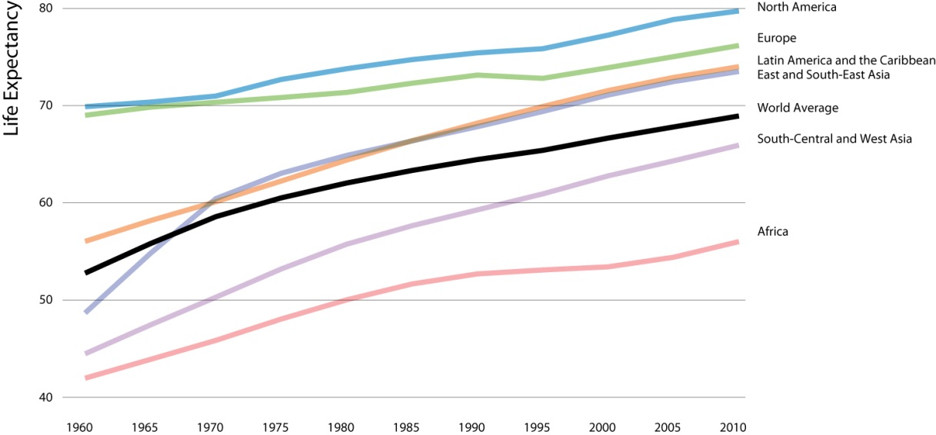

During this very period Asian countries of the old Third World have prospered enormously and even Africa has seen average life expectancy rise by a good ten years. Nothing this good has ever happened on a world-wide scale before in human history.
These are just two major examples of the kind of planetary crisis that the sustainability movement depends on, and neither happened, although people like Ehrlich keep claiming that they're going to; they just keep moving back the schedule. And that's fine – all kinds of things could happen. The main question for me is, what should a reasonable person expect to happen this time, given the track-record of failed scientific prophesies of doom?
It’s not just the track-record, either. There is a lot of evidence that much of what we're being told by mainstream sources is just propaganda. Tell if I'm just being paranoid. Here is the climatologist Steven Schneider, a colleague of Ehrlich's at Stanford, talking openly in 1989 about the problem of getting people to believe that this is happening:

"On the one hand, as scientists we are ethically bound to the scientific method, in effect promising to tell the truth, the whole truth, and nothing but...On the other hand, we are…working to reduce the risk of potentially disastrous climatic change... So we have to offer up scary scenarios…and make little mention of any doubts we might have…Each of us has to decide what the right balance is between being effective and being honest."

It can hardly be crazy for people to take this person at his word when we are in fact being offered scary scenarios with little mention of any doubts. I like scientists a lot, but I don't want to have to wonder whether I am being manipulated every time I talk to them about important things because they're always balancing being effective against being honest. I just want them to be honest, simpliciter.
Is the climate movement being honest with the general public, or isn't it? There are parts of the public presentation of the climate crisis that we can easily evaluate without being scientists ourselves. For example, the mascot of climate change is the beautiful endangered polar bear. Well, we can't actually tell for ourselves whether there is evidence of their being endangered, if that's just a matter of their possibly being wiped out at some point in the future if the most extreme climate disaster scenarios turn out to be true, in which case lots of stuff gets wiped out. But we can tell some things. Here is the picture that our children look at all the time in school, or pictures like it:

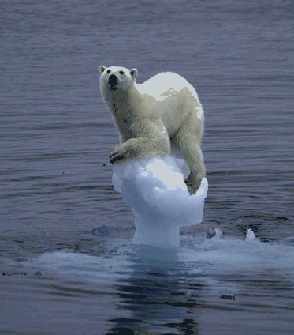

This poor polar bear seems to be stranded on a little piece of melting ice and it looks like he is probably going drown if we don't save him somehow. The problem with this picture is that polar bears are aquatic:

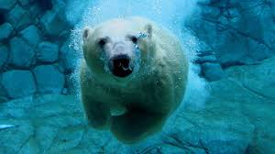

They are marine mammals; they have webbed feet; they have inches of blubber and special fur to keep them warm in freezing water. They are, in fact, the most powerful mammalian swimmers that can also walk on land. They can swim for hundreds of miles without stopping. According to National Geographic, the current record among polar bears with GPS devices stuck to them is 426 miles straight swimming over nine days in a row. Depicting a polar bear as stranded on a little ice floe is as accurate as showing pictures of an eagle stranded on the branch of a tree. This is propaganda. It does not encourage trust.
Taken more seriously as science is this famous graph, the so-called "Hockey Stick", which seems to show a vivid correlation between atmospheric CO2, the blue line here, and global temperature in red – both looking pretty stable over the last thousand years until about a hundred years ago, when we see a sudden exponential-looking increase in both. There's more fluxuation in the temperature changes, but they really look like the two things are tightly connected. But this kind of graph is really misleading. For one thing, the CO2 levels and the temperature are on totally different scales, and the fact that they touch at both ends of the graph is completely arbitrary – it's the choice of the person who makes the graph. (I don't say that this is abnormal, but it tends to be misleading.) Moreover, what looks like a very sharp and even scary increase on the right side of the graph is also just an artifact of how the scale is placed on the y-axis. If you want to make a big visual impact, you can stretch these things out as much as you like – so, here's Al Gore from his movie An Inconvenient Truth, showing that he needs mechanical assistance to get up to where the CO2 is driving global warming "off the chart":

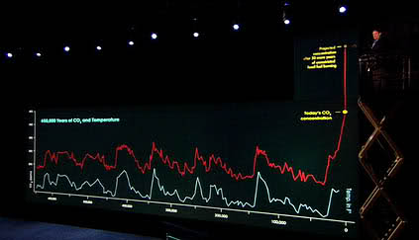

But if you attend only to the data, not its representation, what is being depicted as a monstrous increase over the last century is actually all taking place with eight-tenths of one degree centigrade. Is that a lot? Should we be frightened by that kind of change? Well, maybe, but not from looking at the graph. Stretching things out in graphs like this to make them look impressive is, in fact, the oldest statistical trick in the book. And I know this because I have the book. Here it is: How to Lie with Statistics by Darrell Huff, which was published in 1954 and a best-seller for several years thereafter (there are nine copies of this in the library). It includes a whole chapter on what Huff calls the "Gee Whiz" Graph:

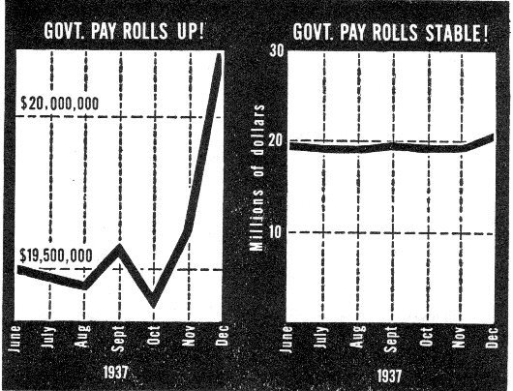

Here he represents the exact same data on two different scales, with two different headlines: "Government Payrolls Up!" if that's what you want people to see; and "Government Payrolls Stable" if that's what you want people to see. Try the same thing with the Hockey Stick by graphing the data in plain old Celsius degrees, and here it is:

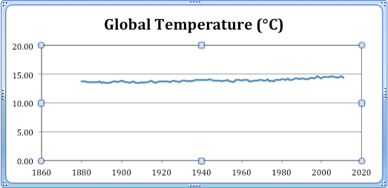

Or, if you prefer the Kelvin scale, it looks like this:

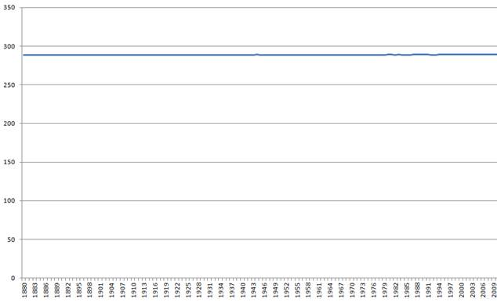

Now, we're all informed adults and we don't have to take things like the stranded polar bear and Al Gore on an elevator seriously, but it bothers me and a lot of other people that tricks like this are being sold to our children as science, and generally used as propaganda to whip up political emotions to support the global economic transformations that environmentalists demand. This kind of marketing can be effective in the short run – and it has been successful with the current generation of students – but it is not conducive to trust over the long run, and adults who are being given this kind of hard sell all the time really resent it.
None of this entails that we are not in an environmental crisis. I've just been talking about what serious people ought to believe, given what they're being told by whom. But let's look a little deeper into the facts – again, I mean the public facts, not technical facts about the climate. What is the so-called consensus of scientists? What does it say, and what is our evidence that scientists agree? Here is a list of things that various scientists or scientific groups or environmental groups that include scientists have said.

(1) that global temperatures have risen over the last century or so, on the order of 8/10 of a degree.
(2) that humans have responsible for some of this increase.
(3) that we have caused most of the increase.
(4) that the increase is unprecedented.
(5) that temperatures are going to keep rising as they have, or faster.
(6) that this might give us problems to solve.
(7) that this will give us problems to solve.
(8) that these problems might be catastrophic.
(9) that this catastrophe will happen unless we take drastic actions to prevent it.
(10) that it is worthwhile, given all we know at this point, for us to take these drastic actions now, regardless of all the foreseeable harm that these actions will bring about.

Now, where exactly in this list does the consensus fall? People are trying to convince us that we're in some kind of climate crisis, and we hear all the time that the debate is over and the science has been settled, and so on, and that 97% of scientists agree. Okay – agree on what?
Here is another poster from the Consensus Project:

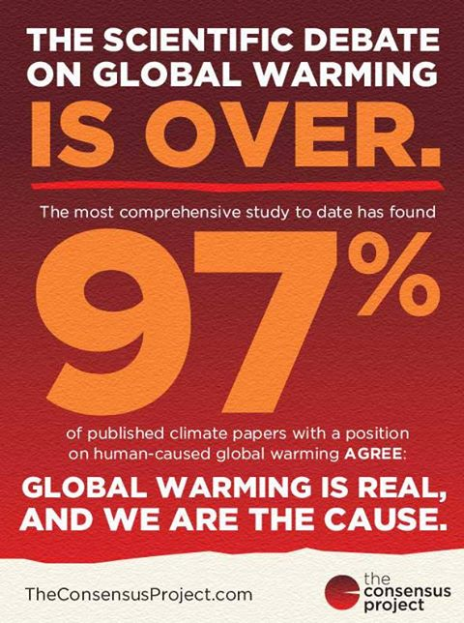

It says:

"The most comprehensive study to date has found that 97% of published papers with a position on human caused global warming agree: global warming is real, and we are the cause"

So, what exactly does this mean? The reference is to the so-called Cook Study. Here again is what the President of the US says it means:

Is that really what it means? Well, first of all, it only gets us down to level three on the list – the study doesn't say anything at all about the warming being dangerous. Secondly, it's a survey of papers, not of scientists, so that part is also wrong. It's possible for a small group of scientists is publishing a whole lot of papers (that's certainly what happens in philosophy, where I wouldn't be surprised if the majority of papers are being published by a few hundred people). So that's two major problems.

Next, we have to look into the study itself to see what's actually been shown. It's called the Cook Study, because it's by a team led by the Australian environmentalist John Cook, and their paper, published last year in Environmental Research Letters, is called "Quantifying the consensus on anthropogenic global warming in the scientific literature." Here's what it says. The team classified about 12 thousand abstracts from climate journals. About third of them either stated or implied some kind of position about global warming. Of those four thousand or so papers, 97% fell into one of these three categories:

either:

they stated that human activity caused most of "recent global warming"
or:
they stated that human activity caused some of the recent warming
and they didn’t state that it was not most of the warming
or:
they implied that human activity caused some of the recent warming
and they didn’t state that it was not most of the warming

Then they added up these three categories and the result was 97%. Now it seems to me that this result does not license the claim that 97% of these papers, let alone scientists, agree that "we are the cause" of global warming. That's just category one, at best. (Note also that there's no screen for the belief that this warming is going to continue, let alone accelerate.) The other two categories don't state or imply that we are "the" cause of GW, only that we are "a" cause of global warming, and not necessarily a significant one. [I had a burrito for lunch, myself, so that's going to produce more than zero greenhouse gas.] To look for a consensus, then, even on the claim that we've caused most of the warming over the last century or so, we have to find the percentage of papers that fall in category (1). Sadly, the article doesn't reveal this, and skeptical opponents had to dig through the supplementary data files to come up with the answer. Here is the breakdown of the 97% consensus reported by this study (as far as I know this has not been challenged). Out of that 97% Category (3) accounted for 72%; category (2) accounted for 23%; and category (1), where the paper actually said that most of the recent global warming was caused by human activity, accounted for only 1.6% of the articles in question. In raw numbers, that's a total 64 papers out of about 4000 that stated or implied a position, which comes out of the original 12000 papers examined. It seems to me that there's a big difference between the 97% that gets constantly repeated and the 1.6% that actually shows up in the data. Cook and his team make a big deal about having checked their classifications against a sample of responses from the paper's authors as a way of showing lack of bias – but that's entirely beside the main point, which is that three categories are being conflated, illegitimately. [footnote; This is the study everybody cites the most these days, but there are other, previous studies that purport to show similar levels of consensus about…something about global warming. I'll leave it as an exercise for interested people to examine these.] I find it really troubling that this paper got published in the first place, let alone broadcast throughout the world as if it were conclusive evidence for anything of interest, let alone used as a weapon to shut people up.
For what it's worth, the Journal of the American Meteorological Society is about to publish a legitimate survey of the society's members, and it comes up with 52% agreeing that global warming is real and being caused mostly by human beings. Although we can note that this goes all the way up to 78% for people identifying themselves specifically as climate scientists and who publish mainly on this topic. [It's an interesting phenomenon, I think, that the core experts among the experts have a much greater consensus, which might mean they know more, but it can also mean that other scientists not within that group are unpersuaded by their arguments – even after two decades of discussion.] In any case, with these numbers it hardly seems like a "settled" discussion among scientists who ought to understand the issue even if they don't write articles about it.
Finally, I want to talk about what counts as science in this whole discussion, and in particular whether this claim of a broad consensus of scientists in favor of a few preliminary facts about the climate crisis (even supposing that such a consensus exists, which it apparently does not) – whether this claim of consensus ought to carry any weight at all in scientific judgments. I turn to my favorite bird-cum-ornithologist, Richard Feynman. Here’s one of his famous slogans, a definition of science itself:

"Science is the belief in the ignorance of experts"

What does he mean by this? How can the experts be ignorant? I'll let the man explain himself how science works, from a famous set of lectures that he gave at Cornell fifty years ago. Here's what he says:

"In general, we look for a new law by the following process:
First, we guess…
Then we compute the consequences of the guess…
Then we compare the computation results to nature...
If it disagrees with experiment, it’s wrong…
In that simple statement is the key to science…That’s all there is to it.”

There is a name for this model of science among ornithologists. It's called hypothetico-deductive falsificationism. We just have to say a little more about the kind of guesswork involved in framing a genuinely scientific hypothesis. What we do is, we look for apparent patterns or regularities in nature, and then we try to imagine a natural law of some sort that matches two criteria. First, it has to make progress in explaining the pattern that we're trying to understand; and second, it has to fit in somehow with the background theories that we already accept – there is no sharp distinction between background theories and hypotheses – it can only be a package deal. So that's how we make the guess. And then we do exactly what Feynman says. We deduce testable predictions from the hypothesis together with the background theories and then we see if those predictions turn out to be true. If they do not, then bye-bye hypothesis (although we might want to replace it with something similar). If they do, then we continue to examine the hypothesis, deducing more predictions, testing them and so on. Eventually, typically over a long period of time, that unfalsified but multiply tested hypothesis merges into the theoretical background while we search for other patterns that might be explained by new hypotheses in an expanding package of theories. That's what's called "normal science" in the business.
We need to distinguish this model of modern, fully empirical scientific method with the pre-modern methodology that passed for science prior to Galileo – and I don't mean religion, it was definitely science of a sort, or natural philosophy as it was called. In the olden days, people came up with recognizably scientific hypotheses in essentially the same way we do now. They sought out patterns and regularities in the natural world, and came up with hypotheses that made sense to them, that is, that fit as well as possible into their existing understanding of the world, but now also subsumed the new patterns that had struck them as in need of explanation (Aristotle, for example, did tons of this kind of work, and did it brilliantly.) Once that had an explanation that seemed to work, they were happy, and went on to other puzzles – except, as Medieval science developed in Europe, these natural philosophers (like Copernicus, say) had to submit their theories to Church authorities, who were exclusively empowered to accept or reject them as consistent with or contrary to existing doctrine (official background theories, if you like). If the new theory passed this test of authority, then it was simply accepted until it was disproven, either by surprises events in nature, or, as it frequently turned out, by Protestants ignoring their authority. This was not an especially cruel system, and by Galileo's day the Catholic Church actively encouraged scientific works of all sorts, provided only that the relevant committees of bishops got the final word.
Is climate crisis theory modern science, or is it more like pre-modern science? To the extent that it is being presented to the public as an authoritative package of supposedly "settled" positions that have been voted on by various committees, when they have not been thoroughly tested by experience and have failed some important partial tests, only to be patched up ad hoc after the fact, and to the extent that people who dissent from these doctrines are being denounced within and shunned by their community as the equivalent of heretics, and to the extent that mainstream scientists are relying on a priestly status as experts to protect themselves from challenges by officially "unqualified" outsiders – to the extent that all this stuff is going on, and it seems to me that a whole lot of it is, the science that supposedly supports the thesis that we're facing a catastrophe in climate change, and the disruptive and potentially extremely disruptive measures demanded by the movement for "sustainability", is not even science in the modern sense.
I'll let my partner Feynman have the last word:

“Religion is a culture of faith; science is a culture of doubt.”

There are serious problems with the study on which this conclusion is based. First, the survey was non-random, solicited on a handful of climate websites where the authors felt some cranks might be hanging out. Second, the sample this produced was tiny; only 129 people who do not believe in climate change. Third, as Lewandowsky et al actually admit elsewhere, the results they got hardly distinguished pro-climate change conspiracy believers from anti-climate change conspiracy believers, quote: …conspiratorial thinking accounts for only a modest component of the variance in people’s opinions about climate change… Lewandowski, et al www.shapingtomorrowsworld.org 2013 Fourth, the very title of the article is directly contradicted by the supplemental data that was temporarily on file. There were, it turns out, exactly ten respondents who said they believed that the moon landing was a hoax. Among these ten, only four were climate change "deniers". The other six were climate change believers. But the article has made Lewandowsky famous, largely because of the unquestionably false title.
quoted in Discover, October 1989
"A female polar bear swam for a record-breaking nine days straight, traversing 426 miles (687 kilometers) of water —equivalent to the distance between Washington, D.C., and Boston, a new study says." Anne Casselman, National Geographic News, July 20, 2011
http://iopscience.iop.org/1748-9326/8/2/024024/article
http://daviddfriedman.blogspot.com/2014/02/a-climate-falsehood-you-can-check-for.html

