Ecology 203, Exam I. February 16, 2001. Print name:_______________________________
Rules: Read carefully, work accurately and efficiently (THIS IS A LONG EXAM!). Answer questions to the best of your ability. You don’t usually have to answer all questions - choose carefully. There are no questions that were submitted by students. Good luck!

Multiple Choice. (ANSWER 15 OF 18; 2 pts each; 30 pts total)

1. Darwin’s main contribution was to describe
a. the origin of species.
b. the process of evolution.
c. the mechanism of evolution.
d. the faults of evolution.
e. all of the above.
2. Emergent properties are
a. primarily parts of plants that stick out.
b. primarily parts of animals that stick out.
c. found in lakes and steams but not land ecosystems.
d. observable only in intact ecosystems.
e. revealed when a system is broken down into is separate pieces through reductionism.
3. Ultimate explanations
a. explain the true nature of natural systems.
b. are built out of proximate explanations.
c. always involve a question that begins with “how.”
d. answer mechanistic questions.
e. are something other than suggestions a-d above.
4. An adaptation is a
a. trait that is genetically determined.
b. learned response to an environmental stimuli.
c. characteristic that influences an organism’s survival.
d. genetically determined characteristic that improves an organism’s survival and reproduction.
e. none of the above.
5. A population that is in Hardy-Weinberg equilibrium:
a. is not evolving.
b. is evolving but not according to natural selection.
c. has stable gene frequencies but not genotype frequencies.
d. has stable genotype frequencies but the gene frequencies may change.
e. all of the above are possible.
6. The Krohne textbook discusses how the rare Mexican pinyon pine exhibits relatively little genetic variation. This is probably due to
a. genetic drift.
b. natural selection.
c. mutation.
d. the failure of evolution to explain everything.
e. the species small population size.
7. The example of the size of human babies represents what type of selection?
a. disruptive.
b. diffuse.
c. directional.
d. stabilizing.
e. deterministic.
8. Animals that look alike but are from separate evolutionary organisms are thought to be examples of
a. convergent evolution.
b. divergent evolution.
b. coevolution.
d. evolutionary stable strategies.
e. all of the above.
9. Females often are choosy about their mates, resulting in bizarre adaptations in males such as elaborate headgear and ridiculously long tails in birds. This is due to what Darwin termed
a. “run-away” evolution.
b. sexual selection.
c. gender-biased allometry.
d. sex-based specificity.
e. parapatric speciation.
10. The “coefficient of relatedness” (r) is an index that estimates the proportion of genes shared by individuals that are identical by descent. The coefficient between sister honeybees is 0.75. This is
a. a closer relationship than between human siblings.
b. more distantly related than human siblings.
c. the same relationship as between a father and mother of identical twins.
d. all of the above.
e. none of the above.
11. Two species that have experienced strong ecological interactions over evolutionary time are said to be
a. coevolved.
b. codependent.
c. in direct competition with each other.
d. in a predator-prey relationship.
e. none of the above.
12. The northern range limit of the saguaro cactus is dependent on
a. water availability.
b. physiological heat tolerance.
c. tolerance of freezing temperatures.
d. the availability of nighttime humidity.
e. the presence of fungal pathogens.
13. Organisms in environments where the level of a resource is causing physiological stress
a. are likely to not reproduce.
b. inevitably must die.
c. are going to die unless their resource levels are quickly returned to near optimal.
d. all of the above.
e. none of the above.
14. One disadvantage for a plant that utilizes the C4 photosynthetic pathway is
a. water use is higher.
b. the Kranz anatomy is inefficient and costly for plants to construct.
c. plants require high light intensity.
d. all of these are disadvantages.
e. there are no disadvantages.
15. Statistical inference involves
a. determining how our data were collected.
b. determining whether our results support or refute the null hypothesis.
c. making statements about the population from our sample.
d. making statements about our sample from the larger population.
e. all of these are aspects of inference.
16. In lecture I discussed the work by David Lack on the reproduction of the common swifts (a bird). The important result from this work suggested that
a. birds that reproduce have more offspring (fledglings) than those that do not.
b. birds that have more eggs than fewer eggs ultimately leave more offspring (fledglings).
c. birds that have either two or three eggs produce the equivalent number of fledglings, which exceeds the production of birds with just a single egg.
d. birds have a counter-current exchange mechanism that allows them to minimize heat loss even while standing in ice-cold water..
e. all of the above (Lack was a versatile scientist).
17. Genetic variability is maintained in populations over time because
a. individuals mate with members of the opposite sex, which are different genetically.
b. mutations balance the tendency for individuals to blend their genes together.
c. traits are coded by genes.
d. natural selection favors genetic variability.
e. all of the above mechanisms are involved in helping to maintain genetic variability.
18. The Hardy-Weinberg Law is a good example of
a. a null hypothesis.
b. a falsified hypothesis.
c. how evolution alters gene frequencies.
d. all of the above.
e. none of the above.

True-False – circle T for true, F for false. (ANSWER 10 OF 13; 2 pts each; 20 pts total).

T F If a population is small the changes in gene frequencies due to random drift are likely to be large.

T F The terms “natural selection” and “evolution” can be used interchangeably (they’re the same thing).

T F All animals exhibit homeostatic temperature regulation.

T F Poikilotherms are also endotherms.

T F Hibernation is an adaptation to avoid water stress (water becomes limiting when tied up as ice).

T F Your book states that kangaroo rats can, if the ambient humidity of the air exceeds 10%, gain all their necessary water metabolically from dry seeds.

T F Plants can vary how much root they grow relative to aboveground biomass (shoots).

T F Plants with leaves lose CO₂ and gain O₂ primarily through the stomates, which are predominantly found on the underside of leaves.

T F The “null hypothesis” is the probability that our p-value is less than 0.05.

T F The Roemer Arboretum was bought by the college in the 19th century.

T F One difference between the book and the lectures is that the book suggests the field of biology is constrained between the level of the organism and entire ecosystems while the lectures have stressed that ecology is broader, including interactions below the level of the organism.
T F Many factors influence the performance of organisms. Since reproduction is the most important measure of individual performance the maintenance of internal body temperature is the most important factor facing organisms in the battle to leave the most offspring.

T F The age of trees can be determined by measuring its girth at 4.5 feet above the ground.

Short, precise answers. Use only the space provided. (ANSWER 3 OF 5; 10 points each; 30 points total)

1. Science and various religions attempt to explain phenomena of the universe. In what simple way, discussed in lecture, are these two approaches different?

2. How is it that crustal plates move about the earth and what is the significance of this for ecology?

3. Below, draw a possible net energy gain curve for an insectivorous bird (it eats insects). Imagine that it flies into a small patch of shrubs where it likes to feed. Explain why your graph looks like it does. Label axes VERY clearly.

4. Provide two examples (either plant, insect, or mammal) of how organisms regulate their temperature.

5. Your field guide discussed the following two questions about birds. Circle one and answer it below.
a. Why do birds forage in mixed-species flocks?
b. Why do birds migrate?

Mandatory questions. (5 points each; 15 points total)

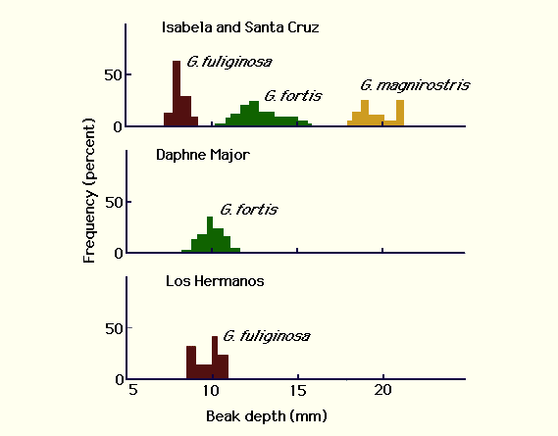1. What is the significance of
this graph?

2. List the four, easily observed characteristics that define natural selection.

3. Draw a graph of the relationship between net productivity of plants and precipitation sampled from various grasslands. Place plausible points on the graph. Draw a best fit line to the data. Provide a plausible equation for the line. Provide a plausible r² value for the line. Label your axes clearly.

