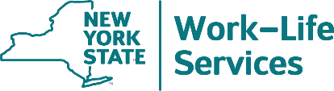

Use the 2022 WellNYS Everyday Monthly Challenges to Become Your Best Self

On January 1, the calendar turns to 2022. Are you interested in
challenging yourself in the new year? This webinar will provide the
2022 WellNYS Everyday Monthly Challenges. These challenges will guide you month-to-month to track, create, eat, plan, move, start, form a team, carve, find out, plan, and use different healthy activities to be your best self by December!

Thursday, January 6, 2022
12:00 Noon – 12:30 P.M.

Presented by
Linda Carignan-Everts, EAP Wellness Coordinator NYS Work-Life Services/Employee Assistance Program
To register for this training session
Go to https://meetny.webex.com/meetny/k2/j.php?MTID=tcd7cd4fa8a98fcaf2f74e12219b730f5 and register.
Immediately, you will receive a confirmation email with instructions for joining the session.
Work-Life Services (WLS) Programs are joint labor-management programs that benefit New York State employees by enhancing employee wellbeing, increasing productivity, and improving morale in the workplace. The WLS programs include the Employee Assistance Program, Network Child Care Centers, and DIRECTIONS: Pre-Retirement Planning. The WLS programs are funded through the collective bargaining agreements between the State of New York and the public employee unions: CSEA, PEF, UUP, NYSCOPBA, GSEU, Council 82, and DC-37. The Governor’s Office of Employee Relations contributes on behalf of management/confidential employees.

