Devonian Stratigraphy of New York State
SDS 2023 Annual Meeting, IGCP 652
Geneseo, New York, 26 July – 07 August 2023

Information form 01 March – registration deadline is 01 May 2023

Please complete and return to:
SDS New York 2023 c/o D. Jeffrey Over
Department of Geological Sciences
1 College Circle – SUNY Geneseo
Geneseo, New York 14454

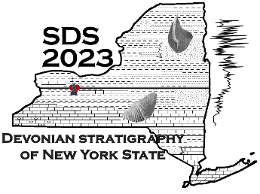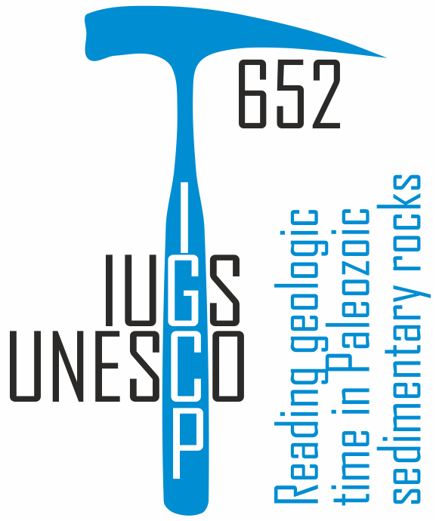

over@geneseo.edu conference web page - https://www.geneseo.edu/SDS_2023

Name: ___________________________________ E-Mail: ________________________________
Institution: _______________________________________
Address: ________________________________________
City: ______________________________ State/Province: __________________
Country: __________________ Postal Code: ______________
Telephone: ______________________ Fax: _____________________________

Conference cost with banquet at PRI-Ithaca - $250 US:
possibly probably almost certainly

Conference cost with banquet at PRI-Ithaca, transport and lodging in Ithaca - $350 US:
possibly probably almost certainly

I will present:
oral paper poster attend but not present - abstract deadline is 1 may 2023 – see abstract form

Pre-conference field trip, cost $550US:
possibly probably almost certainly
Need transport from Rochester/Geneseo to Cleveland on 26 July, 2023 yes no

Intra-conference field trip, cost $50US:
1) Upper Devonian strata or 2) Niagara Falls and Silurian strata
possibly probably almost certainly possibly probably almost certainly

Post-conference field trip, cost $800US:
possibly probably almost certainly
Need transport from Catskill, NY to Rochester/Geneseo on 07 August, 2023. yes no

Official invitation needed: yes no

Tentative schedule:
26 July – Arrive Cleveland, Ohio for pre-meeting field trip – departure from Geneseo and Rochester at 1:00 pm
27 July – field trip departs, Upper Devonian strata - spend night in Erie, PA
28 July – field trip, Upper Devonian strata - spend night in Fredonia, NY
29 July – field trip, Upper Devonian strata - spend night in Geneseo, NY
non-field trip conference participants arrive in Geneseo, NY – welcoming party
30 July – conference begins, stay in Geneseo
31 July – intra-conference field trip – Upper Devonian strata or Niagara Falls, stay in Geneseo
01 Aug – conference, stay in Geneseo
02 Aug – field trip to Lower and Middle Devonian strata and PRI-MOTE in Ithaca, banquet, spend night in Ithaca, NY
post-meeting field trip starts in Ithaca on 03 August
03 Aug – field trip, Middle Devonian strata - spend night in Tully, NY
04 Aug – field trip, Middle Devonian strata - spend night in Schoharie, NY
05 Aug - field trip, Lower and Middle Devonian strata - spend night in Saugerties, NY
06 Aug – field trip, Lower and Middle Devonian strata – spend night in Saugerties, NY – end of field trip
07 Aug – return to Geneseo/Rochester

Important Information

Abstracts Due: 1 May 2023 Meeting Registration Due: 1 May 2023

Pre-meeting field trip includes lodging on 26, 27, and 28 July

Conference lodging is not included in registration. Participants must make their own arrangements for the nights of 29, 30, 31 July and 01 August. A block of rooms has been reserved at the Quality Inn, 4242 Lakeville Road, Geneseo, New York 14454 +1 585 243-0500

The meeting banquet will be held at the Paleontological Research Institute and Museum of the Earth in Ithaca, New York after a field trip. The banquet cost is included in the registration fee. Lodging for participants in the post-meeting field trip is included in the field trip cost. Meeting participants may also register for lodging on the form.

The post-meeting field trip includes lodging on 02, 03, 04, 05, 06 August. Lodging on 07 August is not included in any of the registration fees.

Meals are included on all of the field trips. Meals while in Geneseo, except for the banquet, are not included in the meeting registration.

