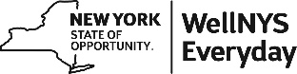

WellNYS Everyday Monthly Webinar
Create and Stick to a Budget

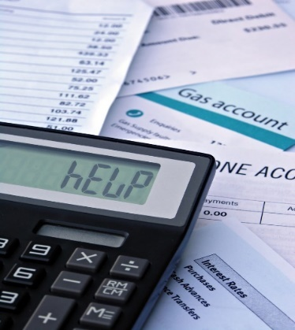

Wednesday, April 5, 2023
12:00 noon – 12:30 P.M.

A budget can take you from where you are,
to where you want to be with your finances.
Join us as we share a monthly budget that assigns every dollar
to a budget category which includes monthly bills, debt, savings,
giving and an allowance for you. After it’s created, we will share how
to stick with it.

Presented by:
Linda Carignan-Everts
EAP Wellness Coordinator

To register for this webinar
Go to https://meetny.webex.com/weblink/register/rf8d130897facbbbcbed112e38410aabf

You will receive a confirmation email with instructions for joining the session. This session will be recorded and made available on the WellNYS Everyday website.

Work-Life Services (WLS) Programs are joint labor-management programs that benefit New York State employees by enhancing employee wellbeing, increasing productivity, and improving morale in the workplace. The WLS programs include the Employee Assistance Program, Network Child Care Centers, and DIRECTIONS: Pre-Retirement Planning. The WLS programs are funded through the collective bargaining agreements between the State of New York and the public employee unions: CSEA, PEF, UUP, NYSCOPBA, GSEU, Council 82, and DC-37 and PNANYS. The Office of Employee Relations contributes on behalf of management/confidential employees.

