WellNYS Everyday Monthly Webinar
Hike New York: Exploring the Great Outdoors

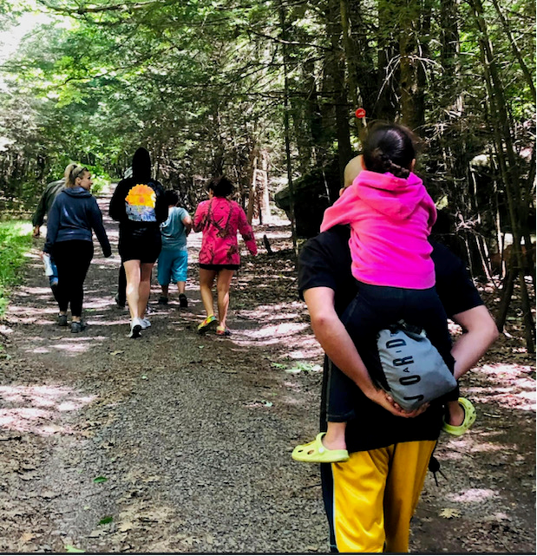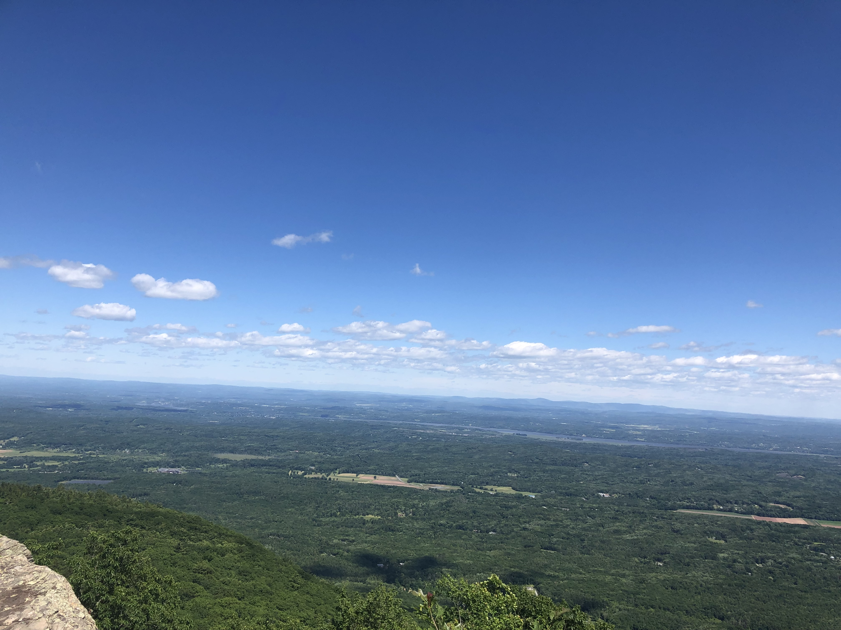

Wednesday, July 12, 2023
12:00 noon – 12:30 P.M.

Hiking is a great way to get exercise while enjoying your surroundings. Whether you choose to go on a challenging mountain hike or a tranquil walk, hiking is a fantastic way to reap the benefits of being outside and active. Join us to learn about some of the great outdoor opportunities that New York has to offer.

Presented by:
Valerie Ryan, WellNYS Ambassador
NYS Department of Motor Vehicle

To register for this webinar
Go to
https://meetny.webex.com/weblink/register/r4826a8883444076ad98673d73917769a

You will receive a confirmation email with instructions for joining the session. This session will be recorded and made available on the WellNYS Everyday website.

Work-Life Services (WLS) Programs are joint labor-management programs that benefit New York State employees by enhancing employee wellbeing, increasing productivity, and improving morale in the workplace. The WLS programs include the Employee Assistance Program, Network Child Care Centers, and DIRECTIONS: Pre-Retirement Planning. The WLS programs are funded through the collective bargaining agreements between the State of New York and the public employee unions: CSEA, PEF, UUP, NYSCOPBA, GSEU, Council 82, and DC-37 and PNANYS. The Office of Employee Relations contributes on behalf of management/confidential employees.

