WellNYS Everyday Monthly Webinar
Building Healthy Meals

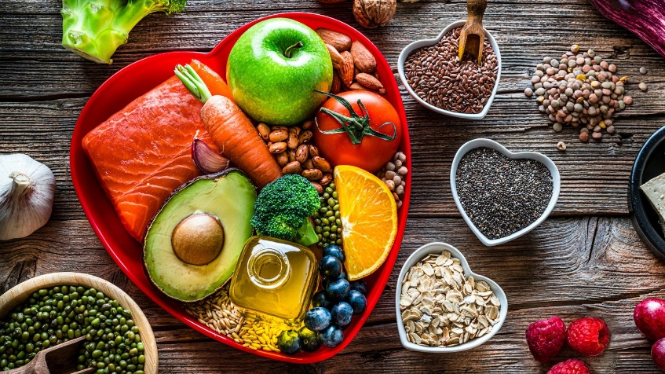

Wednesday, August 9, 2023
12:00 noon – 12:40 P.M.

In this workshop, presented by Registered Dietitian Danielle Munn, you’ll gain tools and knowledge on how to make meal-prep a breeze. Whether it's a need for a quick mid-week dinner or a plan for the entire week, you'll learn how to succeed. Healthy recipes will also be provided.

Presented by:
Danielle Munn
Registered Dietitian, CDPHP

To register for this webinar
Go to https://meetny.webex.com/weblink/register/rf1d283b1a89b9230d4ed3e6b8e8eab21

You will receive a confirmation email with instructions for joining the session. This session will be recorded and made available on the WellNYS Everyday website.

Work-Life Services (WLS) Programs are joint labor-management programs that benefit New York State employees by enhancing employee wellbeing, increasing productivity, and improving morale in the workplace. The WLS programs include the Employee Assistance Program, Network Child Care Centers, and DIRECTIONS: Pre-Retirement Planning. The WLS programs are funded through the collective bargaining agreements between the State of New York and the public employee unions: CSEA, PEF, UUP, NYSCOPBA, GSEU, Council 82, and DC-37 and PNANYS. The Office of Employee Relations contributes on behalf of management/confidential employees.

