WellNYS Everyday Monthly Webinar
Mind Your Health: Ways to Boost Your Brain

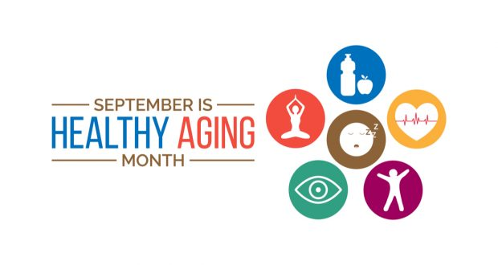
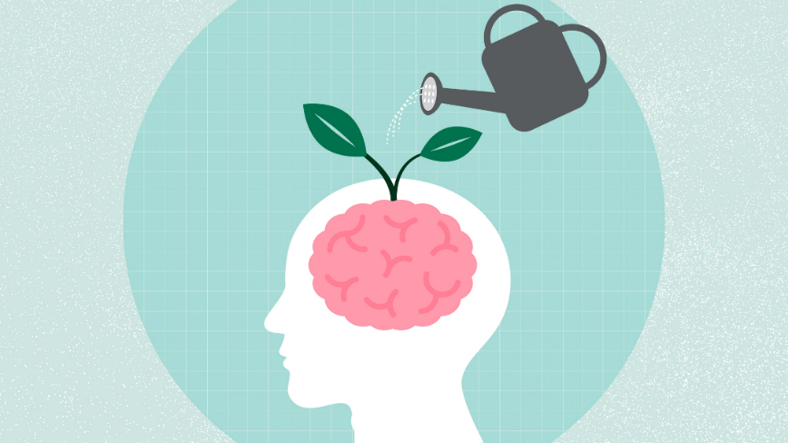

Wednesday, September 13
12:00 noon – 12:40 P.M.

Join us to learn more about how you can promote healthy brain aging. We will discuss science-based strategies that can reduce the risk of cognitive decline and help support a healthy mind and body.

Presented by:
Victoria Kordovski, PhD and Beate Davis, PhD
SUNY Upstate Medical University

To register for this webinar
Go to: https://meetny.webex.com/weblink/register/r3df08c5f7b8a5cde1de41727ec99cb17

Work-Life Services (WLS) Programs are joint labor-management programs that benefit New York State employees by enhancing employee wellbeing, increasing productivity, and improving morale in the workplace. The WLS programs include the Employee Assistance Program, Network Child Care Centers, and DIRECTIONS: Pre-Retirement Planning. The WLS programs are funded through the collective bargaining agreements between the State of New York and the public employee unions: CSEA, PEF, UUP, NYSCOPBA, GSEU, Council 82, and DC-37 and PNANYS. The Office of Employee Relations contributes on behalf of management/confidential employees.

