Contacting a Pathways Peer Advocate via online chat through Discord

In only five brief steps, you can start an online chat with a Peer Advocate on Discord. Our goal is to support all students while also protecting everyone’s privacy to the fullest extent possible.

- Join the Geneseo Pathways Discord server https://discord.gg/gNBhWj89Kk
  - If you don’t have a preexisting account, you’ll be prompted to create your own when you click the link.
  - When creating your profile, expect to be asked for a unique username (we recommend a non-identifying username so that you remain anonymous), your birthday, an email you can access a verification code from, and a password.
  - Only your username can be seen by other users; your email, password, & birthday will remain private.

- Select the Geneseo Pathways Server on the left hand side of the screen (on a mobile device, swipe left to access the server menu and then tap on the Pathways server).
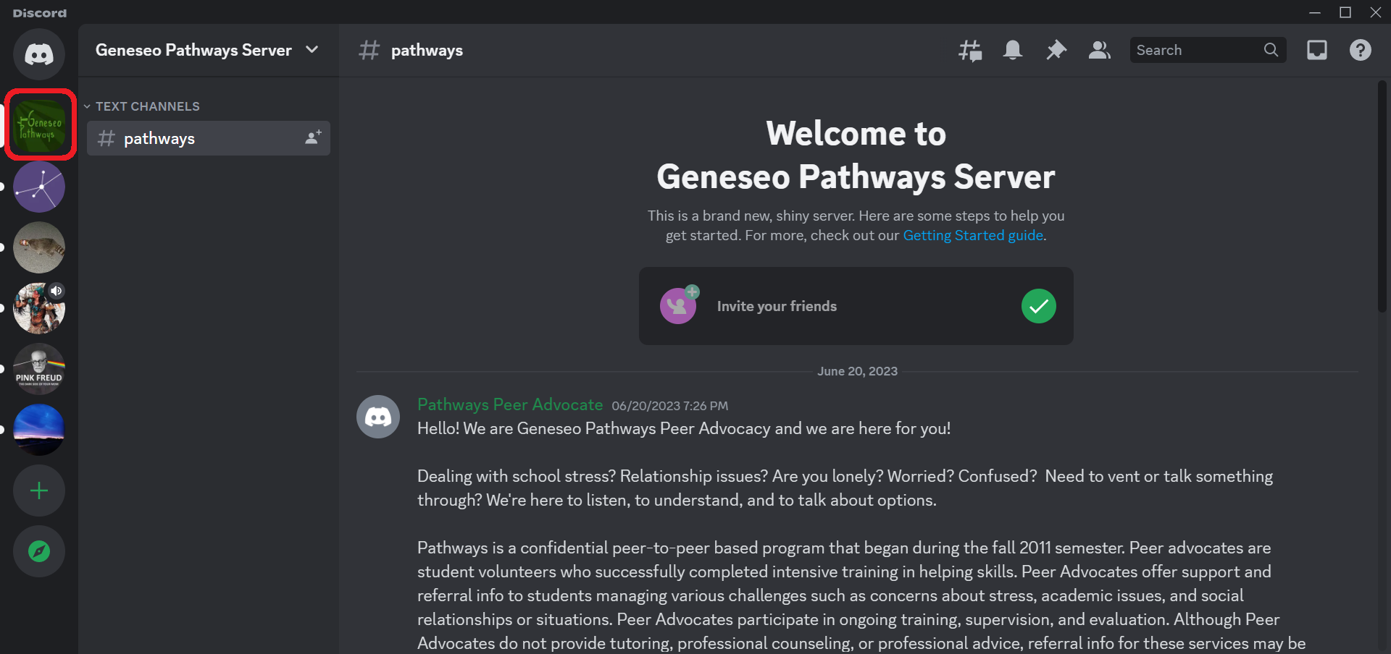

- Click or tap on the Pathways Peer Advocate account. In the text box that appears, send a message that you’d like to chat (on mobile devices, tap the message icon).
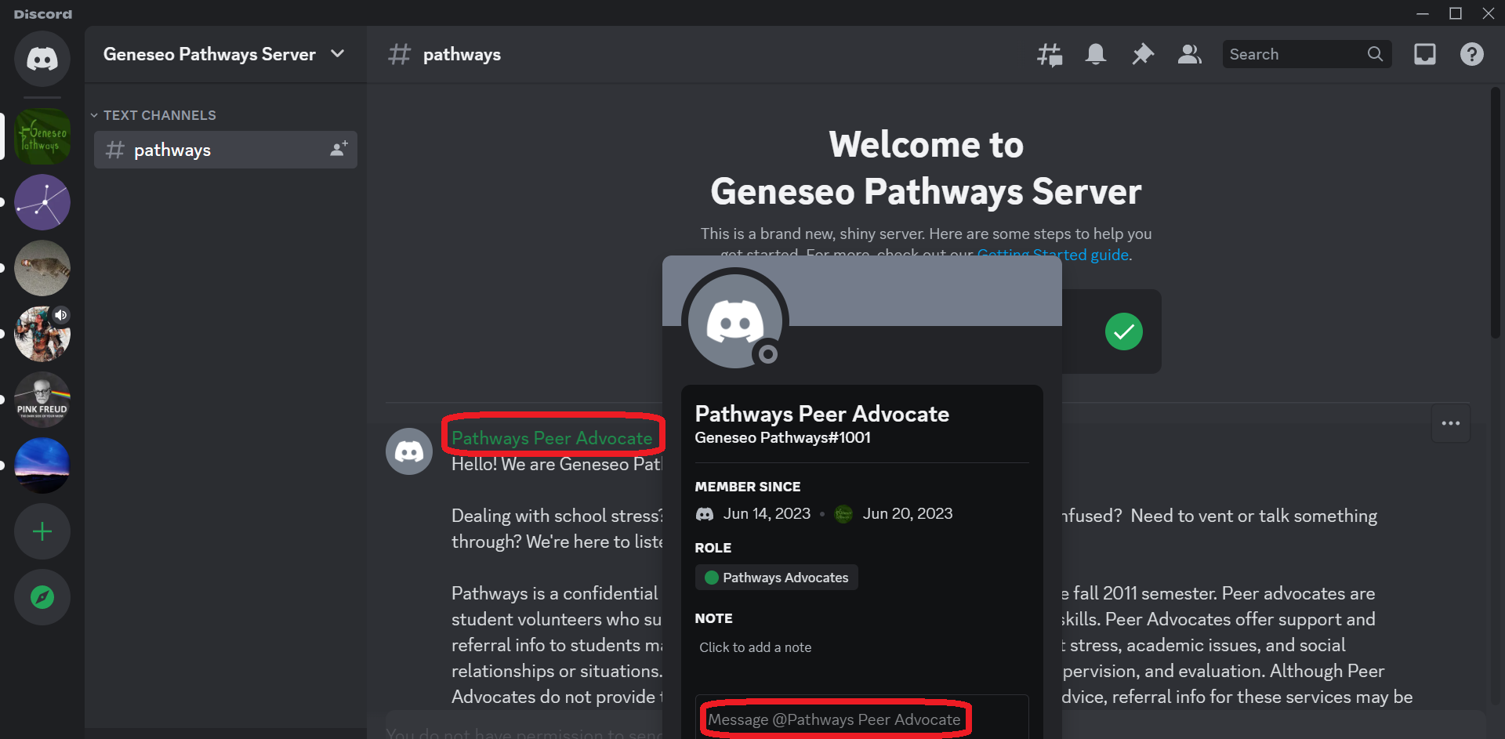

- Friend the Geneseo Pathways account to chat confidentially with an advocate. Do this by clicking the “Add Friend” button at the top of the direct message that opens (on mobile devices, the “Add Friend” button can be found after tapping on the Pathways Peer Advocate account).
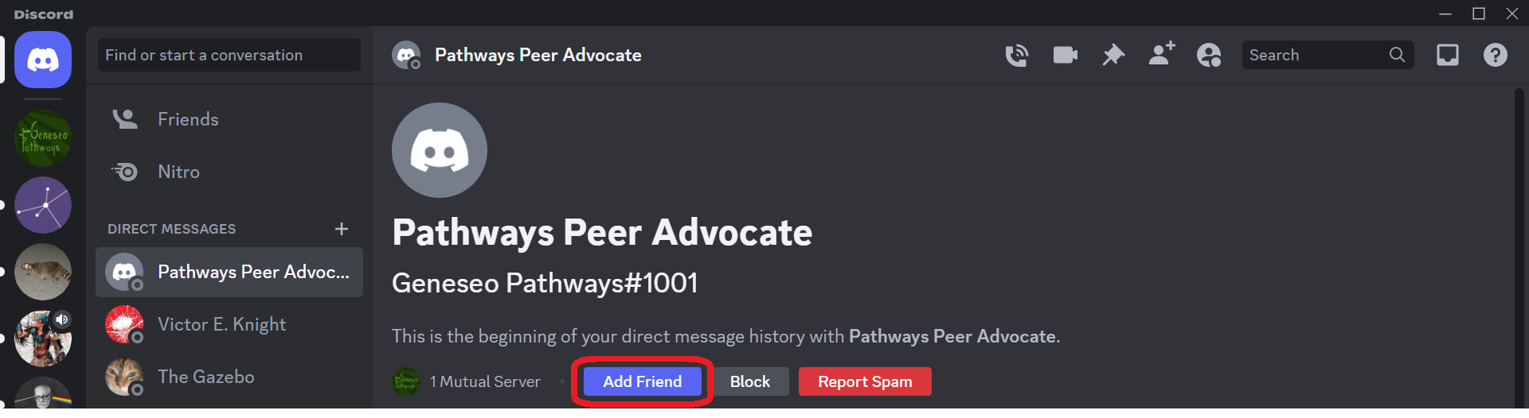

- At some point after adding the Pathways Peer Advocate account as a friend, an advocate will remove your account from the server in order to further ensure confidentiality. However, with the Pathways Peer Advocate account friended, you’ll still be able to chat with a Peer Advocate into the future via direct message!

