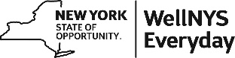

WellNYS Everyday Monthly Webinar
Get to Know Your Community
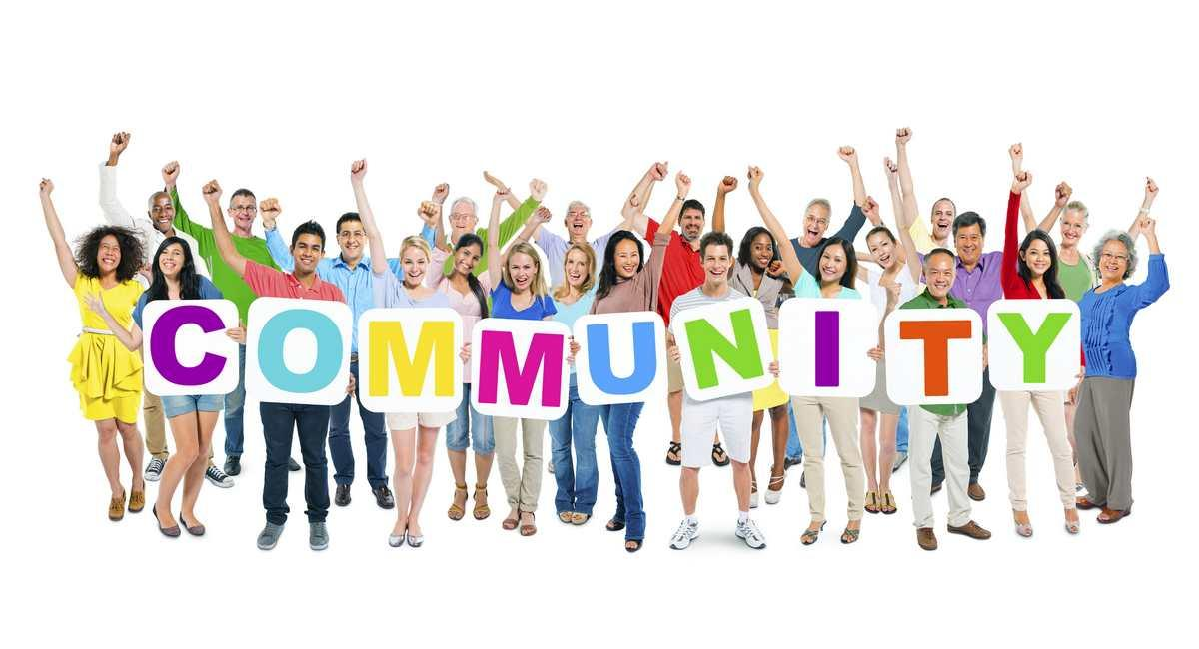
Wednesday, October 11, 2023
12:00 noon – 12:30 P.M.

Your community is where you live, shop, dine, send your children to school, and where you vote. Do you know everything about your community? Join us as we share 25 creative ways to get to know your community. This is especially helpful if you have recently moved.

Presented by:
Linda Carignan-Everts
WLS Wellness Coordinator

To register for this webinar
Go to
https://meetny.webex.com/weblink/register/r4a8c29d899e55dd71e2ffa0c3c10009a
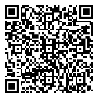
You will receive a confirmation email with instructions for joining the session. This session will be recorded and made available on the WellNYS Everyday website.

Work-Life Services (WLS) Programs are joint labor-management programs that benefit New York State employees by enhancing employee wellbeing, increasing productivity, and improving morale in the workplace. The WLS programs include the Employee Assistance Program, Network Child Care Centers, and DIRECTIONS: Pre-Retirement Planning. The WLS programs are funded through the collective bargaining agreements between the State of New York and the public employee unions: CSEA, PEF, UUP, NYSCOPBA, GSEU, Council 82, and DC-37 and PNANYS. The Office of Employee Relations contributes on behalf of management/confidential employees.

