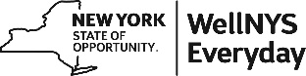

WellNYS Everyday Monthly Webinar
Share Your Favorite Compliments

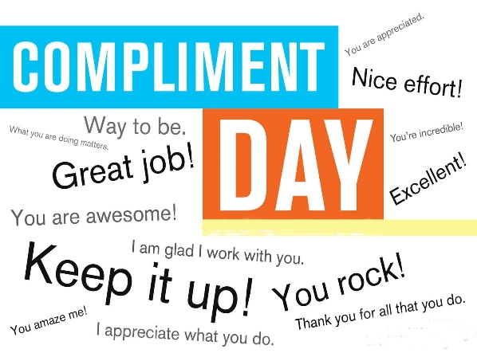

Wednesday, November 8, 2023
12:00 noon – 12:30 P.M.

The WellNYS Daily To-Do for November is to give a compliment to someone today. Compliments build relationships, improve communication, and motivate people. Join us as we share research regarding giving and receiving compliments in the workplace and invite participants to share their favorite compliments.

Presented by:
Linda Carignan-Everts
WLS Wellness Coordinator

To register for this webinar
Go to https://meetny.webex.com/weblink/register/r1d807d3822773015ca06f9ad41c25de7

You will receive a confirmation email with instructions for joining the session. This session will be recorded and made available on the WellNYS Everyday website.

Work-Life Services (WLS) Programs are joint labor-management programs that benefit New York State employees by enhancing employee wellbeing, increasing productivity, and improving morale in the workplace. The WLS programs include the Employee Assistance Program, Network Child Care Centers, and DIRECTIONS: Pre-Retirement Planning. The WLS programs are funded through the collective bargaining agreements between the State of New York and the public employee unions: CSEA, PEF, UUP, NYSCOPBA, GSEU, Council 82, and DC-37 and PNANYS. The Office of Employee Relations contributes on behalf of management/confidential employees.

