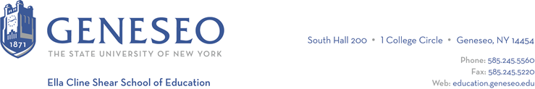

Hello,

Below is the weekly newsletter from the Coordinator of Advisement, Certification, and Communication. You’ll find upcoming School of Education events, along with professional development and employment opportunities shared with the SOE Dean’s Office (we don’t vet any of these opportunities, we just post what’s shared with us). If you have any questions or would like to get in touch with the people or organizations offering opportunities, please don’t hesitate to ask. I’m happy to forward any information I have.

Reminders:

School of Education Events:
For students completing their program this semester, there will be a Certification Information session on Thursday, February 1, 6pm-7pm. The meeting will held via Teams and the meeting ID is: 980512251.

Professional Development Opportunities:
Research by Parkhouse, Lyn, Severson-Irby, Drulis, Senechal, and Lozada maps how teachers become culturally responsive. They followed 19 educators across four schools for two years and found four zones of development during change linked to culturally responsive practices.

Race, Abolition and Intelligence: Preparing Black Youth to “Do More than Survive” Anti-Black Technologies in School and Society will be held January 13, 11am-12pm via Zoom. This presentation will highlight the experiences of three cohorts of Black high school students who participated in a 5-week critical race technology summer program at UCLA, called “Race, Abolition and AI.” The course culminated in a design project where Black youth worked collaboratively to dream up and design race-conscious and algorithmically-just technologies that could help—rather than harm—historically marginalized communities.

Employment Opportunities:
Alexander Central School District is hiring a long-term substitute teacher for a kindergarten classroom.

Allendale Columbia School is searching for an early childhood teaching assistant.

Fairport School District has an immediate need for a middle school special education aide.

Geneseo Central School District has several positions available, including an LTS special education teacher for a co-teaching environment.

The Half Hollow Hills CSD has an anticipated vacancy for a long-term substitute Italian Teacher starting February 12, 2024 and ending April 18, 2024.

Lancaster County School District has several positions available.

Livonia Central School District is looking for an immediate substitute teacher to cover physics and robotics. Contact Chelsea for the job description and more information.

Manchester-Shortsville Central School District is currently recruiting for a long-term substitute High School Mathematics teacher to fill an anticipated maternity leave this spring

Meddeas offers university students and recent graduates a variety of programs that will allow them to live in Spain while gaining teaching experience as language assistants in a private or charter school, under the guidance of an experienced teacher. There is no better way for university students and recent graduates to start a successful career in Education than getting international hands-on experience at a school in Spain with the guidance of expert teachers. This teaching experience abroad will provide a new perspective on pedagogy while being a unique opportunity to learn the second most spoken language in the world! There will be information sessions on January 30th and 31st at 5pm Madrid Time.

