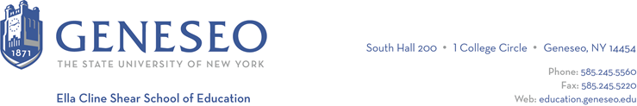

Hello,

Below is the weekly newsletter from the Coordinator of Advisement, Certification, and Communication. You’ll find upcoming School of Education events, along with professional development and employment opportunities shared with the SOE Dean’s Office (we don’t vet any of these opportunities, we just post what’s shared with us). If you have any questions or would like to get in touch with the people or organizations offering opportunities, please don’t hesitate to ask. I’m happy to forward any information I have.

Reminders:

Applications for Graduate Assistantships will close on March 10th. Will you be a graduate student in the School of Education during the 2024-2025 academic year? There are several Graduate Assistant positions available across the college:

SUNY Geneseo LIVES Program: The LIVES Program (Learning Independence, Vocational, and Educational Skills) is a four-year transition program located on campus. The LIVES Program provides students with intellectual and/or other developmental disabilities the opportunity to become more independent, as well as learn vocational and educational skills within an inclusive community. The assistantship requires candidates to serve as a co-teacher in a classroom setting. Preference will be given to those with teaching experience in special education and/or adolescence education. Link to Application Here.

SUNY Geneseo School of Education: Graduate assistants in the Ella Cline Shear School of Education must be enrolled in a School of Education master’s degree program. Graduate assistants primarily work collaboratively with one another, the program faculty, and the Office of Field Experiences in setting up and supporting field experiences for all education programs. Additional responsibilities include, but are not limited to outreach programming, undergraduate student support (i.e. TEACH, registration, TaskStream), mentoring, managing social media accounts, and other administrative responsibilities, such as staffing the reception desk, clerical support, organizing and supporting SOE events, etc. Link to Application Here.

There are also positions available in the Offices of Enrollment Management and Advising.

Professional Development Opportunities:
Total Participation Techniques Book Study is an opportunity for Geneseo Education major students to attend a series of professional development sessions provided by the Rush-Henrietta Teacher Center in Rochester. The sessions are in-person and Geneseo students can attend the sessions for free. The sessions are discussions about effective teaching techniques for all children based on a book called 'Total Participation Techniques - Making Every Student an Active Learner.' If students don't have the book, a physical copy will be provided to the students by the Rush-Henrietta Teacher Center.

Students don't need to attend all sessions. It's completely okay to attend one or two sessions or as many as their schedule allows. The dates of the sessions are March 12th, 26th, April 9th, 23th, 30th at 4-5 pm at Rush Henrietta High School. Registration is online. For more information, reach out to Dr. Jo-Chichester.

Black History Nerds Saturday School: Pro-Blackness: Diversifying Curriculum in K-3 Classrooms and Beyond. In this multivocal discussion, we unpack the concept of Pro-Blackness as it relates to education. We share key premises of Pro-Black Curriculum and Pedagogies. Listeners are invited to think with us about ways Pro-Blackness can be used to interrupt ethnocidal practices that threaten Black children’s culture and spirits. Register online.

Employment Opportunities:
Rochester Academy Charter School is hiring a 5th grade special education teacher in a ICT room and a 3rd grade general education teacher.

