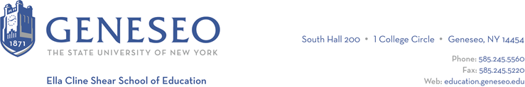

Hello,

Below is the weekly newsletter from the Coordinator of Advisement, Certification, and Communication. You’ll find upcoming School of Education events, along with professional development and employment opportunities shared with the SOE Dean’s Office (we don’t vet any of these opportunities, we just post what’s shared with us). If you have any questions or would like to get in touch with the people or organizations offering opportunities, please don’t hesitate to ask. I’m happy to forward any information I have.

Announcements:
Torianna Robleto, graduating this year from the School of Education, has won a 2024-2025 Fullbright US Student award to Honduras. Read more on Geneseo’s news webpage.

Reminders:
The Master’s Graduation Ceremony will be held on Friday, May 10th at 6pm. Come celebrate our students graduating from the Reading and Literacy program! For those participating, you’ll need to order specific Master’s-level regalia. For those attending and celebrating, there are no tickets required.

The SOE Graduation Celebration will be held on Friday, May 17th at 3:30pm in Wadsworth Auditorium. No tickets required, bring your whole family and friends! We’ll be announcing scholarship winners and celebrating LIVES graduates, too!

Geneseo’s commencement ceremony will be Saturday, May 18th and the School of Education ceremony will be 2pm-4pm. Tickets are required for this event, so graduates be sure to follow all of the instructions you’ve received by email.

Faculty Activities:
Dr. Sharon Peck was the guest speaker on Tuesday for the Monroe County 4-H Volunteer Dinner and she spoke on Play as Self Care. Next month she will be presenting on playful learning and the advocacy work I've done with Healthi Kids and Common Ground Health at this Early Childhood Summit event in Wayne County.

Employment Opportunities:
The Erie County Department of Social Services was approved to participate in the New York State Civil Service Hiring for Emergency Limited Placement program (HELP). The program aims to streamline the hiring process for essential health and safety titles by waiving the Civil Service exam requirement for a duration of one year. Find all opportunities online.

Kealakehe Elementary School in Kailua-Kona, HI has positions posted for general education teachers and special education teachers. Email Chelsea for job descriptions. All applicants should email their resume and cover letter to Catherine Stratton at Catherine.Stratton@k12.hi.us.

The New York State Department of Labor is hosting an education career fair on April 20th at 10am-12pm and 1pm-3pm at RochesterWorks. Attending institutions include Action for a Better Community, Mary Cariola Children’s Center, Hilton Central School District, Education Success Foundation, and the Rochester City School District. Attendees should bring multiple copies of their resumes and wear professional attire. Email Chelsea (cobrien@geneseo.edu) for the flyer.

Norwich City School District has the following vacancies are available for immediate hire as well as upcoming vacancies for the 24/25 school year including: Secondary Math Teacher and Special Education Teacher

