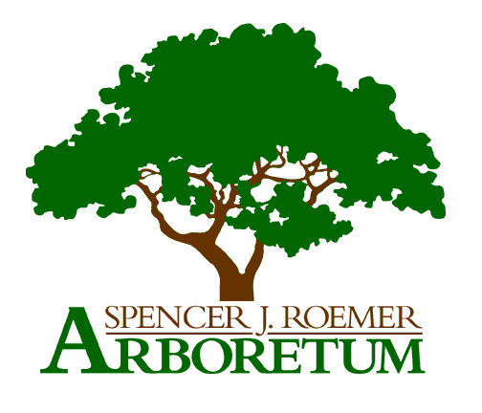
SUNY Geneseo
1 College Circle
Geneseo, NY 14454
Contact: sustainability@geneseo.edu

Request to carry out research or course projects in the Spencer J. Roemer Arboretum

Anyone interested in performing research in the Arboretum (of any kind) or using the Arboretum for a course project that will involve manipulation, collection, and/or off-trail activity should submit this form for approval by emailing it to sustainability@geneseo.edu.

Date of application:

Title of project or activity:

Name(s) of investigator(s) or course leader(s):

Are you from SUNY Geneseo? ☐ yes ☐ no If yes, name of department:

If you are a student, who is your faculty/staff mentor for this project?

Name and address of institution if not SUNY Geneseo:

Type of activity: ☐ research ☐ course activity

Principal contact’s name:

Principal contact’s phone number: E-mail address:

Start date of project: Project end date:

Is this a potential long-term or semi-permanent project? ☐ yes ☐ no

Brief summary of proposed research or course activity (250 words maximum). (A longer proposal can be submitted with, but not instead of, this application, and this summary is required.)

Impact to natural areas (check all that apply):

☐ This project is purely observational and will involve no disturbance.
☐ Exploring/working off trail
☐ Disturbance to soil (digging)
☐ Collecting or moving plants or plant parts
☐ Collecting or moving animals
☐ Collecting or moving other materials (soil, leaf litter, etc.)
☐ Other modifications of the physical environment; describe here:

Does this work involve vertebrate animals? ☐ yes ☐ no

If vertebrate animals are involved, have you applied for IACUC approval?
(For more information: https://www.geneseo.edu/sponsored_research/animal_subjects)

☐ yes ☐ no (Approval of project will be contingent on IACUC approval)

Brief overview of field and/or sampling methods to be used:

Will you be using any field markers to mark plants and/or locations? Briefly describe.
You should provide detailed information about your subject/site markers and approximate locations to our field marker registry once project is approved and markers are finalized. This form will be shared with you. Field markers must be removed by investigator at the end of the project.

