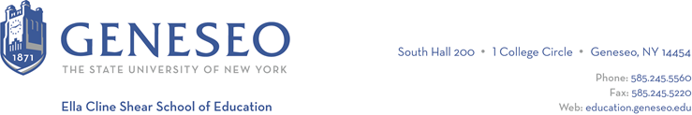

Hello,

Below is the weekly newsletter from the Coordinator of Advisement, Certification, and Communication. You’ll find upcoming School of Education events, along with professional development and employment opportunities shared with the SOE Dean’s Office. If you have any questions or would like to get in touch with the people or organizations offering opportunities, please don’t hesitate to ask. I’m happy to forward any information I have.

Geneseo Event Highlights for Educators:
A Listening Skills workshop hosted by GOLD will be held on Tuesday, September 19th at 2pm.

A Leadership Concepts workshop, also hosted by GOLD, will be held on Tuesday, September 19th at 4pm.

Study Abroad 101 will be held Wednesday, September 20th at 11:15 in MacVittie 321.

There is a Graduate Information Session to learn more about Geneseo’s graduate programs in education on Wednesday, September 27th at 6pm in Doty Hall’s Tower Room. Register at go.geneseo.edu/gradinfo.

Professional Development Opportunities:
The deadline for applications for the Teacher Immersion Fellows Program is TODAY! For further details and the application process, please visit the Teacher Immersion Fellows (TIF) Program website.

The Perry Family Literacy Center is seeking volunteers to assist with tutoring students. They dedicate time to providing 1:1 literacy instruction to students in preK through 3rd grade after the school day. Tutoring takes place at the Perry Elementary School Mondays, Tuesdays, and Wednesdays 3pm-6pm. Volunteers typically sign up for 1-hour time slots, which covers two 30-minute sessions. If you are interested in volunteering, send an email to perryliteracycenter@gmail.com. You can also outreach to Chelsea (cobrien@geneseo.edu) for personal contact information and the flyer.

The NYS Master Teacher Program is offering a Poverty Simulation on Saturday, Sept 23rd from 9:00 am to 12:00 pm on SUNY Geneseo's campus. We welcome faculty, students, staff, and community members to participate. Register using this form. The simulation is a powerful experience that can help people grasp the reality that some of our students, neighbors, colleagues, and community members experience. For some of our students, their income affects their ability to focus and succeed in the classroom. The simulation is designed to sensitize those who frequently interact with low-income families and individuals as well as to create a broader awareness of poverty among policymakers, community leaders, and others. It is being offered free of charge to facilitate broad community engagement. We hope you will join us!

Employment Opportunities:

The Administration for Children’s Services in New York City has a variety of openings available.

The Rochester City School District has several opportunities, including those looking for science teacher positions.

