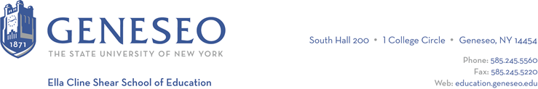

Hello,

Below is the weekly newsletter from the Coordinator of Advisement, Certification, and Communication. You’ll find upcoming School of Education events, along with professional development and employment opportunities shared with the SOE Dean’s Office. If you have any questions or would like to get in touch with the people or organizations offering opportunities, please don’t hesitate to ask. I’m happy to forward any information I have.

Reminders:
Students who are completing their program this semester should submit the application for graduation in KnightWeb. This will move the process forward for your degree conferral. You need your degree before we can recommend you in TEACH! More graduation information is available on the Registrar’s website. Finishing your program in the spring or next fall? Don’t submit the application for graduation yet, you’ll get more information soon.

School of Education Events:
The School of Education Graduate Assistants are holding a fall registration event that is open to all SOE students. The event will run on Monday, October 23rd from 3:00-4:30 pm in Fraser 114 and Tuesday, October 24th from 3:00-4:30 pm in Fraser 114. We will begin each event with an overview of the registration process and end with assisting students who have individual questions. If you have questions specific to registering as an Adolescence certification teacher candidate, try to make it to the Tuesday 10/24 session!

Geneseo Event Highlights for Educators:
Next week Geneseo’s Transfer Fest will highlight National Transfer Student Week with events including tie dying items, offering sweet and savory food items, an alumni transfer panel, and a transfer student brunch. More information is available online!

Interested in being a Student Orientation Coordinator? Attend the information session on October 16th at 5pm.

The 2023 Walter Harding Lecture will be delivered by SUNY Distinguished Professor of Environmental Biology Robin Wall Kimmerer on Thursday, October 19, 2023 at 6:15 p.m. in Wadsworth Auditorium.

Employment Opportunities:
Great LEAPS is hiring part-time reading tutors. Tutors are required to be available for 5 or more hours per week for six months at a time. Every childhood student who has completed Block IV will have the appropriate background to be a successful tutor! Specifically, they’re looking for candidates who have a year or more of experience, availability between 8am and 2pm Eastern time, have a positive, patient, encouraging, and caring attitude. Email colin.c@greatleaps.com with your resume and a short description of why you’d like to be part of their team, including your contact information. Include what times you are available as well as time to meet for a 30-minute video chat. Applications must be submitted by 7pm on October 13th for the first round of consideration.

