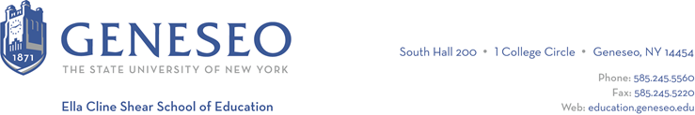

Hello,

Below is the weekly newsletter from the Coordinator of Advisement, Certification, and Communication. You’ll find upcoming School of Education events, along with professional development and employment opportunities shared with the SOE Dean’s Office (we don’t vet any of these opportunities, we just post what’s shared with us). If you have any questions or would like to get in touch with the people or organizations offering opportunities, please don’t hesitate to ask. I’m happy to forward any information I have.

Reminders:
The Office of Field Experiences has started the process of securing student teaching placements for Spring 24. If you have not completed the application process (ie, not submitted your final resume), we will not be securing a placement for you at this time. If you are deferring, please complete the required paperwork.

We will be offering a new graduate-level course this intersession, titled Digital Literacies. It will be offered fully asynchronously online. Please check out the Registration portal for more information about the course. If you’re an undergraduate student interested in this course, check out our website for more information on how to register.

Employment Opportunities:
The Teacher Immersion Fellows (TIF) Program job post for the spring semester is live! It is open until January 26, 2024; however, interested candidates are encouraged to apply early.
The updated job post link (with detailed directions for completing it) is on TIF's website: Teacher Immersion Fellows (TIF) Program (monroe2boces.org). Interested students can find out more about the program by signing into a 30-minute Zoom info session on any of the following dates: 12/4 (2:00 PM), 12/5 (9:00 AM), 1/22 (1:00 PM), 1/24 (1:00 PM), 1/25 (1:00 PM). The Zoom URL, Zoom meeting ID, and Zoom passcode are below.
- https://E2CCB-GST.zoom.us/j/6969465055
- Meeting ID: 696 946 5055
- Passcode: TIFP

Through the Teacher Immersion Fellows Program, any college student has the ability to substitute teach (for $110/day) in one of our 30+ different partner public schools. Fellows may determine their schedule; however, it must be consistent. For instance, if a Fellow would like to work Mondays and Wednesdays, that Fellow reports to substitute teach every Monday and Wednesday for the duration of the semester. Our partner schools are spread out and we offer most of our Fellows districts within a 30-minute drive time from their home. Additionally, our Fellows take required professional development courses (paid at the rate of $15/hour) as well. This program is semester-based, and there is no cost to colleges/universities or Fellows to participate.

Uncommon Schools - Summer Teaching Fellow - Apply here! Juniors and Seniors - apply for this PAID fellowship by Dec. 1st. This unique 7-week summer program allows fellows to engage students and receive real-time coaching on teaching best practices. If fellows successfully complete the program, they receive a job offer upon completing their undergraduate studies.

