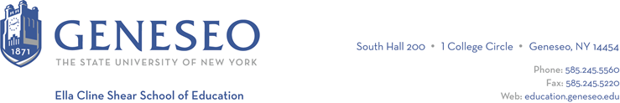

Hello,

Below is the weekly newsletter from the Coordinator of Advisement, Certification, and Communication. You’ll find upcoming School of Education events, along with professional development and employment opportunities shared with the SOE Dean’s Office (we don’t vet any of these opportunities, we just post what’s shared with us). If you have any questions or would like to get in touch with the people or organizations offering opportunities, please don’t hesitate to ask. I’m happy to forward any information I have.

Professional Development Opportunities:
Penn State’s UP Campus is now offering a fully funded M.Ed. in Special Education. Project BRITE, which stands for "Bringing Research and Intervention to Trauma Informed Education," is designed for graduates from any major who have a strong interest in making a difference in the lives of individuals with disabilities.

Key Program Features:
- Full-time, 2-year residential program located at our University Park (main campus) with one summer of coursework.
- An interdisciplinary approach to coursework, school placements, and team building activities.
- Admission Requirements: To be eligible for this program, you need:
  - A completed undergraduate degree by start of 2024 Fall semester
  - Non-Education majors are welcome and encourage to apply
  - A minimum GPA of 3.0.
  - A strong interest in working with individuals with disabilities.
- Financial Support: Project BRITE offers an amazing opportunity:
  - Full tuition and fees coverage for the entire 2-year program.
  - A stipend of $400 for textbooks.

Application Deadline: Applications are now being accepted on a rolling basis until all spots are filled. We have limited openings, and Project BRITE will fund 13 students, so don't miss out on this exceptional opportunity.

If you're ready to take the next step towards a rewarding career in special education, contact Project Director: Dr. Paul. J. Riccomini at pjr146@psu.eduwho will answer your questions and assist in the application process. For more information and to start your application, visit our program website.

Employment Opportunities:
Caledonia-Mumford Middle/High School is hiring an Earth Science teacher. Reach out to Assistant Principal Tim McArdle , email Chelsea O’Brien for contact information.

