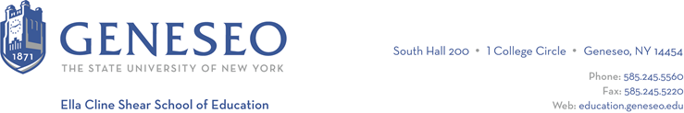

Hello,

Below is the weekly newsletter from the Coordinator of Advisement, Certification, and Communication. You’ll find upcoming School of Education events, along with professional development and employment opportunities shared with the SOE Dean’s Office (we don’t vet any of these opportunities, we just post what’s shared with us). If you have any questions or would like to get in touch with the people or organizations offering opportunities, please don’t hesitate to ask. I’m happy to forward any information I have.

Reminders:
All students who are completing their program this semester should submit the application for graduation in KnightWeb. This will move the process forward for your degree conferral. You need your degree before we can recommend you in TEACH! More graduation information is available on the Registrar’s website. Finishing your program in the spring or next fall? Don’t submit the application for graduation yet, you’ll get more information soon.

School of Education Events:
For the third year in a row, we're proud to be sponsoring the Virtual Antiracist Education Conference with the Antiracist Curriculum Project and other Schools of Education. This year's theme will be "Joy, Community, Sustainability, and Resistance." Be sure to save the date for Saturday March 2nd, 2024. Registration will begin in January on MLK Jr. Day!

Professional Development Opportunities:
Do you want to know more about how to prepare for graduate school? The Career Design Center has put a slide deck together just for that purpose!

Employment Opportunities:
The Children’s School, School No. 15, is hiring a consultant/resource teacher.

Eugenio María de Hostos Charter School is hosting a job fair on December 15th, 10:20am-2pm in the Irondequoit Public Library, Room 213. Email Chelsea for the flyer.

Uncommon Schools has positions posted in Rochester, New Jersey and New York City.

The Wilson Foundation has several vacancies posted.

