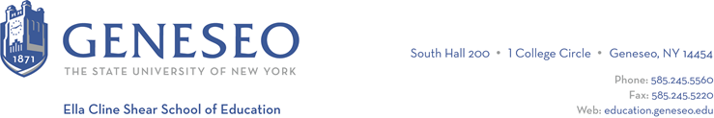

Hello,

Below is the weekly newsletter from the Coordinator of Advisement, Certification, and Communication. You’ll find upcoming School of Education events, along with professional development and employment opportunities shared with the SOE Dean’s Office (we don’t vet any of these opportunities, we just post what’s shared with us). If you have any questions or would like to get in touch with the people or organizations offering opportunities, please don’t hesitate to ask. I’m happy to forward any information I have.

Reminders/Announcements:
If you still need to register for courses in the spring, please consider PASC 105. This course will count as a GLOBE fine arts requirement and is a high impact experience featuring guest artists and collaborations with Geva Theatre in Rochester. For more information, contact Dr. Mark Broomfield (broomfield@geneseo.edu).

As in previous years, students who have completed their program by August 2024 with the exception of student teaching can apply to participate in commencement early. Eligible students are those who will have earned 105 credits by the end of summer 2024, have a 2.5 gpa or greater, and have completed all coursework other than student teaching. If you’re completing your program (in its entirety) in December 2023, May 2024, or August 2024, you do not need to complete this request to participate in the commencement ceremony in May 2024. Applications are due March 15th, 2024.

Geneseo Event Highlights for Educators:
The SUNY Geneseo Study Abroad and Volunteer Fair (in collaboration with Geneseo Student Volunteerism and Community Engagement) will take place on Tuesday, February 6th from 2:30 - 4:30 pm in the MacVittie College Union Lobby/Ballroom.

Professional Development Opportunities:
Intro to Neurodiversity for Educators, a webinar/online workshop, will be held January 19th at 12pm-1:30pm. More information is available online and you can register here.

If you are participating in research as an undergraduate student, there are grants and workshops available:

Undergraduate Travel Research and Creativity (TRAC) Grants -- grants of up to $600 for research or conference presentation expenses (see below for information on required TRAC Grant workshops). Due February 12, 2023 at 8:00am.

Kyrwood Undergraduate Summer Research Fellowship -- for the Social Sciences -- a fellowship of $3,000 for a student to work for two months with a faculty member in the social sciences on the faculty member's existing research project. Due February 19, 2024 at 8am.

Geneseo Foundation Undergraduate Summer Research Fellowships -- full-time fellowships of $3,000 (2 months) or part-time fellowships of $1,000 (approx. 3 weeks) for students to undertake a summer research project. Due February 19, 2024 at 8am.

Student TRAC Grants workshops have been scheduled for:
- Thursday, February 1 at 4 p.m.
- Thursday, February 1 at 5 p.m.
- Friday, February 2 at 4 p.m.
- Friday, February 2 at 5 p.m.
- Monday, February 5 at 2 p.m.
- Monday, February 5 at 3 p.m.
- Monday, February 5 at 4 p.m.
- Monday, February 5 at 5 p.m.

Employment Opportunities:
The NYC Online Teacher Application is now open! Those looking for midyear positions or those starting in the fall are welcome to apply.

Sweet Home Central School District is looking to fill a few teaching positions. Visit the district's Employment Opportunities page to view full postings and application instructions.

