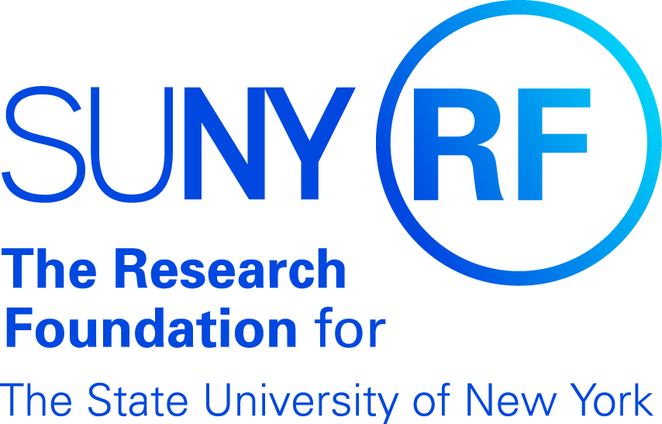
Travel Checklist

Has the Grants Management Office (GMO) been notified of your travels? A two-week advance notice on sponsored programs-related travel is required.

Does the travel meet the Sponsor’s guidelines (foreign vs. domestic, etc.)?

Are there sufficient funds to cover the cost of the trip?

The Research Foundation is exempt from New York State taxes. Obtain a copy of the Exempt Organization Certification Form ST-119.1 to be used on lodging, purchases etc. from the GMO office.

Does the traveler understand The Research Foundation policies regarding what expenses are reimbursable? Seek GMO’s insight if you have questions.

Hotel and meal reimbursements are based on federal per diem rates.

Is travel to a foreign country? If so, please contact GMO at (585) 245-5060 for assistance.

Documentation required for travel reimbursement:
- Travel Payment Request form signed and approved by project director.
- Original receipts.
- Hotel receipt with a zero balance and in the name of the traveler.
- Copy of credit card statement reflecting travel expenses incurred (except for meals).
- No meal receipts necessary.
- Mail completed paperwork to: Grants Management Office, Erwin Hall, Rm 201 - SUNY Geneseo, 1 College Circle, Geneseo NY 14454.

Transportation

GMO processes travel reimbursements at the most cost effective means of transportation. Therefore, has the most cost effective means of transportation been researched? For example, car rental vs. personal automobile mileage.

Is a rental vehicle required? If so, please contact the GMO office for rental agreement information.

All air travel must be on a U.S. Flag carrier - Fly America Act.

SUNY Geneseo’s Grants Management Office- (585) 245-5060
Revised: 30-March-2017

