Student Employees

Sign On:
Employees will sign into the Time and Attendance System (TAS) using the link below and enter their existing user id and password. The first time you sign on, you will be asked to verify your First/Last Name, SUNY ID, and Date of Birth. This verification is to authenticate your user id to your SUNY ID assigned in the system. Click on Submit Answers.
- https://www.suny.edu/time
If EduPerson has been established at the campus, employees will simply sign into the link above and entering their existing user id and password. The verification process is not necessary. The Time and Attendance System is available 24 hours a day/7 days a week.
TAS Home Page:
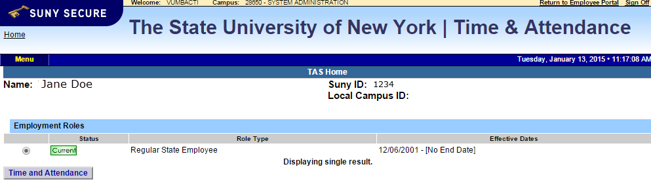
- Select Current Employment Role (shown above). If you only have one role, the radio button will be defaulted to the current role. If you have multiple roles, please select the role in which you will be entering your time in/out for.
- Click on Time and Attendance button to work on your Time Record.

Entering Time Record:
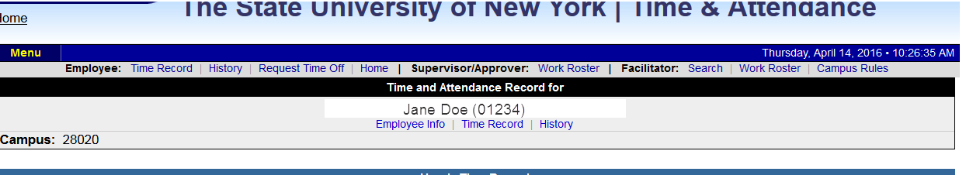
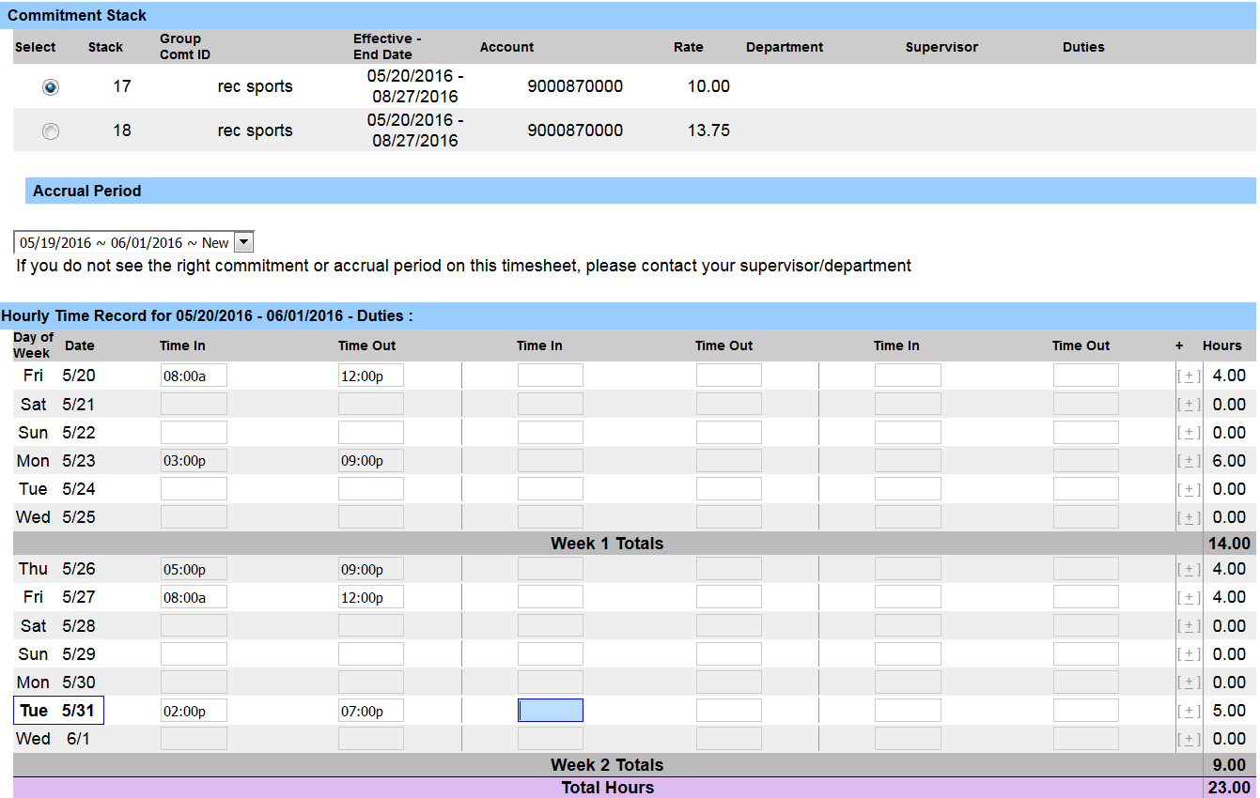
- Please select the commitment stack from the above list in which you would need to enter time in/out.
- Choose the correct accrual period from the drop down box.
- Enter the appropriate time in and out directly in the time record (displayed above). Please enter “a” for AM and “p” for PM. If more time in/out fields for a specific day is required, click on the + button next to the hours column.
- If you need to send comments on the time record for your supervisor, please enter in additional comment sections.
- After each entry, please click on the save time record button. Once the time record is complete for the pay period, select the “I certify” box and submit time record to supervisor (see below).

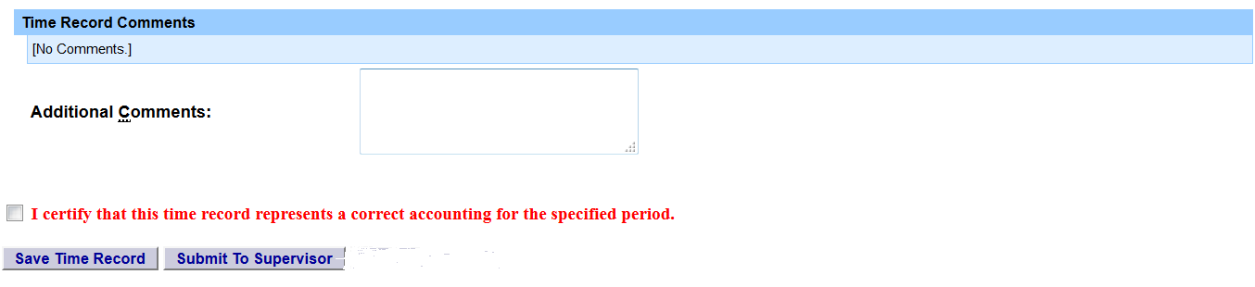

Notifications:
For the supervisor:
You have a pending student time record needing your review and action.
If a supervisor does not take action on the employee’s time record within the timeframe specified by the campus, the time record will be moved up to the supervisor’s supervisor.
For the student if the time record is denied by either the supervisor or by the payroll department from the TAS Payment Roster:
Your Time Record has been disapproved. Please log in to review the denial comments.

