INTRODUCTION TO BEHAVIORAL RESEARCH METHODS, PSYC 251₀₄
Instructor: Vincent Markowski, Ph.D.
Tuesdays and Thursdays, 8:30-9:45am
Bailey 105
Spring, 2016

Course Overview
This course is an exploration and comparison of the diverse methods used to conduct research in psychology. We will learn how investigators design and conduct studies, analyze and interpret data, and share their results with other professionals in the field. The purpose of this course is to train you to become a better consumer of research and to introduce you to the presentation and writing style associated with scientific study. Students are expected to gain a full understanding of the writing and publication format of the American Psychological Association (APA).

Learning Objectives
Students who successfully complete this course will achieve the following objectives:
- Learn how psychologists use the scientific method to continually improve our understanding of human and animal behavior.
- Recognize the differences between experimental and correlation research methods and their respective strengths and weaknesses.
- Examine the relationships between psychological research and ethics.
- Design a logical and objective scientific research project.
- Learn to write, edit, and revise an APA-format research paper.

Course Format and Student Responsibilities
APA-style Paper: A semester-long written project will be divided into 5 separate writing assignments that will be due throughout the semester. Each of the 5 assignments requires a first draft and a final draft submission. A final full written paper is due at the end of the semester. Selecting an appropriate topic for the paper is a key part of the assignment and will be finalized after an office hours meeting with your instructor.

Oral Presentation: Each student will give an oral presentation related to their paper project. The oral presentation should be 10-minutes in length and accompanied by a PowerPoint presentation. Each student will email their PowerPoint file to the instructor no later than 1 day before the oral presentation so they can be posted on myCourses for review by fellow classmates. Briefly, each student should meet the following objectives during their presentation:
1. Discuss the background and purpose of the study.
2. Identify the experimental hypotheses.
3. Summarize the basic methodology.
4. Summarize the most important results.
5. Discuss strengths and weaknesses in the research.
6. Discuss the significance of these findings to the field of psychology.

Exams: There will be four unit exams during the semester. Each exam will be composed of multiple choice, matching, and short answer questions drawn from the lectures, textbook, and student presentations. The testing period will start promptly at the beginning of class. The exam schedule is found on the last page of this syllabus.

Please note that there will be NO make-up exams. Since only three exams scores will count towards your final grade, you can miss or perform poorly on one exam without penalty. If you are absent for two or more exams, withdrawal from the course is strongly recommended. Please plan your personal and professional commitments accordingly.

Class Participation: Each student will purchase an “I>Clicker” and bring it with them to the lectures. The I>Clicker will be used to answer student assessment questions delivered at various times throughout the lecture. Students should email their I>Clicker identification number (located on the back) to the instructor prior to the second class meeting.

Left: The current version of the I-Clicker.
Middle: An earlier version of the I-Clicker. Either one will work for our class.
Right: Location of identification number.
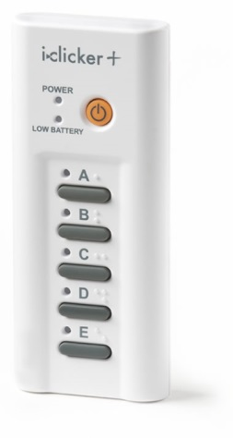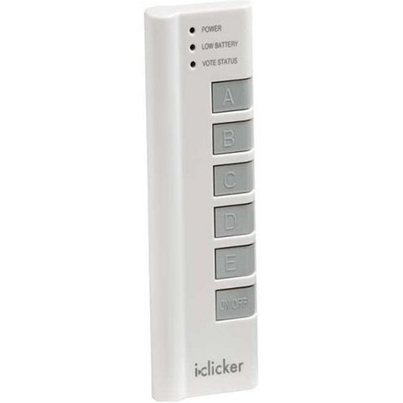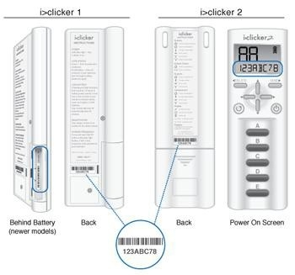

Course Grading Procedure
Your course grade will be based on a simple sum of paper, oral presentation, exam, and class participation points. A letter grade will be assigned using the scale below:

A | 186 points or above | C | 146-155
A- | 180-185 | C- | 140-145
B+ | 176-179 | D+ | 136-139
B | 166-175 | D | 120-135
B- | 160-165 | E | 119 points or below
C+ | 156-159

Each of the 5 writing assignments will be worth 15 points (75 total points or 37% of your final grade). The final full paper will be worth 15 points (8% of your final grade). The oral presentation will be worth 10 points (5% of your final grade). The I>Clicker questions will be worth 10 points (5% of your final grade). Each exam will be worth 30 points, however only your 3 highest exam scores will count towards your final grade (90 total points or 45% of your final grade).

Required Textbook: Ray, William J. (2012). Methods: Toward a Science of Behavior and Experience (10th Ed.). Cengage Publishing. ISBN: 9781111521158
Recommended: APA Publication Manual (6th Ed.). available online or at any bookstore

Contact Information
 | Email | Voice mail | Office
Vince Markowski | markowski@geneseo.edu | 245-5076 | 119 Bailey

Office Hours
 | Morning Hours | Afternoon Hours
Monday | 10-11am | 2-3pm
Tuesday | 10-11am | By appointment
Wednesday | By appointment | By appointment
Thursday | 11am-noon | 12-12:45pm

Minimum Grade for PSYC251 and the Psychology Major: A final grade of C- or higher is required for the psychology major. Students can take PSYC251 up to two times to achieve the minimum grade. Any student who does not achieve a C- or higher after two attempts will be dropped from the major.

Policy on the Use of Cellular Phones in Classroom: The use of cellular phones in a small classroom is disruptive, discourteous, and is not permitted. Please shut off your cellular phone’s ringer before entering the classroom. Students whose cell phones ring during the class will lose 10 points from their course total.

Academic Dishonesty: Plagiarism will result in a grade of E for the assignment and/or final grade. For further information please see http://www.geneseo.edu/dean_office/dishonesty

Students with Disabilities: SUNY Geneseo will make reasonable accommodations for persons with documented physical, emotional or cognitive disabilities. Students should contact the Director in the Office of Disability Services (Tabitha Buggie-Hunt, 106A Erwin) and their faculty to discuss needed accommodations as early as possible in the semester.

WEEKLY SCHEDULE OF TOPICS, EVENTS, AND EXAMS
Jan 19, 21 | Introduction; Ch. 1: What is Science?
Jan 26 | Ch. 2: Naturalistic Observations, Correlational Approach
Jan 28 | Ch. 3: Hypothesis Development
Feb 02 | Library Research Day – meet in Milne Library room 104
Feb 04 | Ch 3 concluded; preparing an APA Introduction section
Feb 09 | Ch 4: Ethical Considerations, Deception & Debriefing
Feb 11 | Ch 4 concluded; draft of Introduction section of paper is due
Feb 16 | Exam 1 on Chapters 1-4
Feb 18, 23 | Ch 5: Measurement Scales & Distributions, Descriptive Stats & Variability
Feb 25 | Ch 6: Inferential Statistics; preparing an APA Methods section
Mar 01, 03 | Ch. 7: Hypothesis Testing, Threats to Internal Validity
Mar 08 | Ch. 7 concluded; draft of Method section of paper is due
Mar 10 | Ch. 8: Experimental Control
Mar 15, 17 | Spring Break…No Class!
Mar 22 | Ch. 8 concluded
Mar 24 | Exam 2 on Chapters 5-8
Mar 29 | Ch. 9: Between Subjects Designs, Factorial Designs & Interaction Effects; preparing an APA Results section
Mar 31 | Ch 10: Within Subjects Designs; draft of Results section of paper is due
Apr 05 | Ch. 10 concluded; Ch. 11: Bias, Placebo Effect, & Demand Characteristics
Apr 07 | Ch. 11 concluded; preparing an APA Discussion section
Apr 12 | Exam 3 on Chapters 9-11
Apr 14 | Ch. 12: Quasi-Experiments and Naturalistic Observation
Apr 19 | GREAT Day…No Class!
Apr 21 | Ch. 12 concluded; draft of Discussion section of paper is due
Apr 26 | Ch. 13: Case Studies
Apr 28 | Student Presentations; preparing an APA Abstract
May 03 | Student Presentations concluded; draft of Abstract and Bibliography sections of paper are due
Thurs. May 05 (8-10am) | Exam 4 on Chapters 12, 13 and the student presentations
Mon. May 09 | Final Paper due by 5pm via electronic submission

