Checklist for Searches
1 | GETTING STARTED
□ | Your Geneseo user account and password are also your user account and password for the Online Employment System (OES). There are multiple user types in the system 1) Committee Reviewer (Search Chair) 2) Search Committee Member, etc. You will be assigned a user type(s) based on your role.
□ | 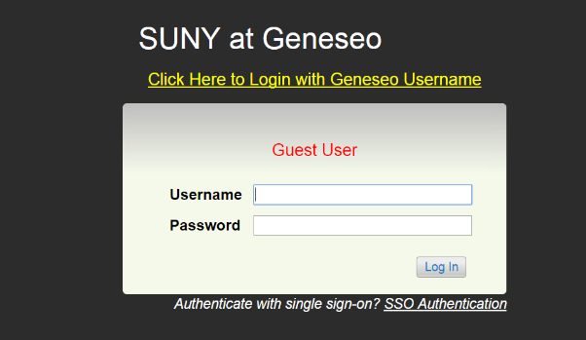  Log into the Online Employment System at: https://jobs.geneseo.edu/hr  You must use the gold “Click Here to login with Geneseo Username” to  sign in. (If you are not a Geneseo employee contact Human Resources  for instructions.)
2 | Search Committee Chair schedules a meeting with HR for Search Process Training.(Many committees hold the Search Process Training and Planning Meeting as one meeting.)
3 | PLANNING MEETING
□ | Search Committee Chair schedules first meeting with committee, department head and/or VP (to charge the committee)
□ | Review the job description and announcement of vacancy (job advertisement), specifically outlining the required and preferred job qualifications. The information is contained in the job posting located in the OES.
□ | Plan outreach and advertising efforts that the committee will perform, this is in addition to advertising provided by HR.
□ | Review the time frame for reviewing applications, reviewing references and conducting initial/campus interviews (refer to dates in the OES). Calendar future meetings, and interview dates. Assign note takers. Decide on operational functions (quorums, voting).
□ | Review the Evaluative Criteria established in the OES. Search committee members will evaluate applicants within the OES.
□ | Collect interview questions from committee members and develop list of initial and campus interview questions.
□ | Forward initial and campus interview questions to Human Resources for approval. Final approved interview questions need to be sent to Human Resources.
4 | APPLICATION REVIEW AND APPROVALS
□ | All search committee members and search committee chair evaluate applicants using the evaluative criteria function in the OES.
□ | Meet to discuss applicants based on individual evaluations and review results. Committee formulates an overall evaluation for each applicant, including recommendations for initial interviews.
□ | In the OES, Committee Reviewer changes the applicant status of the applicants recommended for an initial interview to “Recommended for Initial Interview to Department”.
5 | INITIAL INTERVIEWS AND APPROVALS
□ | Committee receives approval to conduct initial interviews from Affirmative Action and the Department. (System status: “Initial Interview Approved”. The Committee Reviewer receives an email for each candidate that is approved.)
□ | Conduct Initial Interviews- committee members record answers to initial interview questions.
□ | Meet to evaluate candidates based on application materials and results from initial interviews. Committee formulates an overall evaluation for each applicant, including recommendations for campus interviews.
□ | Committee Reviewer completes the evaluative criteria for each candidate who received an initial interview. This step is completed in the OES.
□ | In the OES, Committee Reviewer changes the applicant status of the applicants recommended for a campus interview to “Recommended for Campus Interview to Department”.
□ | Once approval is received, from Department, Affirmative Action and Division (System status: “Campus Interview Approved” the Committee Reviewer receives an email for each candidate that is approved.); create an interview itinerary and schedule interviews according to the itinerary.
6 | CAMPUS INTERVIEWS
□ | Hold the interviews according to the itinerary.
□ | Search Chair needs to collect the Background Investigation Release Form from each candidate interviewed. (Background Investigation Release found at: http://www.geneseo.edu/hr/forms).
□ | Forward the completed background authorization forms to Human Resources. Human Resources will run a background investigation on the selected candidate only.
7 | RECOMMENDATION TO HIRE
□ | Meet to evaluate candidates based on application materials, results from initial interviews, results from campus interviews and results from references. Committee formulates an overall evaluation for each applicant, including final recommendations of acceptable or not acceptable.
□ | In the OES, Committee Reviewer completes the evaluative criteria for each candidate who received a campus interview.
□ | In the OES, Committee Reviewer changes the applicant status for each candidate interviewed, in accordance with the recommendations of the committee. Search Chair will meet with hiring manager/department head/chair about the recommendations and status changes.
8 | EXTENDING AN OFFER/HIRING
□ | The VP/Provost, or their designee, of the hiring department contacts final candidate to make the unofficial verbal offer. The negotiated and accepted offer will be captured in the OES using the Hiring Proposal function (see instructions for creating a Hiring Proposal)
□ | Department and/or VP/Provost Office completes the Geneseo Employment Recommendation (GER) form and forwards it to the VP/Provost, President and HR.  Human Resources will work with VP/Provost Offices to obtain an authorized GER form and an official appointment letter signed by the President.
9 | FINAL STAGES
□ | HR works with the Division secretary and Search Chair to change the status of applicants that remain in the system to either “Interviewed Not Hired” or “Not Interviewed Not Hired”,Etc., and notes the appropriate reason for non-hire. Applicants will be informed by email about their status.
□ | Search Committee Chair will collect all interview notes/documentation from committee members and send to HR for retention in the official search file.

