
Time and Attendance System (TAS)
Faculty (Full-Time and Part-Time/Adjunct) Guide

General Overview:
Faculty accrue and may charge sick leave credits when they are unable to come to work. Appropriate use of sick leave accruals include personal illness, medical or dental appointment, or caring for a family member due to illness. Faculty are also able to use family sick leave credits (up to 30 days of their existing sick leave balance per year, 7/1 – 6/30). The Time and Attendance System (TAS) allows for the on-line tracking and submitting of accrual records for faculty.
Faculty are expected to complete and submit an accrual record for each month of obligation. Consistent with Article 23.9 of the UUP Agreement, each month’s record should be submitted as soon as possible at the end of the month. The deadline for attendance by the 10th of the following month.
TAS can be accessed from any computer with internet access and should make the process of submitting accrual records much more convenient and efficient for all.
General Sick Leave Use Guidelines:
Full-Time Faculty: If a faculty member is unable to come to work to teach his/her class, and cancels a class, or classes, (including having the class taught by a colleague) due to illness, sick leave credits should be charged for the absence.
Full-Time Faculty: If an illness or injury prevents the faculty from reporting to work for multiple days in a row, the faculty should charge those days of absence to sick leave credits, regardless of the nature of the specific work obligation on each day (i.e. even if the faculty is not scheduled to teach classes on that day). We do not require the faculty member to obtain alternate coverage or to submit a coverage plan. If absence due to illness is going to extend beyond a class meeting, we expect communication with the chair so coverage can be identified, where appropriate.
Part-Time (Adjunct) Faculty: If an adjunct must cancel a class due to illness or injury, sick leave credits should be charged. Example: If an adjunct teaches one class, M, W, F, and cancels the Monday class due to illness, one (1) sick leave day should be charged.
If there are any questions related to these guidelines, they should be addressed with the department chair, and the chair will contact the provost office and/or human resources, as needed, to discuss specific circumstances.

Sign On:
Faculty will sign into the Time and Attendance System (TAS) by accessing SUNY Geneseo’s MyGeneseo.


Once logged into MyGeneseo open the SUNY Self Serv tab. 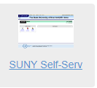

From the Self Service screen, select the link for Time and Attendance (TAS).
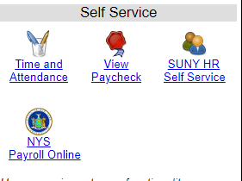

TAS Home Page:
- Select Current Employment Role (shown above).
- Click on Time and Attendance button to work on your Time Record.
- If you wish to view your paycheck click the View Paycheck button. Paycheck information will be available the Monday before payday.

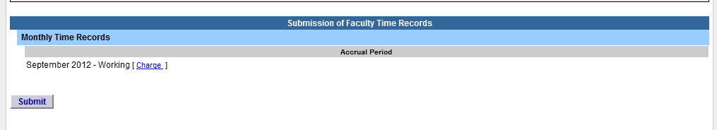
To Complete Time and Attendance Record:

- When you log in, you will see the most recent month that still requires action.
- If you DID NOT take any sick leave days –
  - Select ‘Submit’ – your September record has now been submitted to your dept. chair for approval. Your action for the month is complete.
- If you DID use sick leave:
  - Select the ‘Charge’ link
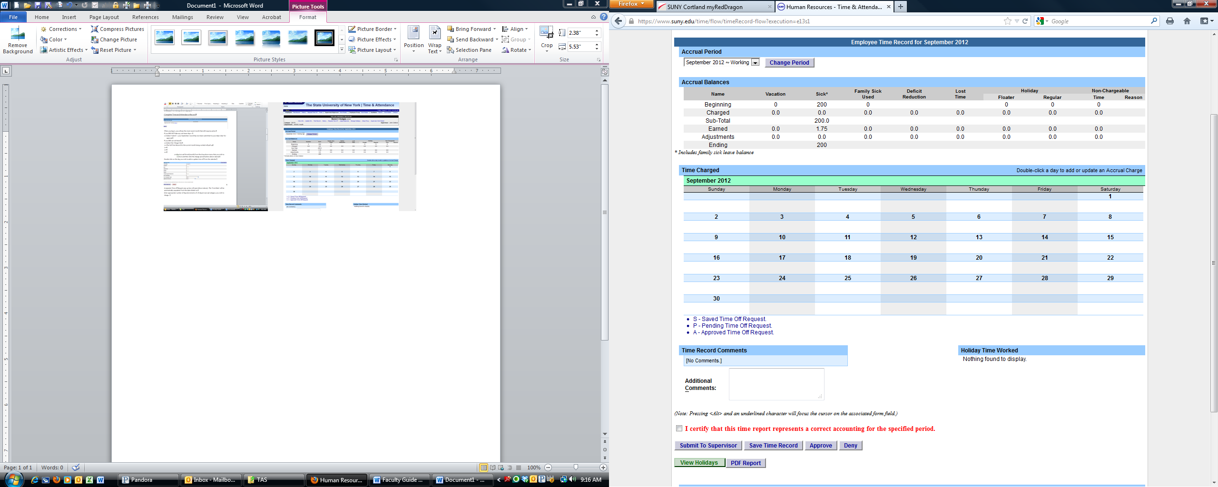
  - The full Attendance Record for the current month being worked will pull up – see below

- Double click on the day you wish to add or update time off from the calendar.
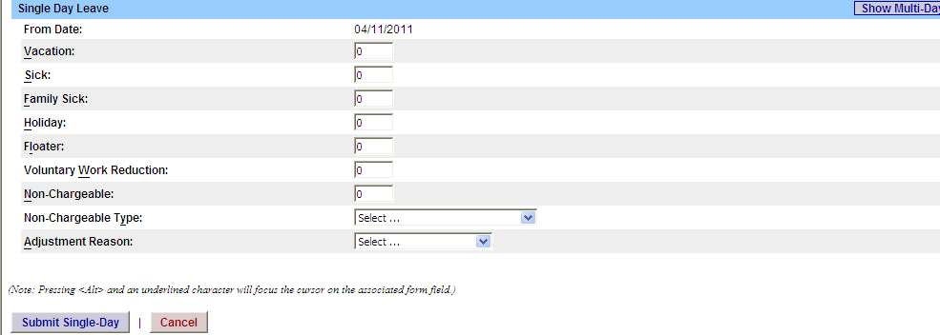
- A separate Time Record Posting pop up box will open (shown above). The ‘From Date’ will be automatically populated from the date clicked on.
- Enter appropriate number of sick days (increments of .25 days) in the Sick accrual category. If time off was for a family member, place it in the Family Sick category.
- NOTE – Faculty do not earn vacation, holidays, or floaters, so no entries should be made in these categories. Non-Chargeable types (such as conference, jury duty) should be entered when appropriate.
- To submit multiple day requests, click on Show Multi-day button on the upper right hand corner from the time off request pop up box. To Date field will now be available to enter a date range.
  - For multi day requests, ‘Number of Consecutive Days’ is defined as Work Days and will default as M-F. 10 in this section – the calendar will automatically skip your pass days, Saturday/Sunday.
- Click on Submit. After submitting, you will be brought back to your time record you were previously working on. The time off will now appear on your monthly calendar.
- Review what has been entered and then select ‘Save Time Record’ or what you entered may be lost.
- Once time record is complete for the month, check the box to certify that the information entered is accurate (located in front of the red certification statement) and then select ‘Submit to Supervisor’
- NOTE – The previous months’ time record must have been approved by your supervisor before you can submit another month. If you notice that a previous month has not yet been approved, please ask your supervisor to log into TAS and approve it.

Non-Chargeable Time:
The Time and Attendance System allows the College to track time away from the workplace that is not chargeable, i.e. travel/conference, jury duty and other. This time needs to be tracked using the quarter hour method.
Leave Type | Definition
Administrative Leave
Bone Marrow/Organ Donation | Leave for employees with absences related to the donation of bone marrow and/or organ donation.
Cancer Screening | Employees are provided with four hours of leave for cancer screening.
Conference | Faculty member should have an approved travel requisition in place to document that the travel is approved and should have completed and submitted to the dept chair/dean the attached coverage plan for classes.
Jury Duty | Paid leave for jury duty is provided with supplemental documentation that indicates employee met the jury duty obligation. This is received from the court.
Off Campus Meeting | Faculty member should have an approved travel requisition in place to document that the travel is approved and should have completed and submitted to the dept chair/dean the attached coverage plan for classes.
Professional Exam | For Classified service emplyees only.
Training/Professional Development | Faculty member should have an approved travel requisition in place to document that the travel is approved and should have completed and submitted to the dept chair/dean the attached coverage plan for classes.
Sabbatical Leave | Geneseo does not track sabbatical leave on the attendance form.
Employee Organizational Leave | For local union officials only
Presidential Sick Leave | Additional sick leave granted by the College President when sick leave is exhausted. Eligibility requirements apply.
Volunteer Firefighter/Ambulance Squad Member | The appointing authority shall excuse a reasonable amount of tardiness if caused by participation in appropriate voluntary emergency activities, subject to whatever evidence of such participation may be deemed necessary by the appointing authority. Absences (other than tardiness) or early departures related to such voluntary civic activities must, in all cases, be charged to leave credits and cannot be excused. Such early departures require advance approval.
American Red Cross Disaster Volunteer | Provides up to 20 workdays of paid leave without charge to leave credits per calendar year for employees who are certified by the American Red Cross as disaster volunteers to participate in specialized disaster relief operations. Requests for the services of such volunteers are made in writing by the Red Cross to the appointing authority and are subject to the approval of the appointing authority.
Workers Comp Leave | Absence due to work related injury or illness (must be authorized by NYS Insurance Fund)
Leave Without Pay | Multiple purposes when an employee is absent, still employed, but not receiving pay.
Extraordinary/Inclement Weather | Faculty are expected to meet their class obligations unless the college suspends classes due to weather. There are no official provisions for faculty declaring their own weather-related absence. They should follow the Class Cancellation & Extraordinary Weather Conditions Policy which allows for some discretion. Faculty may not charge absence to sick leave that is due to inclement weather conditions.

SIGN OFF
- To sign-off and sign-out of the SUNY browser, click the “SIGN-OFF” at the top right of the page.
- Then, you can close the browser by clicking the “X” at the top right of the screen.

