
Time and Attendance System (TAS)
Approving Faculty Time Records

Accessing Approval Page:
The approver, either the department chair or the department secretary (as an approver designee) will sign into TAS and access your home page. Example below:
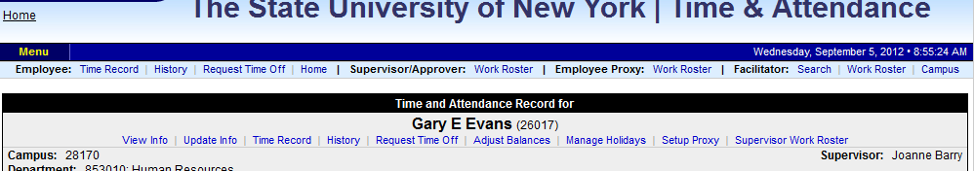

Department Chair: Under your name, select ‘Supervisor Work Roster’
Department Secretary/Designee: Above your name, select the Supervisor/Approver ‘Work Roster’
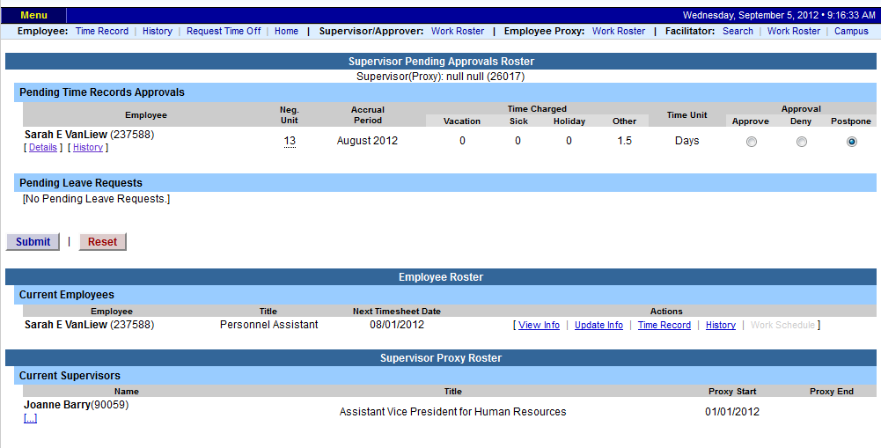
Approval Screen:

Approver Designee
Department Chairs: From the approval screen, you will automatically see a list of all employees that report to you for time keeping purposes. This list will be under the header labeled ‘Employee Roster’
Approver Designee: Under the header Supervisor Designee Roster, you will see a list of all employees you have been set up as a designee for, most will be one name.
- From here, please select the […] under the supervisor’s name – and a full list of employees will populate similar to the department chair view.
Pending Time Records Approvals:
- To Approve employees time record– select APPROVE radio button
- To Disapprove – select DENY radio button. When denying an employee’s time record, a comment field will open. Comments are required by the supervisor to let the employee know the reason for denial.
- IGNORE radio button can be selected if supervisor does not wish to take action on the employees time record at that time.
- Supervisor also has the option of clicking on the VIEW DETAILS button to see the employee’s time record in its entirety for more information.
- Once action has been selected, click Submit.

Employee Roster:
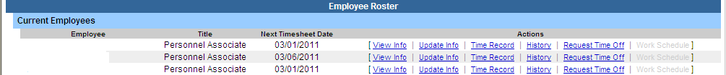
- List of all employees that reports to the supervisor.
- A supervisor sees all the employees that they supervise. If there is a […] under one of their employees, then that employee is also a supervisor. If you click on the […] you get the supervisor roster for that supervisor, and you have all the same supervisor privileges.
- Supervisors are able to view Employee Information Detail, Time Record, History and Time off Requests from their work roster.

