
Time and Attendance System (TAS)
Supervisor Role – Reviewing & Approving Requests/Time Records

TAS Home Page:
- Select Current Employment Role (shown above).
- Click on Time and Attendance button to work on your Time Record, Time off Request, or to review your work roster.

Supervisor Work Roster:
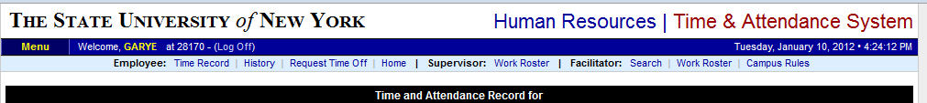

- Select Work Roster (shown above)
- Will show all Time Records and/or Pending Leave Requests that require action.

Pending Time Records Approvals:
- To Approve employees time record– select APPROVE radio button
- To Disapprove – select DENY radio button. When denying an employee’s time record, a comment field will open. Comments are required by the supervisor to let the employee know the reason for denial.
- IGNORE radio button can be selected if supervisor does not wish to take action on the employees time record at that time.
- Supervisor also has the option of clicking on the VIEW DETAILS button to see the employees time record in its entirety for more information.
- Once action has been selected, click Submit.

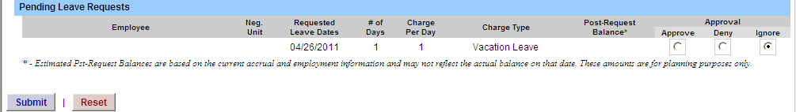
Pending Leave Requests:

  - To Approve employees Time off Requests – select APPROVE radio button
  - To Disapprove – select DENY radio button. When denying an employee’s time record, a comment field will open. Comments are required by the supervisor to let the employee know reason for denial.
  - IGNORE radio button can be selected if supervisor does not wish to take action on the employees time record at that time
- Once action has been taken, click submit

Employee Roster:
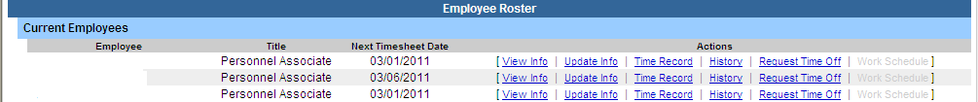
- List of all employees that reports to the supervisor.
- A supervisor sees all the employees that they supervise. If there is a […] under one of their employees, then that employee is also a supervisor. If you click on the […] you get the supervisor roster for that supervisor, and you have all the same supervisor privileges.
- Supervisors are able to view Employee Information Detail, Time Record, History and Time off Requests from their work roster.

