
Time and Attendance System (TAS)
Completing and Submitting Time and Attendance Record –
Unclassified (MC, UUP) Non-Hourly

To Complete Time and Attendance Record:
- Select the Accrual Period (month) from the drop down menu that you wish to work on and then click the change period button (shown above).
- Double click on the day you wish to add or update time off from the calendar.
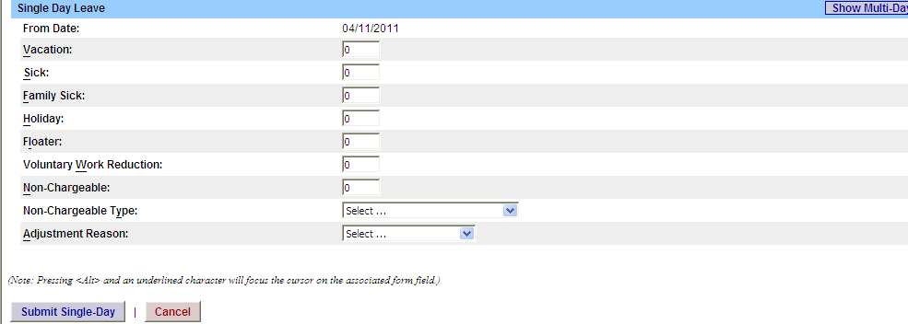

- A separate Time off Request pop up box will open (shown above). The From date will be automatically populated from the date clicked on.
- Enter appropriate number of days (increments of .25 days) in accrual category you wish to charge.
- To submit multiple day requests, click on Show Multi-day button on the upper right hand corner from the time off request pop up box. To Date field will now be available to enter a date range.
- For Non-Chargeable time, enter appropriate number of days (increments of .25 days) then select the non-chargeable type from the drop down selection.
- Click on Submit. After submitting, you will be brought back to your time record you were previously working on. The time off will now appear on your monthly calendar.

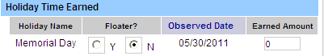
- Holiday/Floater Time Earned (shown above) – if a holiday/floater is available within the month and not worked, no action needed. If the holiday/floater was worked, in the earned time field change 0 to 1 day. This will automatically update the holiday/floater accrual balance.

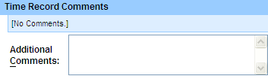

- Time Record Comments (shown above) – available if employee would like to submit comments attached to the time record for their supervisor.

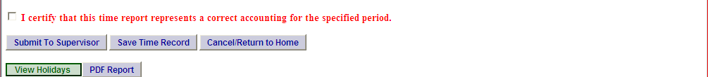

- Once time record is complete, check the box to certify that the information entered is accurate before submitting to supervisor (shown above).
- If time record is complete and wish to send to your supervisor, click on Submit to Supervisor. If time record is not complete, click Save which will allow you to go back into your time record to add or update before submitting to supervisor.
- If you do not wish to save or submit your time record click simply click Cancel/Return to Home.
Notes:
- If a Time Record is disapproved by the supervisor, the time record will show back in the Accrual Period drop down in working status. You will then be able to make any changes needed and resubmit to your supervisor.
- View Holiday – list of all holidays/floaters that are observed at each campus.
- PDF Report – allows employees ability to print time record.
- Existing Time Off Request – list any existing time off request employee may have pending approval from supervisor.
- Audit Details – keeps an audit of all add/updates to time record.
- Message Board – automatic messages to employee making them aware of overdue time records, expiring holidays, and approaching max limit by year end, etc.

