

Sociomedical Sciences Speaker Series

Life without Vegetables:
Spectral Foods, Disrupted Foodways and Memories of Health Otherwise in Samoa

2:30pm on Wednesday, February 19, 2020
Doty Recital Hall

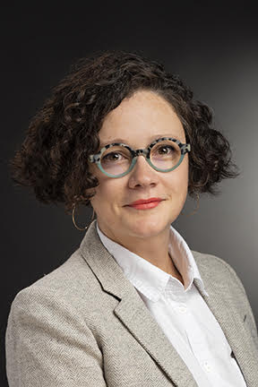
Dr. Jessica Hardin is a medical anthropologist and assistant professor at the Rochester Institute of Technology. Her book Faith and the Pursuit of Health Cardiometabolic Disorders in Samoa explores how Pentecostal Christians manage chronic illness in ways that sheds light on health disparities and social suffering in Samoa, a place where rates of obesity and related cardiometabolic disorders have reached population-wide levels.
Dr. Hardin’s presentation will examine the relationship between plantations (small family gardens) and vegetables (mostly introduced) in Samoa. She will be describing how Samoans remember and imagine life without vegetables, before the advent of cheap foods like tinned meats and chicken. She will explain how vegetables are spectral foods because their requirement for good health points back to historic disruptions to foodways rooted in colonial and missionary expansion. The need for vegetables only indicates the absence or attenuation of Indigenous foodways, situating health as never achievable, a state to be strived toward that never manifests.
__

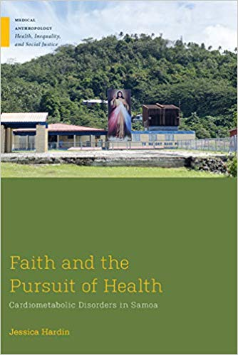
Sponsored by the Office of the Provost, the Department of Anthropology, and the Center for Integrative Learning
Please join us for a post-talk reception in the Center for Integrative Learning (Doty 303)

