Search Committee Chair Checklist
 | SEARCH COMMITTEE CHAIR TASKS
□ | Review the process for leading and conducting a search: http://www.geneseo.edu/hr/search-committees.
□ | Request a user account for the Online Employment System (OES). The search committee chair will need their own user id and password to log in and make changes and/or update statuses in the OES: https://jobs.geneseo.edu/hr. To a create user id and password -- see back page.
□ | Give the Guest User Account log in information for the OES to your search committee members. They will need this to view applicants. Guest User ID:__________________________ Password: ________________________
 | SEARCH COMMITTEE TASKS
1. | Initial Meeting:
□ | Provide all committee members with a copy of the job description.
□ | Create a standard rating tool to be used when reviewing applications; send to Affirmative Action for review and approval prior to using. A copy of the final approved tool needs to be sent to Human Resources.
□ | Determine the interview methods (Telephone/Skype, on campus, or both).
□ | Establish an action plan and timeframe for application review.
2. | Application Review:
□ | Search committee meets to discuss applicants and determines who will be scheduled for an interview.
□ | Collect interview questions from committee members and develop list of interview questions.
□ | Forward interview questions that will be used to Affirmative Action for approval. Final approved interview questions needs to be sent to Human Resources.
3. | Interviews:
□ | If you are conducting phone interviews (telephone or Skype), email the list of candidates to be interviewed to Affirmative Action for approval.
□ | Once approval is received from Affirmative Action, conduct phone interviews.
□ | Enter the candidates who will interview on campus into the “Candidates for Interview” section in the OES for approval. REMEMBER TO CLICK SUBMIT, THEN CONFIRM.
□ | Once approval is received, schedule interviews with the candidates, search committee, and other involved hiring authority.
□ | Hold the interviews.
□ | All candidates interviewed must complete the authorization form for a background check. (Background Investigation Release found at: http://www.geneseo.edu/hr/forms).
□ | Forward the completed background authorization forms to Human Resources. Human Resources will run a background investigation on the selected candidate only.
□ | With the committee, discuss the interviews and forward final candidate recommendations to the hiring authority.
□ | Complete the “Final Candidate List” section in the OES with the candidates who are being considered for the position; submit in OES for approval. REMEMBER TO CLICK SUBMIT, THEN CONFIRM.
□ | Call Victoria in Human Resources at 5616 to see what loose ends might need to be completed in OES.
4. | Recommendation to Hire Final Candidate:
□ | The VP/Provost of the hiring department contacts final candidate to make the unofficial verbal offer. Offer summary tools for negotiation of unofficial offer found at: http://www.geneseo.edu/hr/forms.
□ | Complete the Recruitment Profile portion in the OES; submit in OES for approval. The Recruitment Profile must be completed in full before any official offer of appointment letter is sent to a candidate. REMEMBER TO CLICK SUBMIT, THEN CONFIRM.
□ | Once the candidate accepts the unofficial offer, complete the Geneseo Employment Recommendation (GER) form and forward it to the VP/Provost, President and then HR.  Human Resources will work with VP/Provost offices to obtain an authorized GER form and that the official appointment letter is signed by the President. Human Resources will work with the search committee chair to ensure all sections in the OES are completed and that the search is closed at the time the official appointment letter is sent to the selected candidate.
5. | Final Stages
□ | Search Committee Chair will collect all interview notes/documentation from committee members and send to HR for the official search file.
□ | In the OES change the status of any remaining applicants. Notify any applicants, who remain, by letter that they are not being hired/moved forward in the process of the search.
Please contact Victoria Phipps at (585) 245-5616 or phipps@geneseo.edu for questions or assistance.

User Account Set-up in Online Employment System

Use the following steps to set up a user account in the online employment system:

1. Open an internet browser such as Internet Explorer, Firefox, etc.
2. In the browser type this address: https://jobs.geneseo.edu/hr.
3. On left side of web page you will see “Create User Account” – click this.
4. Enter your information into the fields:

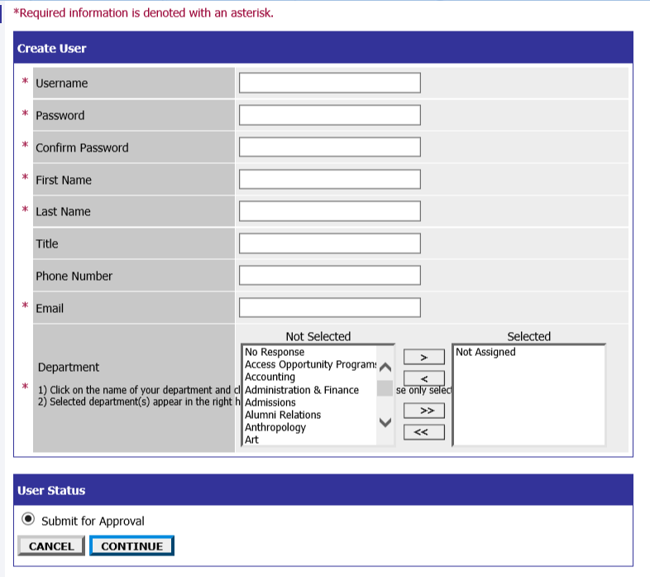

5. Click Continue. Then click confirm. HR will approve and notify you that the account is approved.

