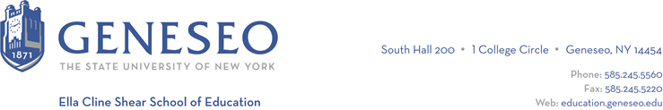

Hello,

Below is the weekly newsletter from the Coordinator of Advisement, Certification, and Communication. You’ll find upcoming School of Education events, along with professional development and employment opportunities shared with the SOE Dean’s Office (we don’t vet any of these opportunities, we just post what’s shared with us). If you have any questions or would like to get in touch with the people or organizations offering opportunities, please don’t hesitate to ask. I’m happy to forward any information I have.

Professional Development Opportunities:
Spring 2025 study abroad and academic year 2024–2025 faculty-led study abroad programs applications are now open. Students can explore opportunities and begin an application on Horizons. Deadlines to apply vary.

Registration is open Stanford’s Neurodiversity Summit 2024: Putting Strengths-Based Approaches in Action. The summit is scheduled for September 22-24 and is offered in-person or virtually and registration starts at $20.

The Career Design Center has opened applications for the Internship and Living Stipend for Fall 2024. This award, funded through SUNY, enables students to participate in credit-bearing, on- and off-campus, unpaid internships, fieldwork, or curricular applied learning in public service and high-demand nonprofit sectors. Funding can support transportation, parking, childcare, housing, food, and other incidental costs and expenses. Applications from students will be accepted on a rolling basis until September 13.

Employment Opportunities:
Bay Knoll School in Irondequoit, NY is seeking a kindergarten teacher. Information about this opportunity was shared by a Geneseo alum. While a job posting is not listed on the website, you could email the school (BayKnollSchool@BayKnollChurch.org) or contact the principal, Sue Kingman (kingman@bayknollschool.org) to learn more.

HFM BOCES PTECH is an early college high school in Johnstown, New York. They are searching for a math teacher as well as a special education teacher. Positions are posted in the OLAS portal.

Norwich City School District has a remaining employment opportunity for a secondary math teacher. See the attached flyer for additional details. Norwich offers a best in class, competitive compensation and benefits package. There are also several YouTube videos which feature a Norwich teacher describing a “day in the life” and why they choose Norwich.

New York City Public Schools: There is still time for students and alumni to complete their Online New Teacher Application and take advantage of robust job search supports, including:
- access to vacancy lists in their subject area
- invitations to virtual and in-person networking events
- Invitations to virtual job search workshops

Upcoming Information Sessions:
NYC Public Schools SWD Teacher Candidate Information Session
Open to students and alumni who are certified or on track to be certified by September 2024 to learn about the Special Education landscape, teaching at NYCPS and the application process.
Tuesday, July 23
5:00 pm ET
Click to register

NYC Public Schools Live Online Application Support Session
Open to students and alumni who are certified or on track to be certified by September 2024, this is your last opportunity to join us. Complete your application, get answers to your questions, and troubleshoot any application issues.
Wednesday, July 31
5:00 pm ET
Click to register

