Permits must be permanently affixed and displayed in the window as shown below:

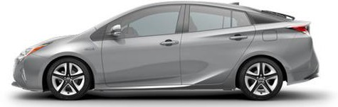
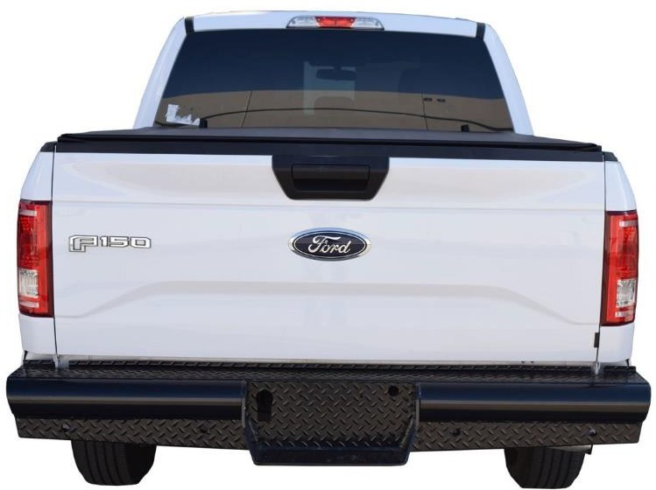
Failure to comply may result in ticketing and/or towing at the owner’s expense.
