Principles of Ecology Laboratory BIOL 204: Sections 01, 02, 03
Fall 2025
Wednesdays Section 01-11:30 am to 2:20 pm; Thursdays Section 02-9:30 pm to 12:20 pm; Section 03-2:00 pm to 4:20 pm

Course Overview
The Ecology laboratory is designed to complement the second-year ecology course, Principles of Ecology (Biology 203). Laboratories will consist of research projects that address questions at different levels of ecological organization, from organisms to populations, com- munities, and ecosystems. We explore research questions and methods used by a variety of sub-disciplines of ecology to expose students to the diverse nature of this field. You will be engaged in all aspects of the development of an ecological study: making observations, formulating hypotheses and predictions, designing experiments and strategies for data collection, statistical and graphical analysis, interpreting results, and reporting findings in written and oral formats.

Course Details
Instructor: Wendy A Owens Rios
Email: wowens@geneseo.edu
Office Hours: Wednesdays 3pm-4pm; Thursdays 12:45pm-1:45pm, Friday’s 8:00am-9:15am
Required text: No required text

Learning Outcomes
Upon completion of this course, successful students will be able to:
- Make observations, generate hypotheses, and carry out simple experiments and/or col- lect data to answer questions from different sub-disciplines in ecology.
- Collect ecological data using appropriate sampling methods and instrumentation.
- Organize, analyze and present ecological data using appropriate quantitative statistical and graphical analyses
- Explore and evaluate the primary ecological literature to provide background information for their studies as well as to help put their results into the context of other ecological research.
- Communicate their findings using the conventions of scientific writing in reports and oral presentations.
- Productively collaborate with a team to plan and carry out projects and communicate scientific information and results effectively.

Course organization & Grading
All the labs that we will be working on will build upon each other. Your assignments will be divided between individual and group assignments. There will be no quizzes only written assignments, R assignments, and one presentation with final lab report. Each week we will focus on one aspect of the ecosystem. We will be collecting data at the Research Reserve starting with herbaceous plants, tree data, soil characteristics and Aquatic insects.

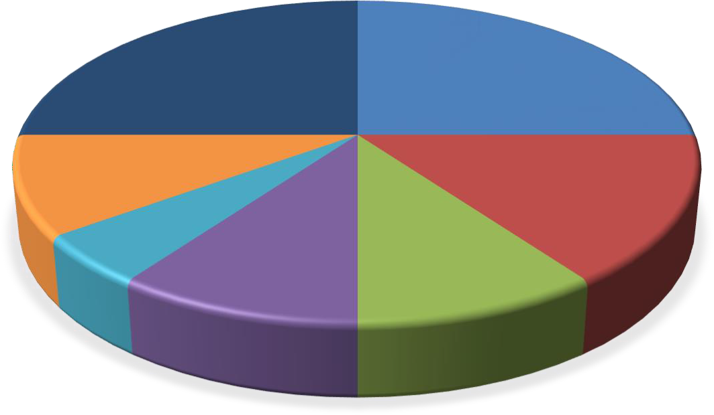
Group Final Paper
25%
R assignments-
Individual 25%
Final
Presentation-Group 10%
Literature Mini-
Presentation-group
5%
Worksheets-
Individual 15%
EDDIE Project-
Individual
10%
Mini Lab Report-
Individual 10%

Figure 1-Pie chart of Assignment Grade distributions

Assignment Submissions
All assignments will be submitted via Brightspace. Worksheets will be handwritten and you may take a photo of your written work to submit. In this age of AI, it is important that you are submitting your own work. You will be working in groups therefore I understand similar work will come from group members. You will also submit typewritten answers into Brightspace based on your field notes. The R assignments, submissions will be the .RMD file and knitted document either in Word or as PDF (depends on how you are knitting the document). Full credit will only be allowed if both files are submitted. There will be a rubric attached to each assignment to make sure you complete all the requirements to get full credit.

Lab Worksheets
Each lab exercise will have a worksheet where as individuals, you will fill out after each lab exercise to turn. These are worth 15% of your final grade. They will have questions related to the topic and you will be able to find answers in the lab exercise handout or I will direct you to resources to help you answer the questions. These are done in lab and no make-up worksheets will be accepted as these are for in class work only.

Reports
Two lab reports will be submitted individually. The first one is a Mini-Soil Report where each of you will do lab report on your groups findings about the soils you sample. The second will be a data project and more information will be forthcoming. Each of these assignments will be worth 10% each of you final grade.

R Assignments
There will be 3 R assignments for a total of 25% of your grade. The first assignment will be an introduction to R and the other two assignments will introduce more advanced code that can be used in your final project.

Literature Presentation
This will be a group project where you will present a current article related to the labs. It will be worth 5% of your grade as a group. It is practice for the final project.

Final Report and Presentation-Group
Each group will be assigned a portion of the total Research Reserve data collection to analyze and write up a scientific report and will present their results to the rest of the class. The Presentation will be worth 10% of your final grade and the final paper will be worth 25% of your final grade.

Table 1-Assignments

Assignments | Quantity | Percentage
R assignments-Individual | 3 | 25%
Worksheets-Individual | 6 | 15%
Mini Lab Report-Individual | 1 | 10%
EDDIE Project-Individual | 1 | 10%
Literature Mini-Presentation-group | 1 | 5%
Final Presentation-Group | 1 | 10%
Group Final Paper | 1 | 25%
Table 2-Letter Grade distribution

A | >93%
A- | 90-92.9%
B+ | 87.0-89.9
B | 83.0-86.9
B- | 80.0-82.9
C+ | 77.0-79.9
C | 73.0-76.9
C- | 70.0-72.9
D | >65.0
E | <64.9

