Principles of Ecology Laboratory-Spring 2025 BIOL 204: Sections 01, 02

Thursdays Section 01-9:30 am to 12:20 pm & Section 02 at 2:00 pm to 4:50 pm

Course Overview
The Ecology laboratory is designed to complement the second-year ecology course, Prin-ciples of Ecology (Biology 203). Laboratories will consist of research projects that address questions at different levels of ecological organization, from organisms to populations, com-munities, and ecosystems. We explore research questions and methods used by a variety of sub-disciplines of ecology to expose students to the diverse nature of this field. You will be engaged in all aspects of the development of an ecological study: making observations, for-mulating hypotheses and predictions, designing experiments and strategies for data collec - tion, statistical and graphical analysis, interpreting results, and reporting findings in written and oral formats.

Course Details
Instructor: Wendy A Owens Rios
Email: wowens@geneseo.edu
Office Hours: Monday’s & Wednesday’s 10-11:15am & Friday’s 11am-12:30 pm
Ecology TA’s: Chloe Girling & Jason Pun- Office hours & Study sessions TBD

Learning Outcomes
Upon completion of this course, successful students will be able to:
- Make observations, generate hypotheses, and carry out simple experiments and/or col-lect data to answer questions from different sub-disciplines in ecology.
- Collect ecological data using appropriate sampling methods and instrumentation.
- Organize, analyze and present ecological data using appropriate quantitative statistical and graphical analyses
- Explore and evaluate the primary ecological literature to provide background infor-mation for their studies as well as to help put their results into the context of other ecological research.
- Communicate their findings using the conventions of scientific writing in reports and oral presentations.
- Productively collaborate with a team to plan and carry out projects and communicate scientific information and results effectively.

1

The labs in this course are designed to build on one another, with assignments divided be - tween individual and group work. At the start of the semester, we will explore various meth-ods of data collection at the whole-ecosystem level, incorporating key lab techniques used in Ecology. After Spring Break, we will go the Research Reserve where you will apply these methods and collect data to create a final report and presentation.

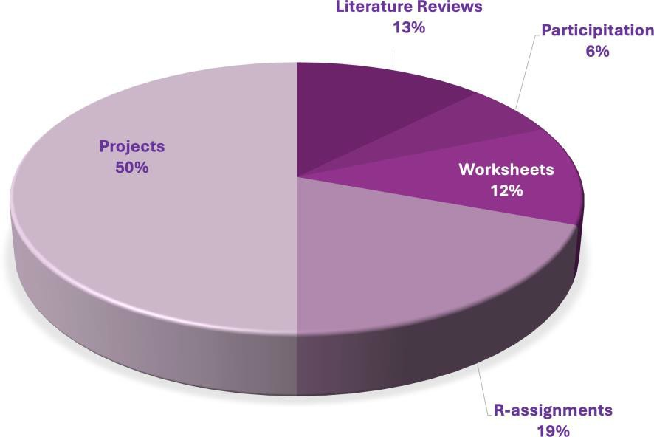

Figure 1: Grades

Date | Lab # | Lab Activity
Thursday, January 23, 2025 | Lab 1 | Syllabus, group dynamics exercise, Journal Arti-  cle/Annotated Bibliography
Thursday, January 30, 2025 | Lab 2 | Mini-Presentation & Introduction to R
Thursday, February 6, 2025 | Lab 3 | Soils & mini-lab report
Thursday, February 13, 2025 | Lab 4 | Soils
Thursday, February 20, 2025 | Lab 5 | Forest Data Analysis
Thursday, February 27, 2025 | Lab 6 | Plant Diversity Sampling Techniques & Data Analysis
Thursday, March 6, 2025 | Lab 7 | Literature Review of Forest and plant diversity
Thursday, March 13, 2025 | Lab 8 | Field Skills
Thursday, March 27, 2025 | Lab 9 | Field Trip: Soils Samples from Ridge & Riparian
Thursday, April 3, 2025 | Lab 10 | Field Trip: Tree Walk
Thursday, April 10, 2025 | Lab 11 | Field Trip: Forest Communities
Thursday, April 17, 2025 | Lab 12 | Any remaining lab work
Thursday, April 24, 2025 | Lab 13 | Presentations
Thursday, May 1, 2025 | Lab 14 | Ground Cover Survey

Assignments & Due Dates

Participation
Attendance and participation are very important in a lab course. Each week we build on the previous week. Therefore participation is about 6% of your grade. If you are sick, it crucial that you communicate with me and your group members. More than 2 absences will result in a notice to your advisor and potentially affect your overall grade. Below is the table on how I will keep track of attendance and overall participation.

Participation | Points | Comments
Attendance | 30 | 2 points for each lab attended + 2 points if  you never miss a class
Overall Participation | 20 | Engaging with peers and with professor
Total | 50

Literature Reviews
Throughout the semester I will be assigning Annotated Bibliographies and lists of peer re-view journal articles to use in your final report. I will show you how to properly format reference lists and incorporate into your reports. These assignments are split between indi-vidual and group assignments.

Literature Review Assign-  ments | Points | Lab | Individual  or Group | Due Date |  | Mode of Delivery
Annotated Bibliography 1 | 10 | Lab 1 | Individual | Thurs, Jan 30,  2025 |  | Scanned-  Handwritten on worksheet & submit  to brightspace
Mini-Presentation | 30 | Lab 1 | Group | Thurs, Jan 30,  2025 |  | Present in class &  submit to brightspace
Dissecting Journal Article  Worksheet | 10 | Lab 1 | Group | Thurs, Jan 23,  2025 |  | Due in class, turned  in by end of class
Annotated Bibliography 2 | 10 | Lab 4 | Individual | Thurs,  20, 2025 | Feb | Handwritten  Typed, turn brightspace | in | &  to
Peer Review Journal Arti-  cles - Soils | 15 | Lab 4 | Group | Thurs,  13, 2025 | Feb | Google doc shared  with me and submit-ted via brightspace
Annotated Bibliography 3 | 10 | Lab 7 | Individual | Thurs,  13, 2025 | Mar | Handwritten  Typed, turn brightspace | in | &  to
Peer Review Journal Arti-  cles - Plants | 15 | Lab 7 | Group | Thurs, Mar 6,  2025 |  | Google doc shared  with me and submit-ted via brightspace
Total Points | 100

Worksheets
Worksheets are mostly assignments done as a group to be handed in by the end of class with hard deadline due by the following week.

Worksheets | Points | Lab | Due Date | Mode of Delivery
Soils Worksheet | 15 | Lab 3 | Thurs, Feb 20,  2025 | Scan worksheet and sub-  mit to Brightspace
Forest Worksheet | 15 | Lab 5 | Thurs, Feb 27,  2025 | Scan worksheet and sub-  mit to Brightspace
Diversity Worksheet | 15 | Lab 6 | Thurs, Mar 6,  2025 | Scan worksheet and sub-  mit to Brightspace
Community Science Work-  sheet | 15 | Lab 8 | Thurs, Mar 13,  2025 | Scan worksheet and sub-  mit to Brightspace
Tree Worksheet | 15 | Lab 10 | Thurs, Apr 10,  2025 | Scan worksheet and sub-  mit to Brightspace
Forest Community Data | 10 | Lab 11 | Thurs, Apr 17,  2025 | Scan datasheet and submit  to Brightspace
Ground Cover Surveys Data | 10 | Lab 13 | Thurs, Apr 24,  2025 | Scan datasheet and submit  to Brightspace
Total | 95

R Assignments
We will do a lab exercise on how to start with R and then there will be individual assignments. Also there will be an excel assignment that will include data analysis.

R-Assignments &  Data Analysis | Points | Lab | Group or  Indiv | Due Date | Mode of Delivery
R in Lab Exercise 1 | 10 | Lab 2 | Group | Thurs, Jan 30,  2025 | Group Worksheet
R Assignment #1 | 50 | Lab 2 | Individual | Thurs, Feb 6,  2025 | Brightspace
R Assignment #2 | 50 |  | Individual | Thurs, Mar 6,  2025 | Brightspace
Forest Statistics Re-  port | 45 |  | Group | Thurs, Feb 27,  2025 | Brightspace

Projects
There will be 2 smaller projects in the beginning of the semester and then we conclude with the final large project.

Projects |  |  |  | Points | Lab | Group or In-  div | Due Date |  | Mode of Delivery
Mini  Soils | Lab | Report | - | 75 | Lab 3 | Individual | Thurs,  2025 | Feb 20, | Shared Google Doc &  submitted as PDF to Brightspace
Tree Report |  |  |  | 75 | Lab 5 | Individual | Thurs,  2025 | Feb 27, | Shared Google Doc &  submitted as PDF to Brightspace
Final Presentation |  |  |  | 100 | Lab 14 | Group | Thurs,  2025 | May 1, | Shared Google Slides  & submitted as PDF to Brightspace after presenting
Final Paper |  |  |  | 150 | Lab 14 | Group | Mon,  2025 | May 12, | Shared Google Doc &  submitted as PDF to Brightspace
Total |  |  |  | 400

Assignment Submissions
All assignments will be submitted via Brightspace. Worksheets will be handwritten and you may take a photo of your written work to submit. In this age of AI, it is important that you are submitting your own work. You will be working in groups therefore I understand similar work will come from group members. You will also submit typewritten answers into Brightspace based on your field notes. The R assignments, submissions will be the .RMD file and knitted document either in Word or as PDF (depends on how you are knitting the document). Full credit will only be allowed if both files are submitted. There will be a rubric attached to each assignment to make sure you complete all the requirements to get full credit.

College Policies & Resources

Academic Honesty

Plagiarism
When writing scientific reports we rely on previous knowledge from many past researchers and though we may write our own interpretation of these facts we must acknowledge their contributions otherwise it is considered unintentional plagiarism. In this class I will empha-size methods on how to use citations in your written work.

AI resources
AI, like Chat-GPT. You must do your own work, which means that you should not utilize tools like Chat-GPT for any aspect of our course work. Such use is a form of academic dis-honesty. Use of such tools is not only cheating, it will also cheat you of the opportunity to learn and develop your own skills. AI is tool to use in many forms. I will permit the use of ChatGPT for finding errors in your R code and anything coding related. As for your writing assignments, the use of AI is not permitted and will result in No points award for assign-ment.

Accommodations
SUNY Geneseo is dedicated to providing an equitable and inclusive educational experience for all students. The Office of Accessibility will coordinate reasonable accommodations for persons with disabilities to ensure equal access to academic programs, activities, and services at Geneseo. Requests for accommodation including letters or review of existing accommoda- tions should be directed to Dr. Amy Fisk in the Office of Accessibility Services in Erwin Hall 22 or access@geneseo.edu or (585) 245-5112. Students with letters of accommodation should submit their letter to each faculty member and discuss their needs as soon as possible. Please contact the Office of Accessibility Services for questions related to access and the process for requesting academic accommodations:

Student responsibility: Please submit your letter of accommodation to us at the begin-ning of the semester and make an appointment to discuss arrangements.

Instructor responsibility: We are committed to working with you to figure out how to create a just learning environment while meeting the learning outcomes of the course. Unless you communicate otherwise, we will keep all accommodations confidential.

Safeguarding your Mental Health
Diminished mental health, including significant stress, mood changes, excessive worry, or problems with eating and/or sleeping can interfere with optimal academic performance. The source of symptoms might be strictly related to your course work; if so, please speak with us. However, problems with relationships, family worries, loss, or a personal struggle or crisis can also contribute to decreased academic performance. SUNY Geneseo provides mental health services to support the academic success of students. Counseling Services, a part of the Lauderdale Center for Student Health & Counseling, offers free, confidential psychological services to help you manage personal challenges that may threaten your well-being. In the event we suspect you need additional support, we will express our concerns and the reasons

for them, and remind you of resources (e.g., Counseling Services, Career Services, Dean of Students, etc.) that might be helpful to you. It is not our intention to know the details of what might be bothering you, but simply to let you know we are concerned and that help, if needed, is available. Getting help is a smart and courageous thing to do – for yourself /and
/for those who care about you.

Important Dates

Date | Event
Tuesday, January 21, 2025 | 1st day of classes
Tuesday, February 25, 2025 | Diversity Summit
March 15 thru 22nd | Spring Break
Wednesday, April 23, 2025 | Great Day
Wednesday, May 7, 2025 | Last Day of Classes

