Principles of Ecology BIOL 203-02
Fall 2024
MWF 10:30 to 11:20

Course Overview
In this Ecology course, you will learn about the interactions between organisms and their environments. We aim to uncover the processes that influence the distribution and abundance of life on Earth. We’ll examine ecology at various levels, from individual organisms to populations, communities, and ecosystems.
The course will highlight the importance of natural selection and evolutionary principles in understanding these interactions. You’ll see how ecologists use the scientific method to answer questions about ecological systems. We will also introduce you to quantitative tools like mathematical models, statistics, and data visualization to help interpret ecological data. Additionally, we’ll discuss how ecological principles can be applied to address environmental and conservation issues.

Instructor
Name: Wendy A Owens Rios
Email: wowens@geneseo.edu
Office Hours: Monday’s 12-1pm, Tuesday’s and Thursdays 2-3:30pm
Office: ISC 139B

Course Requirements
Computer: Mac or PC
Software: Microsoft Office (Geneseo provides for free), R and RStudio Textbook: Ecology (6th ed) by Bowman & Hacker. ISBN: 9780197614044 Top hat Account: Join Code 295589


Learning Outcomes
Upon completion of this course, successful students will be able to:
- Explain how ecological patterns and ecological interactions contribute to evolutionary outcomes
- Apply knowledge of ecological processes and develop models to explain ecological patterns and make predictions
- Visualize, analyze, and interpret data to document ecological patterns and test hypotheses
- Apply knowledge of ecological concepts to predict impacts of human activities on ecosystems and biodiversity
- Synthesize ecological knowledge to evaluate the value of healthy ecosystems and the sustainability of human activities
- Productively collaborate in a group to solve problems and communicate scientific in-formation and results effectively

Grading
Grading will be based on several types of assignments including quizzes and exams.

Writing Exercise
Each lecture will begin with a individual writing assignment. I will pose a question about the current topic and you will neatly handwrite your answer on piece a paper. This paper will be given to me after 5 minutes and I will choose one answer randomly to read to the rest of class. We will discuss briefly. This exercise is worth 2 points and if you are late to class, there will be no make up. But you only are required 20 of these assignments and there are 28 opportunities and up to 10 additional bonus points.

Quizzes
There will be 10 online quizzes due on Sunday nights related to the chapters we have already discussed. They will be multiple choice, open book and you can repeat the quiz once to get a better grade. They are worth 20 points each.

Exams
There will be 4 exams with each progressively worth more points. The first exam will be 75 points, second exam 100 pts, third exam 125 points, and final exam 150 pts. Also of note the exams are worth approximately 3-6%.

Homework
There will be 4 individual assignments that require the use of R to analyze data. Each of these projects are worth 100 points. Please see a rubric on the grading.

Group Paper and Discussion
Every two weeks we will discuss a classic paper that I will assign. You will work in groups and dissect a section of the paper that I assign to you. You will be required to read the whole paper, answer assigned questions, search for relevant current article that cites the article and as a group present your interpretation of your assigned section with relevancy to current literature, . This will be a total of 6 papers.
Table 1: Course Assignments and point values

Assignments | Quantity | Points | Total Points | Notes
Writing Exercise-In Class | 25 | 2 | 50 | Bonus possible (no more than 10 extra points)
Group pa-  per/Discussion | 6 | 25 | 150
Homework R  Scenarios | 4 | 100 | 400
Quizzes | 10 | 20 | 200
Exams | 4 | 75-150 | 450 | Each test will be worth more with the final exam being worth the most
Total |  |  | 1250

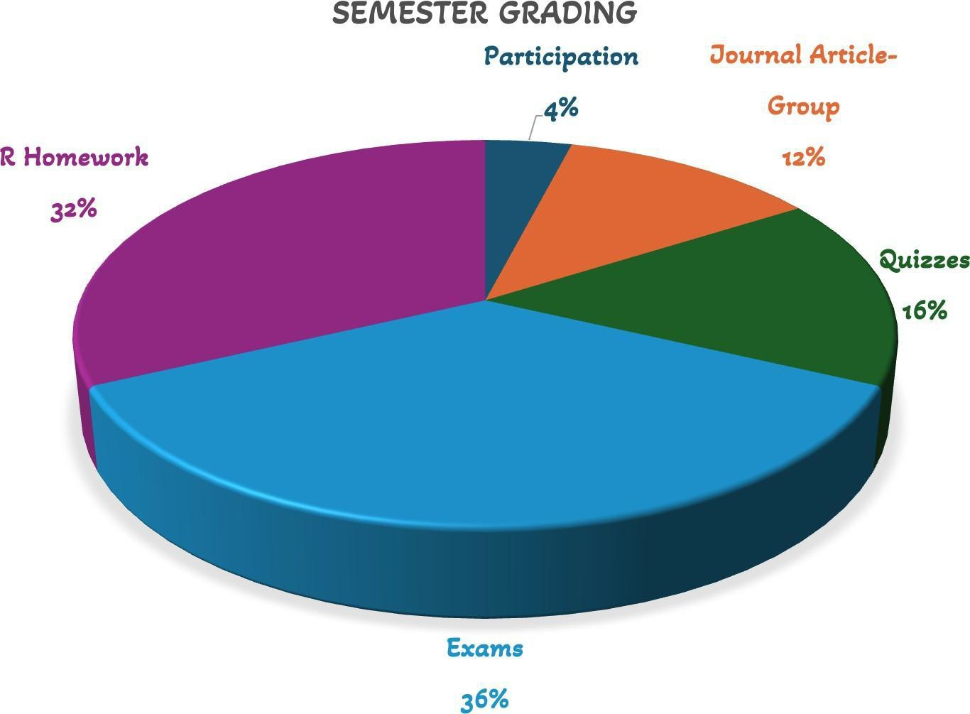
Figure 1: Grades

Owens Rios Fall 2024 3

Table 2: Exams-Divided between Multiple Choice (MC), Short Answers (SA) and Essays. Chapters covered in exams are approximate and are subjected to change

Exam | Points | Date | Chapters | MC | SA | Essay
Exam #1 | 75 | 25-Sep | Chap1-4, Chap9-11 | 70% | 30% | 0%
Exam #2 | 100 | 25-Oct | Chap12-Chap15 | 50% | 30% | 20%
Exam #3 | 125 | 21-Nov | Chap15-Chap19 | 40% | 40% | 20%
Exam #4 | 150 | TBD | Chap5, Chap20-  Chap22 | 40% | 40% | 20%

Course Schedule
Day | Date | Topics/Activity | Relevant Resources | Assignment Due Dates
Monday | 26-Aug | Intro to Course | Syllabus, Classic Lit, lecture for-  mat | Intro Question
Wednesday | 28-Aug | Chapter 1 | Group Assignment 1 on classic  lit | Intro Question
Friday | 30-Aug | Begin Chapter 2 | Group Assignment on classic lit
Monday | 2-Sep | Labor Day | No class | Quiz #1 Due
Wednesday | 4-Sep | Chapter 2-3
Friday | 6-Sep | Chapter 3 & Paper Discussion | Group Assignment on classic lit | Introduction to R Due
Monday | 9-Sep | Chapter 3-4 |  | Quiz #2 Due
Wednesday | 11-Sep | Chapter 4 | Group Assignment #2
Friday | 13-Sep | Intro to R Assignment - finish  chapter 4
Monday | 16-Sep | Unit 3 - Populations |  | Quiz #3 Due
Wednesday | 18-Sep | Chapter 9 & 10
Friday | 20-Sep | Chapter 9 & 10 | Paper Discussion | Paper Worksheet/Reflection
Monday | 23-Sep | Chapter 9 & 10 |  | Quiz #4
Wednesday | 25-Sep | Exam Review | Group Assignment #3
Friday | 27-Sep | Exam #1
Monday | 30-Sep | Chapter 12
Wednesday | 2-Oct | Chapter 12
Friday | 4-Oct | Chapter 13 | Paper Discussion | Paper-Worksheet/Reflection
Monday | 7-Oct | Chapter 14 |  | R Assignment #2 Due
Wednesday | 9-Oct | Chapter 14 | Group Assignment #4
Friday | 11-Oct | Chapter 15
Monday | 14-Oct | No class |  | Quiz #6
Wednesday | 16-Oct | Chapter 16
Friday | 18-Oct | Chapter 16 | Paper Discussion | Paper-Worksheet/Reflection
Monday | 21-Oct | Chapter 16-17
Wednesday | 23-Oct | Chapter 17 | Group Assignment #5 | Quiz #7
Friday | 25-Oct | Exam #2
Monday | 28-Oct | Chapter 17
Wednesday | 30-Oct | Chapter 18
Friday | 1-Nov | Chapter 19 | Paper Discussion | Paper-Worksheet/Reflection
Monday | 4-Nov | Chapter 19 |  | R Assignment #3 Due
Wednesday | 6-Nov | Chapter 5
Friday | 15-Nov | Chapter 20
Monday | 18-Nov | Chapter 20 |  | Quiz #9
Wednesday | 20-Nov | Chapter 21 | Group Assignment #6
Friday | 21-Nov | Exam #3
Monday | 25-Nov | TBA |  | Quiz #10
Wednesday | 26-Nov | No class
Friday | 28-Nov | No class
Monday | 2-Dec | Chapter 21 | Final R Assignment Due
Wednesday | 4-Dec | Chapter 22 | Final Group Assignment Discussion | Paper Worksheet/Reflection
Friday | 6-Dec | Chapter 22
Monday | 9-Dec | Last day of class - Exam Review
TBD | TBD | Exam #4 | Final Exam Week | Will include MC from previous  exams

Student success resources at SUNY Geneseo

Accessibility and accommodations
SUNY Geneseo is dedicated to providing an equitable and inclusive educational experience for all students. The Office of Accessibility will coordinate reasonable accommodations for persons with documented physical, emotional, or cognitive disabilities to ensure equal access to academic programs, activities, and services at Geneseo. Students with approved accommodations may submit a semester request to renew their academic accommodations. Please visit the OAS website for information on the process for requesting academic accommodations. Please contact the Office of Accessibility Services for questions related to access and accommodations: access@geneseo.edu, 585-245-5112, www.geneseo.edu/accessibility-office.

Reporting bias-related incidents
Here at SUNY Geneseo, we want to provide a space where everyone feels welcome to learn and grow in their identities as well as in their role as students, faculty, and staff. If, in the unfortunate instance, you experience an incident of bias, we encourage you to reach out to the Chief Diversity Officer (routenberg@geneseo.edu), Director of Multicultural Affairs (charcum@geneseo.edu), and/or our University Police Department. In trying to create an environment that facilitates growth through diverse thoughts and ideas, reporting incidents of bias—including threats, vandalism, and microaggressive behaviors—can help bring a better understanding of our campus climate as well as provide opportunities for learning and restoring harm.

Other resources
Additional resources are available to support your academic success and well-being, including academic support services, library research help, computer and technology support, food security support, and emergency funding. See the “Student success resources” and “Well-being and mental health” pages in the Brightspace course orientation module for more information about these services.

Owens Rios Fall 2024 7

