Principles of Ecology Laboratory BIOL 204: Sections 01, 02, 03
Fall 2024
Wednesdays Section 01-11:30 am to 2:20 pm; Section 02-2:30 pm to 5:20 pm; Thursdays Section 03-9:30 am to 12:20 pm

Course Overview
The Ecology laboratory is designed to complement the second-year ecology course, Principles of Ecology (Biology 203). Laboratories will consist of research projects that address questions at different levels of ecological organization, from organisms to populations, communities, and ecosystems. We explore research questions and methods used by a variety of sub-disciplines of ecology to expose students to the diverse nature of this field. You will be engaged in all aspects of the development of an ecological study: making observations, formulating hypotheses and predictions, designing experiments and strategies for data collection, statistical and graphical analysis, interpreting results, and reporting findings in written and oral formats.

Course Details
Instructor: Wendy A Owens Rios
Email: wowens@geneseo.edu
Office Hours: Monday’s 12 pm-1pm; Tuesday’s 1pm-2pm & Thursday’s 2-3:30pm. Required text: A Field Guide to Eastern Forests by John Kricher (Houghton Mifflin, 1998; ISBN: 978-0395928950)

Learning Outcomes
Upon completion of this course, successful students will be able to:
- Make observations, generate hypotheses, and carry out simple experiments and/or collect data to answer questions from different sub-disciplines in ecology.
- Collect ecological data using appropriate sampling methods and instrumentation.
- Organize, analyze and present ecological data using appropriate quantitative statistical and graphical analyses
- Explore and evaluate the primary ecological literature to provide background information for their studies as well as to help put their results into the context of other ecological research.

1

- Communicate their findings using the conventions of scientific writing in reports and oral presentations.
- Productively collaborate with a team to plan and carry out projects and communicate scientific information and results effectively.

Course organization & Grading
All the labs that we will be working on will build upon each other. Your assignments will be divided between individual and group assignments. There will be no quizzes only written assignments, R assignments, and one presentation with final lab report. Each week we will focus on one aspect of the ecosystem. We will be collecting data at the Research Reserve starting with herbaceous plants, tree data, soil characteristics and leaf-litter insects. The final two weeks, we will do a data assignment using all the skills in R you learned to better analyze the data.
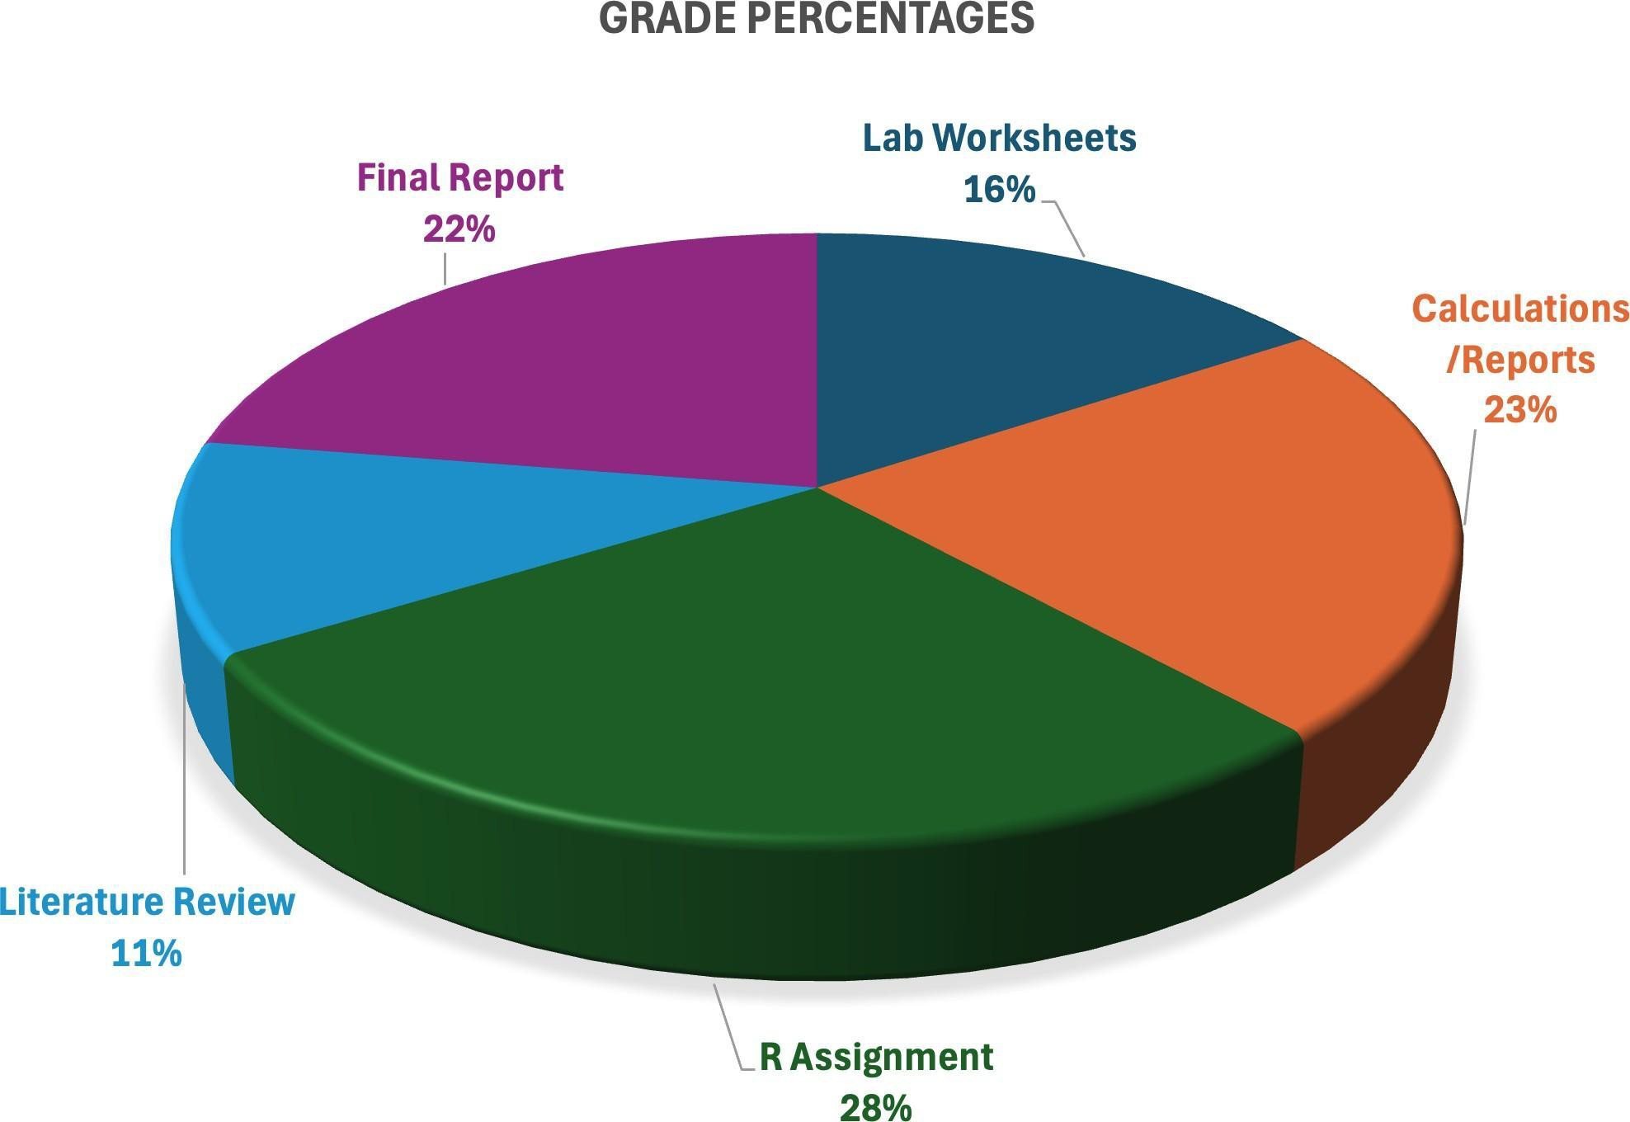

Figure 1: Grades

Owens Rios Fall 2024 2

Table 1: Assignment Details
Assignment | Group or Individual | Assignment Category | Points | Format
Arboretum Plants | Individual | Lab Worksheet | 20 | Handwritten & Typed
Research Reserve plants | Individual | Lab Worksheet | 20 | Handwritten & Typed
Forest Communities | Individual | Lab Worksheet | 20 | Handwritten & Typed
Soil Carbon | Individual | Lab Worksheet | 20 | Handwritten & Typed
Leaf Litter | Individual | Lab Worksheet | 20 | Handwritten & Typed
Soil Characteristics | Individual | Lab Worksheet | 20 | Handwritten & Typed
Diversity Calculations | Group | Calculations/Report | 50 | Handwritten & Typed
Soil Characteristics/Carbon | Group | Calculations/Report | 50 | Handwritten & Typed
Forest Communities Calculations | Group | Calculations/Report | 50 | Handwritten & Typed
Leaf Litter Calculations | Group | Calculations/Report | 50 | Handwritten & Typed
Intro to R | Individual | R assignment | 50 | R code
Using R with Diversity | Individual | R assignment | 100 | R code
Using R with Non-parametric | Individual | R assignment | 100 | R code
Data Lab-Intro | Individual | Lab Worksheet | 20 | Handwritten & Typed
Data Lab Calculations | Group | Calculations/Report | 70 | R code, Typed
Literature Review-List | Group | Other | 20 | Typed-APA format
Annotated Bibliography | Individual | Other | 20 | Typed-APA format, handwrit-  ten notes
Research Reserve Presentation | Group | Final | 100 | PowerPoint
Research Reserve Report | Group | Final | 100 | PDF/Word document

Table 2: Lab Activities and Assignment Due Dates(subject to change
Week of | Lab Activity | Assignment Due
August 26th | Plant surveys in Arboretum | Datasheet submitted to Google Drive
September 2nd | Plant surveys at Research Reserve | Arboretum Worksheet/Intro to  R/Research Reserve Datasheet
September 9th | Forest Communities | Research Reserve Worksheet/Forest Community Datasheets/Diversity  Calculations
September 16th | Soil Sampling and Soil Carbon set up | Forest Communities Worksheet/Soil  Characteristic Datasheets
September 23rd | Collect Soil Carbon/Collect Leaf Lit-  ter | Soil Characteristic Worksheets/Leaf  Litter Datasheets
September 30th | Leaf Litter set up for in-  sects/Analyzing Forest Communities | Forest Communities Calculations
October 7th | Identify Insects, Calculate Diver-  sity/Assign Lab Report Topics | Leaf Litter Worksheet
October 14th | Soil Analyses/Carbon | Leaf Litter Calculations
October 21st | Soil Analyses/Intro to Literature Re-  view | Soil Characteristic Calculations
October 28th | Soil Analyses | List of Literature, Annotated Bibliography
November 4th | Report Writing | Rough Draft Due
November 11th | Presentation - Assign Components by  Group | Presentation
November 18th | Data Lab | Final Lab Report
December 2nd | Data Lab | Data Lab

Assignment Submissions
All assignments will be submitted via Brightspace. Worksheets will be handwritten and you may take a photo of your written work to submit. In this age of AI, it is important that you are submitting your own work. You will be working in groups therefore I understand similar work will come from group members. You will also submit typewritten answers into Brightspace based on your field notes. The R assignments, submissions will be the .RMD file and knitted document either in Word or as PDF (depends on how you are knitting the document). Full credit will only be allowed if both files are submitted. There will be a rubric attached to each assignment to make sure you complete all the requirements to get full credit.

Lab Worksheets
Each lab exercise will have a worksheet where as individuals, you will fill out after each lab exercise to turn in. They will have questions related to the topic and you will be able to find answers in the lab exercise handout or I will direct you to resources to help you answer the questions. These worksheets will be completed by hand but also you will neatly type the answers in Brightspace to make it easier to grade. Therefore each assignment will have two submissions, your scanned written worksheet and your typewritten answers. Though, you will be working in groups I expect that each of you take time to write your own answers.

Calculations and Reports
There will be 5 calculations or report assignments worth 50 points each submitted as a group. These will include your .RMD files, knitted R files, scanned copies of calculations, and written results paragraphs that I will give you a rubric on how to complete these.

R Assignments
There will be 3 R assignments each worth 100 points. For full credit, you will submit a .RMD file and a knitted file either in word or pdf. Each assignment will have an attached rubric. These are individual assignments.

Literature review
For the final presentation and report, you will need to do a literature review of relevant peer review articles to include as citations in your final paper. This is a group project to create a relevant list. Individually, you will choose one of those articles to do an Annotated bibliography

Final Report and Presentation-Group
Each group will be assigned a portion of the total Research Reserve data collection to analyze and write up a scientific report and will present their results to the rest of the class. Each of these are 100 points each and I will request rough drafts.

Owens Rios Fall 2024 5

