Fall 2024 Aquatic Community Ecology (BIOL 312) SUNY Geneseo

Instructor: Isidro Bosch, Professor of Biology
(Office ISC 260; E-Mail: Bosch@geneseo.edu; phone: 245-5303

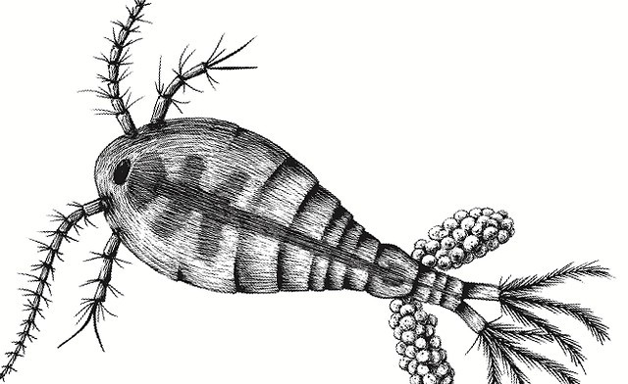
Office Hours: Mon. 12:00-1:00, W 1:00-2:00,
Tue. 3:30-4:30 or by appointment
Course Schedule: MWF Lecture: 10:30 -11:20 ISC 325;
R 2:00-4:50 in ISC 105
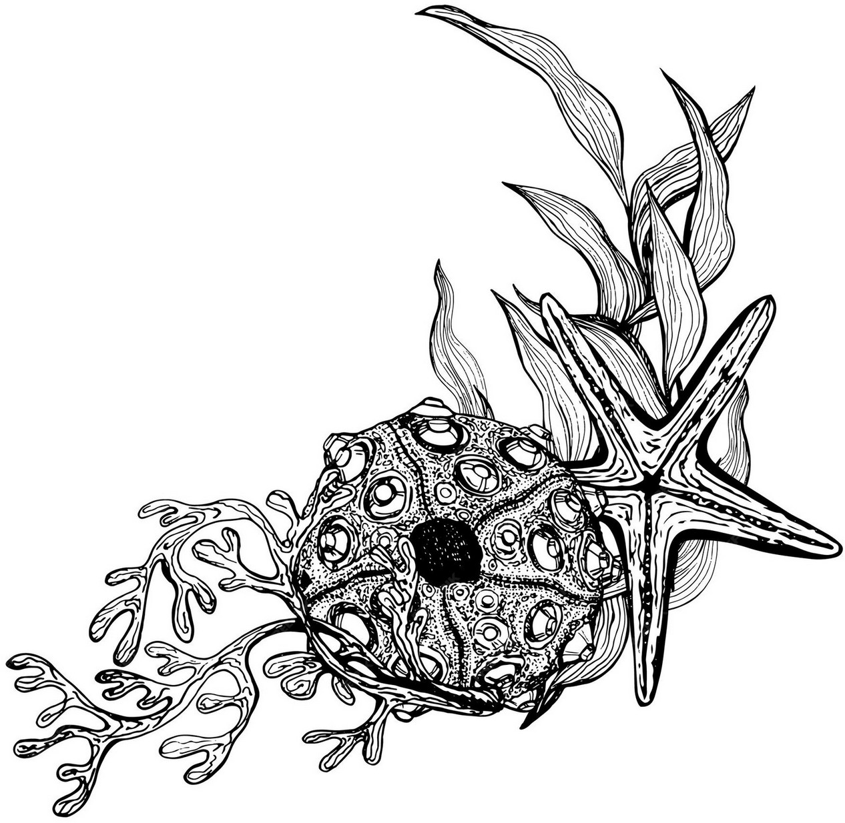
4 cr (3 hr lec., 3 hr lab)

Course Description
In this course we will study the communities and ecosystems that are characteristic of streams, lakes and marine environ-ments. The topics we cover are intended to develop your understanding of the ecology of these systems and increase your awareness of the many ways human-related processes (ex. fishing) that affect their natural integrity and stability.

The success of this course depends on your contributions to our activities. Part of our time will be spent in a lecture format, but the goal is to engage in active learning through discussions of research, readings, and conversations about relevant topics.
The laboratory portion of the course will consist of several projects centered on a study of Conesus Lake and other Finger Lakes. These “lab” projects are intended to develop your technical skills in the field of aquatic biology and to build your understanding of lake ecology and water quality management. One major goal in conducting these studies is to use our expertise as biologists to gather information that could help protect the lake ecosystem and sustain the quality of services it provides to its stakeholders.

You’ll be involved in two group studies during the semester. One is a “data mining” activity in which you will ask a pertinent question of your choice about the ecological history or state of a lake or lakes and then analyze data from previous studies to answer your question. The project will culminate in a group presentation. A second project will be a scientific investigation of some aspect of lake ecology, using Conesus Lake or other nearby lakes as our study systems. This will be an empirical research study consisting of multiple field data collection opportunities, sample and data analysis. Your deliverables will be a poster
presentation to a public audience, an in-class presentation and a scientific journal-style report.

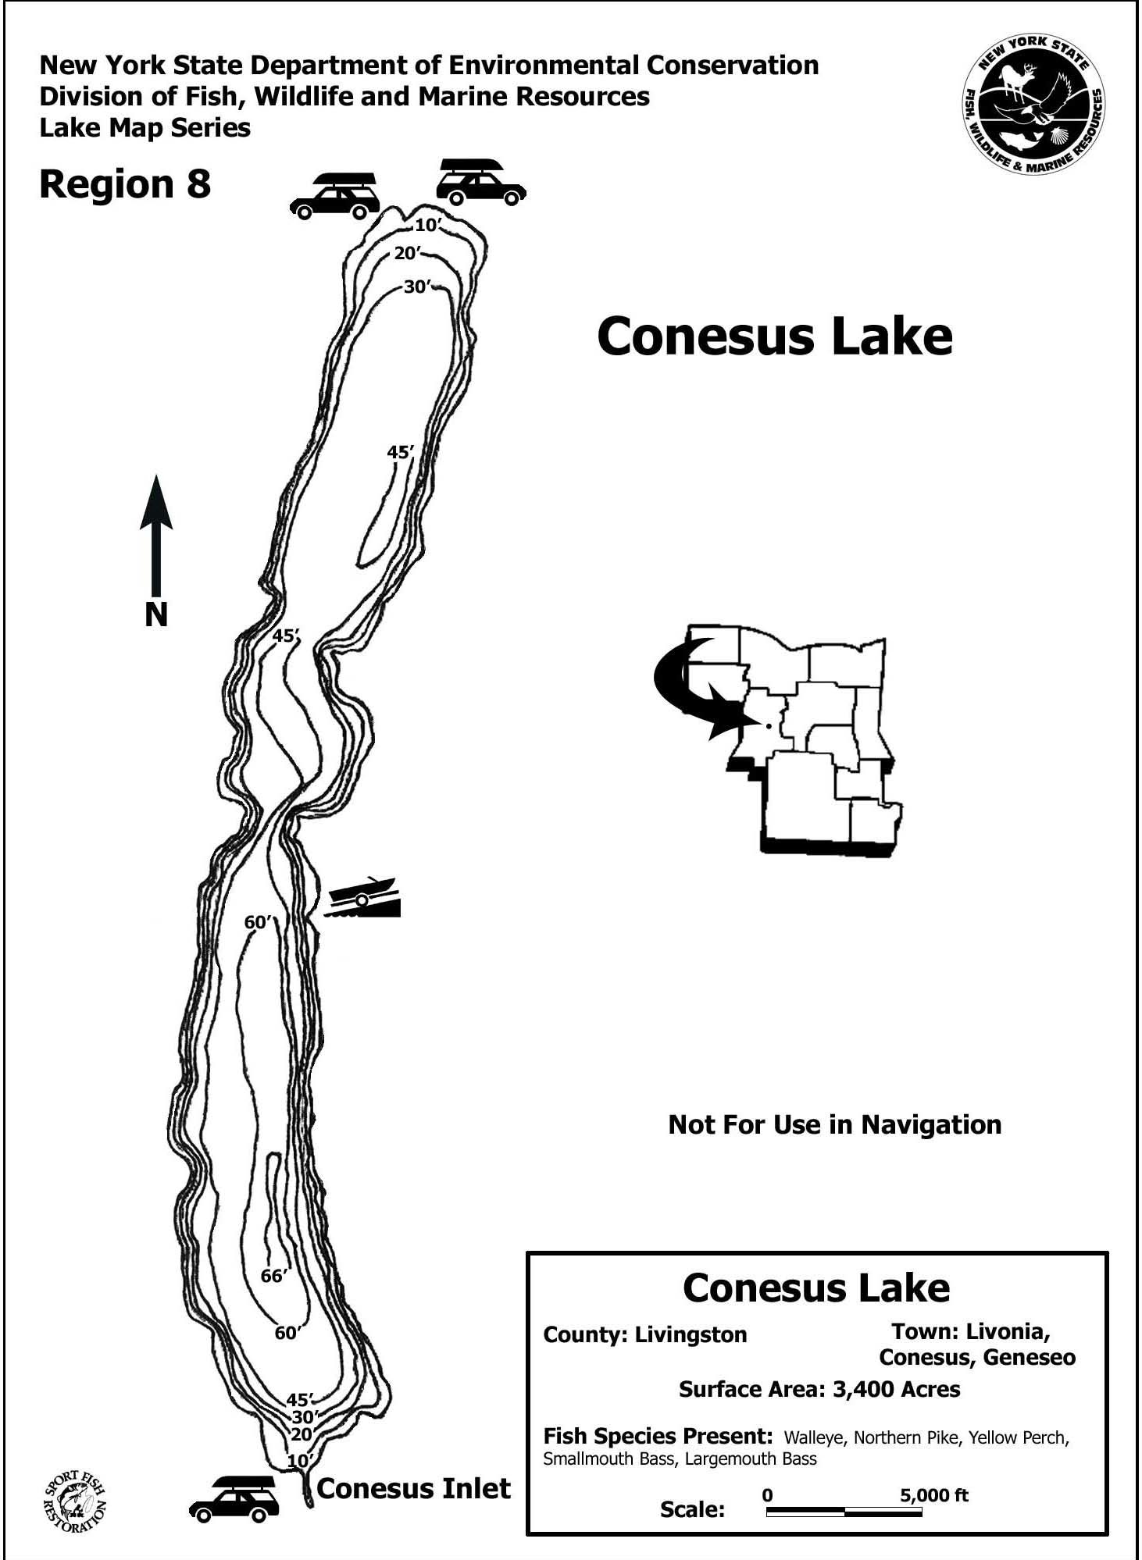
This year once again we’ll be working primarily in Conesus Lake, one of the smallest and shallowest of the Finger Lakes. Located about 6 miles east of Geneseo, Conesus Lake serves as the drinking water supply for more than 12,000 residents of Livingston County- in fact it is the source of the very water you drink if you live or work in Geneseo. Residents refer to Conesus Lake as the jewel of Livingston County but in recent years the lake has experienced a textbook of problems such as colonization by multiple invasive species, excessive phosphorus and nitrogen inputs, and harmful algal blooms. Your projects investigating the Conesus Lake ecosystem will contribute to a better ecological understanding of important processes and perhaps even a better future for Conesus Lake.

Pre-requisites: Biology 203 or a comparable Ecology course

Readings: We do not use a textbook (see comments below). The instructor will assign readings and provide the articles as pdf files or other medium.

Intended Learning Outcomes:

To achieve minimum competency in this course should be able to:
- Describe and critically evaluate the key physical and biological processes that determine the organization and dynamics of freshwater and marine communities and ecosystems.
- Identify common patterns in the organization and dynamics of aquatic systems.
- Demonstrate an understanding of how human activities disrupt the ecological balance of aquatic ecosystems and critically evaluate potential strategies for management and mitigation of such problems.
- Demonstrate practical competence in carrying out selected analytical procedures and quantitative data analyses that are utilized in aquatic biology.
- Investigate and synthesize scientific literature and formally communicate scientific information in a manner that is effective for the discipline.
Learning outcomes will be assessed primarily through exams and a take home essay final. Success in meeting the fourth learning outcome will be assessed through your work in field and laboratory activities and by your contributions to the success of the three significant research assignments (see Grading section below).

Grades:

The final course grade will be determined by your performance in a variety of activities that are designed to develop academic and scientific competency in Biology.

Exams 48%: 3 midterm exams (43%) and one take-home final essay (5%).
Data Presentation 10%: Working in a group, you will give an oral report that quantitatively explores biological, physical or chemical trends based on studies of the Finger Lakes.
Poster Presentation 5%: Poster on your research project to be presented to a public audience at the Watershed Education Center, in Lakeville by Conesus Lake.
Research Report 15%: Formal written group report based on analyses carried out in the laboratory portion of the course. The report will follow a standard journal format.
Research “Chalk Talk” 5%: Present a “chalk talk” on your lake research to the class without computers or computer-generated graphics – you are asked to only use the whiteboard.
Discussion 2%: each student will lead a class discussion of a scientific paper assigned by the instructor; preparation and effectiveness in leading the class discussion will be evaluated.
Participation (16%): includes preparation for class and laboratory activities; participation in field trips, environmental analyses and laboratory activities; and contributions to the dynamics of class discussions. (Corresponding to 4 different parts of the semester).
Total Score | Grade Scheme
93-100 % | A
89 - 93 | A-
86 - 89 | B+
82 - 86 | B
79 - 82 | B-
76 - 79 | C+
71 - 76 | C
66 - 71 | C-
61 - 66 | D
< 61 | E

Assignments and Due Dates | % of Final Grade
3 MT exams (9/23,10/21, 12/8) | 10%,15% 18%
Final Exam Essay (12/13) | 5%
Research Report (12/13) | 15%
Leading Discussion (TBD) | 2%
Data Mining Presentation (10/11) | 10%
Poster(12/3), Chalk Talk (12/13) | 10%
Participation | 15%

Readings:

We do not use a textbook in this class as no single textbook provides adequate coverage of both freshwater and marine community ecology. Readings for lectures and group discussions will be from the scientific and popular literature. Articles will be made available primarily in digital format. Reading assignments listed by first author are included in the syllabus.

Fall 2023: Reference List of Readings for Aquatic Community Ecology
- Cummins, K.W.1974. Structure and Function of Stream Ecosystems. BioScience 24: 631-641
+ supplementary reading on the phenomenon of stressed streams.
- Zhu, B. 2006. Alteration of ecosystem function by Zebra Mussels in Oneida Lake: impacts on submerged macrophytes. Ecosystems 9:1017-1028.
+ supplementary reading on invasive macrophyte species in the Finger Lakes
- Moss, B. 2011. Allied attack: Climate change and Eutrophication. Inland waters 1:101-105
+ supplementary reading on climate change effects on drinking water by Fillipelli & Ortiz
- Heisler, J. 2008. Eutrophication and harmful algal blooms: a scientific consensus. Harmful Algae 8:3-13 + supplementary reading on HABS forming species in New York State.
- Hairston Jr., N. 2005. Species-specific Daphnia phenotypes: a history of industrial pollution and pelagic ecosystem response. Ecology 86:1669-1678. + supplementary reading on understanding lake food webs.
- Walsh et al. 2016. Invasive species triggers a massive loss of ecosystems services through a trophic cascade. PNAS 113:4081-4085. +supplementary reading Nature Conservancy page on Great Lakes invasives species.
- Mumby, P.J. et al. 2004. Mangroves enhance the biomass of coral reef fish communities in the Caribbean. Nature 427: 533-536. + supplementary reading on seagrasses.
- Hughes, TP. 1994. Catastrophes, phase shifts and large-scale degradation of a Caribbean coral reef. Science 265: 1547-1551. + supplementary reading on Diadema response network
- Ricci et al., 2022. Coral growth anomalies, neoplasms, and tumors in the Anthropocene Trends in Microbiology 30:1160-01173. +supplementary reading on stony coral diseases
- Coral restoration TBD
Supplementary Reading: NOAA Fisheries Restoring Coral Reefs
- Estes et al. 2011. Trophic Downgrading of Planet Earth. Science 333:301-306
+ supplementary reading on role of predatory fish.
- Falkowski, P. 2012. The power of plankton. Nature 483: S17-S20
+ supplementary reading on iron controversy.

Maintaining an environment conducive to learning:

Because you are a small group, your individual contribution to the work in this class including lecture meetings and paper discussions is essential. Please try and attend all the lecture meetings. Missing one or two is not going to affect your participation grade but chronic absences will. It is important that you attend all laboratory meetings. Do your very best to arrive to class on time, stay through class, use your laptop and other technology only for class-related activities, and turn off your cell phone ringtones (including vibration mode).
Technology can be beneficial as a tool for education. For this reason, laptops and smartphones are permitted so you can take notes and view classroom materials. But please do not view social media websites, check your e-mail or play games. These diversions affect your work and distract those around you. I can usually tell when students are on-line, and it is distracting to me too. If you are being affected by the behavior of others around you, its ok to ask them to stop since their activities are disrupting your learning. Unexpected phone noises are disruptive and highly frowned upon in our class. If you have an emergency that requires your cell phone to be turned on just let me know so I am not surprised when it rings.

Because the class involves so much project work and field trips, it is important that we have efficient lines of communication. I will do my very best to deal with your emails quickly.
However, while occasionally I will send or read emails outside of normal business hours, for the most part I will not reply to emails received after 5:30pm until the next day and weekend emails until Monday. Please know that I do not expect that you will read or respond to my messages outside of normal business hours.

Health and Wellbeing:

Your health and wellbeing are foundational to your ability to learn, and if you find that you are feeling unwell (physically or mentally) and it is impacting your ability to complete your coursework, don’t hesitate to reach out to your professor. Please remember that it’s never a mistake to ask for help. The Dean of Students (585-245-5706) can assist and provide direction to appropriate campus resources. We are a small group so there won’t be any problem with me responding to individual needs as appropriate.
In a similar way, I will occasionally ask for some patience, flexibility and understanding on your part. I will generally try to post lecture notes at least 2 hours before class and have your work graded within a week after submission. If I am slow some time to grade an assignment, if I am a bit late posting a video lecture, please be patient (and feel free to send a ‘nudge’). You will never suffer any disadvantage in the course because of delays on my part.

Diversity and Equity:

It is my intent to create a learning environment that supports all students. I believe the diversity that you bring to this class should be viewed as a resource, strength, and benefit. I strive to present materials and activities that are respectful of gender identity, sexuality, disability, age, socioeconomic status, ethnicity, race, nationality, religion, and culture. If you have any suggestions to improve how the course is run or to better the culture of our class please don’t hesitate to let me know. For ideas, questions, or concerns related to diversity, equity, and inclusion in the Biology Dept., please reach out to bio-diversity@geneseo.edu.
Schedule for Aquatic Community Ecology Course

Week |  | Mon | Wed | Th Lab | Fri
1  Aug. 26-30 | Lecture | Lee l. Course Intro  None | Lee 2.Stream Ecology  None | Field Equipment | Lee 3.Stream Ecology  1. Cumins
1  Aug. 26-30 | Reading
1  Aug. 26-30 | Due
1  Aug. 26-30 | Lab
2  Sep. 2-6 | Lecture | Labor Day-No classes | Lee 4. Lake Mocrophytes | Mocrophytes Survey  State of Conesus Lake  Conesus Lake | Lee 5.Lake Mocrophytes  2. Zhu
2  Sep. 2-6 | Reading
2  Sep. 2-6 | Due
2  Sep. 2-6 | Lab
3  ,.. Sep 9-13 | Lecture | 6.Stratification and Climate | 7. Nutrients | Field:Stratification  Conesus Lake | 8. Nutrients  3. Moss
3  ,.. Sep 9-13 | Reading
3  ,.. Sep 9-13 | Due
3  ,.. Sep 9-13 | Lab
4  II" Sep 16-20 | Lecture | 9. Phytoplankton | 10.Primary Production | Trophic State  Hemlock Lake | 11. Reviewfor Exam 1  4. Heisler
4  II" Sep 16-20 | Reading
4  II" Sep 16-20 | Due
4  II" Sep 16-20 | Lab
5  II" Sep 23-27 | Lecture | 12.Exam I  Lee1-11 | 13.Zooplankton | Zooplonkton  Conesus Lake | 14. Zooplonkton  5. Hairston
5  II" Sep 23-27 | Reading
5  II" Sep 23-27 | Due
5  II" Sep 23-27 | Lab
6  Sep 30-Oct4 | Lecture | 1S. Herbivory | 16. Food Web Dyanamics | Microbes | 17.Top-Down Forces
6  Sep 30-Oct4 | Reading
6  Sep 30-Oct4 | Due
6  Sep 30-Oct4 | Lab
7  Oct. 7-11 | Lecture | 18. Biomanipulation | 19. Invasive Species  6. Walsh | 20. Estuaries/Mangrove
7  Oct. 7-11 | Reading | 18. Biomanipulation | 19. Invasive Species  6. Walsh | Conesus Lake
7  Oct. 7-11 | Due
7  Oct. 7-11 | Lab
8  Oct 14-18 | Lecture | Fall Break | 21.Seogrosses  7. Mumby | Lob  Doto MiningPresentations | 22. Review for Exam 2
8  Oct 14-18 | Reading
8  Oct 14-18 | Due
8  Oct 14-18 | Lab

Week |  | Mon | Wed | Th Lab | Fri
9  Oct. 21-25 | Lecture  Reading | 23.EXAM2  Lee13-22 | 24.Coral Reefs/Competition | Project Sample Analysis | 25. Reefs  8. Hughes
 | Due |  |  | Project Sample Analysis | due Report Methods
 | Lab |  |  | Project Sample Analysis
10  Oct. 28 -  1-Nov | Lecture Reading Due  Lab | 26. Reef Health | 27. Coral diseases  9. Ricci et al | Project Sample Analysis | 28. Restoration  J0. Restoration* TBD  Due Report Intro
11 | Lecture | 29. Rocky shores | 30. Rocky/Subsidies |  | 31. Start Kelp Beds
Nov. 4-8 | Reading
 | Due
 | Lab |  |  | Writing ResuIts
12 | Lecture | 32.Trophic Cascades | 33.Regime shifts |  | 34. Water Column
Nov. 11-15 | Reading |  | 11. Estes
 | Due
 | Lab |  |  | Project Work | Due Results Section
13 | Lecture | 35. Design Posters | Thanksgiving | Thanksgiving | Thanksgiving
Nov.18-22 | Reading |  | Break | Break | Break
 | Due
 | Lab
14  Nov. 25-29 | Lecture Reading | 36. Oceanography | 37.Work on Posters  12. Falkowski | Posters Due | 37. Deep Sea
 | Due Lab |  |  | Posters Due
15 | Lecture | Poster preview | Wed. Exam review |  | 39. EXAM3
Dec. 2-6 | Reading |  | Lee 24-36
 | Due | Tuesday Conesus Lake Watershed
 | Lab |  | Education Center | Project Work
16 | Lecture | 41.Synthesis |  |  | Final Exam
Dec. 9-13 | Reading Due Lab | Essay topics |  |  | 3-6 PM  Essays Due Final Reports Due

