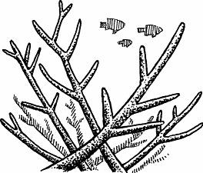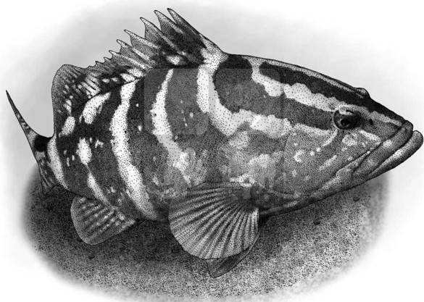
Spring 2024
Biodiversity of Coral Reefs (BIOL 314)
Geology of Coral Reefs (GSCI 314)
SUNY Geneseo

Biodiversity of Coral Reefs (BIOL 314)
Geology of Coral Reefs (GSCI 314)
Spring 2024 | SUNY Geneseo
Instructor: Isidro Bosch, Professor of Biology
Office ISC 260; e-mail: bosch@geneseo.edu; phone: 245-5303
Office Hours: M 1-2 PM, T 3:30-4:30, W 11:30 AM-1 PM
Instructor: D. Jeffrey Over, Professor of Geological Sciences Office ISC 249; e-mail: over@geneseo.edu; phone: 245-5294
Office Hours: TBA
Course Schedule: Lecture TR: 2:00-3:15 ISC 137; (3 credit: 2 hr Lecture -3 Lab in Bahamas)

Course Description
Coral reefs are hotspots of marine biodiversity that are in serious jeopardy principally due to human related factors such as fisheries, eutrophication, and carbon dioxide emissions. Students enrolled in Biology 314 or GSCI 314 will have the opportunity to study the biotic interactions and the geological processes that shape these amazing ecosystems and to learn about present threats to reef health, focusing on Caribbean/Atlantic reefs.
During the first half of the semester on campus you will study the basics of coral reef ecology and geology primarily through lectures and readings. In addition, you will be asked to work in small groups to identify a research project, propose a formal plan of investigation, and carry out the proposed study while in the Bahamas during the “laboratory” portion of the course. The project work will culminate in two deliverables that will be completed on campus during the second half of the semester: a group research poster presentation on GREAT Day (Wednesday, April 24) and an individually written scientific report due on April 30, 2024.
For the study abroad/field portion of this course you will spend 9 days working at Gerace Research Institute on San Salvador Island in The Bahamas, where you will experience first-hand the remarkable diversity, beauty, and the fragile nature of coral reefs and learn how the past and future of the Bahamas Islands and The Bahamas nation are inextricably linked to its coral reefs.
To enroll in BIOL 314/GSCI 314 students must have completed a college course in Ecology or Environmental Science, or a comparable course. Enrollment is by permission of instructor.

Activities Abroad
The trip to San Salvador Island and our stay at the Gerace Research Institute are coordinated by SUNY Geneseo’s Study Abroad Program. You will need a valid passport to enter the Bahamas and return to the U.S.A. If you are not a U.S. citizen in addition to your passport you will/may need a valid re-entry permit and a visa. Please check with the Study Abroad Office if you have any questions about international travel. While on San Sal, the group will be active in the field during the day and will also meet for about an hour or more of course-related activities each evening. Our field activities typically involve multiple hours in the water each day, swimming over reefs and other habitats at depths of 2- 10m. Safety during these outings is a priority. Proper snorkeling gear is required, including an emergency snorkeling floatation device. To demonstrate proficiency in snorkeling, students while in Geneseo must attend 3 pool sessions organized by your instructors.

Readings
There is no required textbook. The instructors will assign readings from the scientific literature and from popular magazines. Copies of these articles will be provided as pdf files. Students working in pairs will be responsible for organizing and leading a short discussion centered on one of the assigned readings. Before departure for the Bahamas, you will be provided an informative field course booklet containing travel information, readings, species lists, assignment rubrics and more.

Participation
Preparation and cooperation in all class activities is very important in any course, but they are critical to the success of a small class size and while studying abroad. We devote a considerable amount of time to discussion topics and to preparation for field studies, and then we have a very brief and hectic time doing our field work on the island. We encourage you to be well prepared for class meetings, to show enthusiasm and interest during class activities, and to behave responsibly in all cases, especially while we are away from campus (There is no “I” in “Study Abroad”). During our travels abroad and our stay on San Salvador we will be representing SUNY in a foreign nation. Even when abroad, students and faculty are legally bound by the laws of the United States and the SUNY Geneseo code of conduct. We are also expected to respect the cultural norms and laws of our host country. Once we leave campus your instructors have ultimate authority for all course activities and participant actions.

Learning Outcomes - To achieve minimum competency in this course students should be able to:

- Identify common organisms and describe the key features of the ecology and geology of the Bahamian marine environment, focusing on coral reefs and their component habitats.
- Explain how the processes of carbonate geology and changing climates have shaped the Bahamian island group and their coastal zone and created the five major habitats in the Bahamian reef environment.
- Discuss ways in which human activities disrupt the balance of coral reef systems and potential strategies for management/mitigation of such problems.
- Develop a persuasive proposal for a field research project to carry out in the Bahamas and execute that project effectively in the field.
- Demonstrate aptitude in writing a scientific journal-style report.
- Create a poster for GREAT DAY describing the research project to a general audience.
- Demonstrate intellectual and personal growth through teamwork, cross-cultural engagement, and self-reflection.
- Reflect on and explain Sense of Place within a remote geographical region of the world to understand sense of belonging and global citizenship.
The first three learning outcomes will be assessed through your preparation for class, participation in class and your performance in a single mid-term exam. Success in meeting outcomes 4-6 will be determined by your work on three different but related projects: (i) A proposal to conduct a field study;
(ii) A scientific journal style research paper reporting the results of the field project to a scientific audience; and (iii) A poster presentation describing the project and aspects of your personal experience to a general audience. The last two learning outcomes are grounded on the expectation that you will treat this class an opportunity to grow personally and intellectually, and to reflect on how the trip abroad, and your experience learning about coral reefs affect your sense of belonging and global citizenship.
Assignments, Grading and Due Dates
Quizzes 5%: 5 quizzes on identification/ecology of reef species, including one at the end of our stay on the island (schedule TBD).
Proposal for a Research Project 10%: Oral presentation describing a proposed research project that must include an analysis of a scientific problem and the complete design of a field study.
Midterm Exam 20%: Midterm Exam on geology and ecology of Caribbean reefs, based on lectures.
Field Notebook 10%: This should be a well-organized, legible account of all the official activities and observations. A waterproof notebook will be provided as part of your course materials, and on the first evening there will be a lecture on best practices for maintaining a field notebook.
Progress Report 5%: This will be an 8-10 min summary presentation of your data, completed analysis and plans for further work.
Poster Presentation 10%: A poster describing the results of this project is to be presented for GREAT Day Students must submit an abstract of the project before departure by March 8.
Research Report 20%: Formal written report based on analyses carried out in the laboratory portion of the course. The report will follow standard scientific journal format.
Participation 20%: includes preparation for class, diligence in meeting deadlines, contributions to the dynamics of class discussions, and cooperation and effort on campus and especially during the field studies.
Score | Grade
93-100% | A
90 - 93 | A-
87 - 90 | B+
83 - 87 | B
79 - 83 | B-
75 - 79 | C+
71 - 75 | C
66 - 71 | C-
61 - 66 | D

Assignments and Due Dates | % of Final grade
Quizzes (Schedule TBD) | 5
Proposal (Due Th 2/29) | 10
Exam (3/5) | 20
Field Notebook (3/28) | 10
Progress Report (4/9) | 5
GREAT day poster (4/24) | 10
Research Report (4/30) | 20
Group Participation | 10
Class Participation | 5
Cooperation | 5
TOTAL | 100

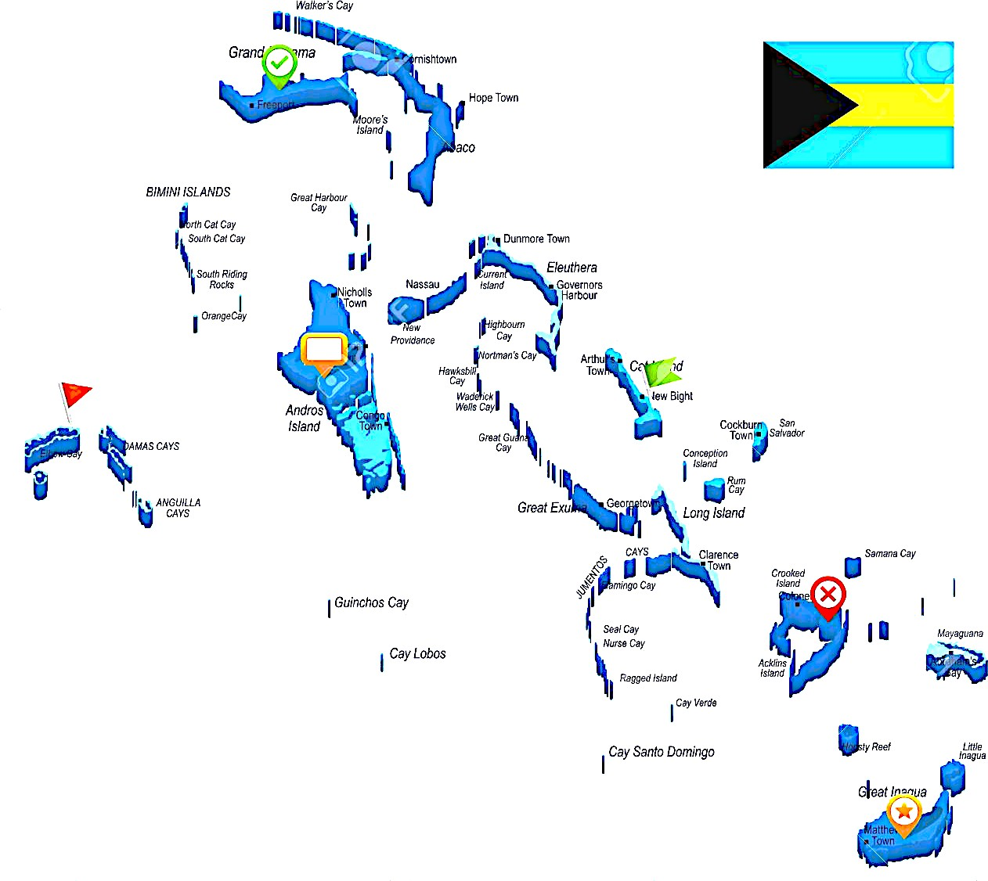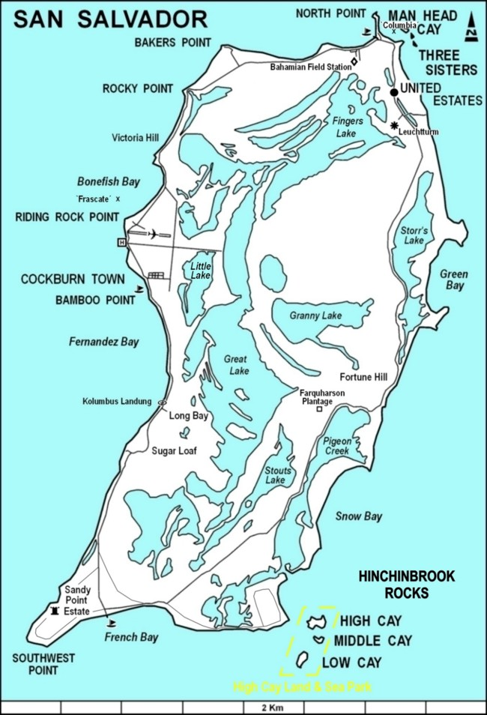

Tentative Schedule of Class Meetings
Week | Date | Day | Topics
1 | 1/23 | T | Intro to Coral Ecosystems and other Bahamian Habitats (Lect A)
 | 1/25 | Th | Historical Geology of Coral Reefs (Lec B)
2 | 1/30 | T | Cnidarians and Coral Biology (Lec C)
 | 2/1 | Th | Invertebrate Biology (Lec D) (Read 1: TBD)
3 | 2/6 | T | Geological Origin of the Bahamas (Lect E)
 | 2/8 | Th | Island Geology, Glacial Cycles and Stratigraphy (LEC F) (Read 2: Toomey 2013)
4 | 2/13 | T | Vertebrate Primer/Fishes of San Salvador (Lec G)
 | 2/15 | Th | Zooxanthellae/algae ; Start Coral Reef Ecol. (Lec H) (Read 3: Allem and Furla 2018)
5 | 2/20 | T | Coral Reef Ecology (Lec I) (Read 4 TBD)
 | 2/22 | Th | Threats to Coral Reefs (Lec J) (Read 5 TBD)
6 | 2/27 | T | Diversity Summit (no classes)
 | 2/29 | Th | Proposal Presentations (GREAT Day Abstracts due)
7 | 3/5 | T | Midterm Due. Logistics for Research/Travel (receive books, instructions, etc.)
 | 3/7 | R | Fly ROC –NAS-San Sal
8 | 3/7-16 |  | FIELD STUDIES IN SAN SALVADOR
 | 3/16 |  | Fly: San Sal- Miami-ROC
9 | 3/19 | T | Complete field notebooks and consolidate field data
 | 3/21 | Th | Complete field notebooks and consolidate data
10 | 3/26 | T | Statistical Analysis I (Regressions/Correlations) (Read 6: Fisheries)
 | 3/28 | Th | Statistical Analysis II: Two- Multi-Treatment Tests) (Submit field notebooks)
11 | 4/2 | T | Writing a scientific paper/composing a poster (Read 7: Mumby, Caribbean Reefs)
 | 4/4 | Th | Work on Poster for GREAT Day
12 | 4/9 | T | Progress Report Presentation
 | 4/11 | Th | Work on Poster for GREAT Day (Read 8: Van Oppen, Assisted Evolution of Corals)
13 | 4/16 | T | Finish and Submit Poster for GREAT Day
 | 4/18 | Th | In Class Poster Presentation/ Report Consultations
14 | 4/23 | T | Report Writing Consultations No formal Class Prior to GREAT Day
 | 4/24 | W | GREAT Day
 | 4/25 | Th | Report Writing Consultations
15 | 4/30 | T | Reports Due
 | 5/2 | Th | Report Revisions Consultations
16 | 5/7 | T | Final Revisions Due
17 | 5/14 | T | Final Exam Period (3:30-6:00 PM)

