Biology of Insects (Biology 345)
Fall 2024
(Lecture: TR 9:30 – 10:45 am, ISC 137; Lab: W 2:00 – 4:50 pm, ISC 206)

Course overview

Why study insects? The theoretical ecologist Robert May wrote, “To a good approximation, all species are insects.” This claim comes from the fact that of the 1.5 million described species, almost over 900,000 are insects. The number of described species is certainly an underestimate of the actual number, which has
recently been estimated to be as many as 5.5 million. Insects are ubiquitous in the earth’s terrestrial ecosystems, occupying practically every possible ecological niche as herbivores, predators, parasites, scavengers, and decomposers. They provide valuable ecosystem services, as pollinators, biological control agents, food sources for other species, and decomposers of plant and animal detritus. While many of their activities benefit humans, an understanding of insect biology is also important to help control their negative impacts as vectors of disease and agricultural and forest pests. The small body size, abundance, short generation time, high reproductive rate, and ability to be experimentally manipulated have made insects valuable model organisms in the study of biology, significantly impacting research in fields such as physiology, genetics, biochemistry, development, ecology, and evolutionary biology. This course will introduce you to the biology of insects, from insect diversity, classification, and evolutionary history, to their morphology, physiology, behavior, ecology, and relevance to human activities. My hope is that it will inspire wonder and respect in you for these remarkable organisms!


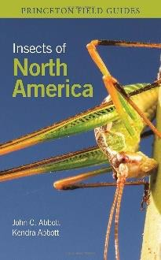
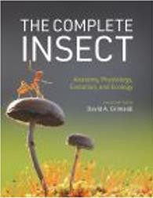
Dr. Jennifer L. Apple (she/her/hers)
Office: ISC 258 Lab: ISC 340
e-mail: applej@geneseo.edu Phone: 245-5442 Office hours: To be determined
Required texts: Insects of North America by John C. Abbott and Kendra K. Abbott (Princeton University Press, 2023; ISBN: 978-0691232850)
The Complete Insect edited by David A. Grimaldi (Princeton University Press, 2023; ISBN: 978-0691243108)

Learning outcomes

Successful students in this course will be able to
- integrate knowledge about the morphological, physiological, and ecological traits of insects to explain the success, abundance, diversity, and ecological importance of insects
- interpret the evidence for the proposed evolutionary relationships of insects and related groups and how this informs insect systematics
- to identify insects to order and the most common families in major orders; use a dichotomous key for identification
- apply a variety of methods to collect insects and prepare insect specimens for a formal collection using standard museum techniques
- develop and improve observation skills to recognize organisms and patterns in the natural world
- interpret and synthesize primary literature
- effectively communicate the context, interpretation, and significance of research findings

How this course will run

The lecture portion of the course will introduce you to many aspects of insect biology: classification and evolutionary history, anatomy, physiology, development, life history, behavior, and ecology. We will also address the impacts of insects and applied topics like medical entomology and conservation biology. In the course laboratory, you will practice methods of collecting, preserving, and curating insects. During several local field trips you will have opportunities to collect specimens and practice common methods of insect sampling. You will also be required to develop an insect collection that meets specific criteria, and this will likely involve time going out and collecting on your own, as well as working in the lab outside of regular lab times to prepare and identify your specimens. The lab will also include activities to learn about insect internal and external morphology, insect identification, and ecological patterns in insect distributions.

To maximize hands-on learning that is so important to the field of entomology, I will be using some of our
“lecture” periods during the TR 9:30-10:45 am time slot for more “lab” oriented activities, like viewing reference specimens and practicing identifying insects to the order or family level. These hands-on activities will be emphasized during the early part of the semester to ensure you receive effective instruction and opportunities for practice with identification before you must turn in your insect collection (before Thanksgiving).

How is your grade determined?
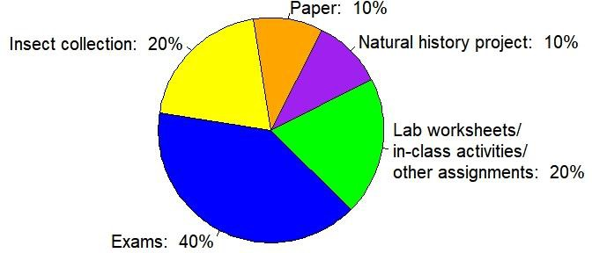
Exams (40% of grade)

You will be assessed on your knowledge of material presented in lab and lecture through several exams/identification quizzes during either the lecture or the lab period; some exams will have practical components requiring identification of insect specimens or structures.

Insect collection (20% of grade)

The best way to learn about insects is to get a close look at them and experience the habitats where they live. Thus, a big part of this course involves collecting insects and learning how to preserve them in a way to facilitate their identification, which often involves viewing key characters under a microscope. Field trips at the beginning of the fall semester will provide opportunities for collecting, but you may also need to go out on your own to collect more. Note that as the fall progresses insects will be more difficult to find, so it is imperative that you concentrate your collecting early in the semester. Your collection will consist of both a physical component and a photographic component with 20 specimens each.
Your physical collection of 20 specimens must include:

  - adult representatives from 8 correctly identified orders of insects (including at least one of each of these 6 orders: Orthoptera, Hemiptera, Coleoptera, Diptera, Lepidoptera, Hymenoptera)
  - adult representatives from 15 unique families, correctly identified Your photographic collection of 20 specimens must include:
- adult or immature representatives from at least 8 correctly identified orders of insects
- no more than 5 representatives from the same family of insect
- photographs that include a personalized scale bar

Identification slide show/video. You will also prepare a slide show or video explaining how you arrived at the identification of two of your physical specimens to the family level. More details will be provided.

You should try to keep up with identifications so you know if you are missing orders or families, before it is too late. A collection box will be provided for preparing your physical collection as well as all required collecting supplies. All insects must be properly labeled and mounted according to provided guidelines. Your photographic collection should be presented in a series of Powerpoint or Google slides according to provided guidelines. More details on the insect collection will be provided in another document. Note that the insect collection is a MANDATORY component of this course – you cannot pass the course without turning in a collection.

Natural history project (10% of grade)
The field of entomology has long benefitted from knowledge gained through doing natural history, defined by Thomas Fleischner (2001) as "a practice of intentional focused attentiveness and receptivity to the more-than-human world, guided by honesty and accuracy." The observation, description, and documentation of insect habits, behavior, and interactions can lead to research questions, hypotheses, and ultimately insights into the biology of these organisms and their roles in our ecosystems. For this project, in a field journal you will record your own observations of where you observe insects, what they are doing, patterns you notice, in addition to questions and hypotheses that you develop. In your journal you should describe notable insect encounters from each of our field trips. In addition, you should conduct your own insect-focused observations on at least four additional occasions besides our field trips, which all share a common theme (approved by the instructor). These could involve repeated visits to a particular field site, comparing the same habitat or vegetation type in different sites, focusing on a particular insect taxon in multiple settings, or some other theme. In addition to taking notes, you should also be making sketches and/or taking photos (or sound recordings) that will help in communicating your observations to others. Ultimately you will prepare a short presentation to share with the rest of the class. More details on this assignment will be provided in another document.

Perspective or review paper (10% of grade)
You will have an opportunity to explore more in depth a topic of your choice through writing a 4-6 page paper (1300-1600 words) that focuses on a recent important study on insect biology. The style of your paper will
resemble that of the “Perspectives” articles found in Science magazine or the “Dispatches” in Current Biology –
these are articles that highlight recent findings and help contextualize them for a broad audience. Alternatively, instead of focusing on a single study you can focus on a contemporary topic in insect biology and write a short review article (like the “Reviews” found in Science magazine, but shorter). Your focal study or topic must be approved by the instructor and cannot already be the subject of a published commentary or

review. Note that this paper is also a MANDATORY component of this course – it contributes to the department writing requirement.
Laboratory worksheets, in-class activities, and other assignments (20% of grade)

Whenever we do hands-on work in lab (or lecture sessions) you will have a worksheet to complete and turn in. We may also have short Question of the Day activities or longer activities to complete in class periods. Several other larger assignments are included in this category, including intermediate assignments related to developing your paper, and the slide show project demonstrating your identification skills. More details will be provided on Brightspace.

Grading scale

A | 93-100% | B | 83-86.9% | C | 73-76.9%
A- | 90-92.9% | B- | 80-82.9% | C- | 70-72.9%
B+ | 87-89.9% | C+ | 77-79.9% | D | 60-69.9%

I follow conventional rounding procedures, so a 92.94% would represent an A- (rounded down to 92.9%), while a 92.95% would be rounded up to 93.0% and an A.

How to be successful in this course

Collect, photograph, and observe early and often!
Don’t wait until the days get noticeably shorter and the nights are cool to collect your insects, take photos, and conduct your natural history observations – you will discover insects are harder to find and not as diverse! To ensure that you get enough orders and families represented in your collection, it is best to take advantage of the warmer conditions at the beginning of the fall semester. Also don’t delay in preparing and reviewing your specimens to make sure that you have the diversity you need.

Take advantage of course resources and study aids
I continually update a Google doc with study questions that you can use to help guide your review of course material (available in a Google drive folder; make your own copy of to create a version you can edit). PDFs of the lecture slides are also posted in a Google drive folder.
Come see me if you need help!

Office hours. I am available for in-person office hours. If any of the posted times do not suit you, you can email me to set up another appointment for an in-person meeting or video conference via Teams. When doing so, please suggest some possible times that you are available to meet in your email to make our correspondence more efficient.
Email communication. I can often answer your questions by email as well. I will try to respond during the same day for emails sent M-F by 6 pm (if I see the message – I do not constantly monitor email). Otherwise please expect a response by the end of the next business day. If you have not heard from me by then, feel free to send me a reminder email.

Back up your work

Do yourself a favor to avoid last-minute computer calamities and stress by saving your work frequently and backing up your files using some kind of cloud storage system like Google Drive, OneDrive, Dropbox, or some other service. Also, don’t wait until the day before a deadline to get started!

Attendance guidelines, public health, and your well-being and mental health
Guidelines for attendance and public health considerations

SUNY Geneseo is a residential liberal arts college where we all learn together in a shared space. Our laboratory community is vital for engaging in discussions, solving problems, and answering questions together. I strive to create an interactive and collaborative laboratory space, and in return I expect you to attend and engage in the activities.

We know that COVID is shifting from a pandemic to endemic stage, and it’s possible that some of you may get infected over the course of the semester. Because we want you to be successful and because we value your contribution to the course, we expect you to prioritize consistent attendance. If you are experiencing symptoms associated with COVID on a day we have class, please take a self-test. If you test negative and feel well enough to attend, put on a well-fitting mask, come to class, and maintain physical distance as much as possible. If your symptoms do not allow you to attend class, stay home (except to go to the health center), rest, and take care of yourself. I can support you to keep up with class if you are out for COVID or other health-related reasons, but I need you to be proactive in letting me know when you will be absent and why. Although I can work with you on keeping up, you may miss some course content and extended absences may impact your ability to realize your full potential in this class. For extended absences (i.e., more than a couple of days of classes), you should contact the Dean of Students (585-245-5706; deanstu@geneseo.edu) who can assist with reaching out to all of your professors about challenges you face and accommodations you may require. I want you to succeed and learn in this class, and I want to protect our community from COVID as best as I can.

Student well-being and mental health

Prioritizing well-being can support the achievement of academic goals and alleviate stress. Eating nutritious foods, getting enough sleep, exercising, avoiding drugs and alcohol, maintaining healthy relationships, and building in time to relax all help promote a healthy lifestyle and general well-being.
As a student, you may experience a range of challenges that can impact your mental health and thus impact your learning; common examples include increased anxiety, shifts in mood, strained relationships, difficulties related to substance use, trouble concentrating, and lack of motivation, among many others. These experiences may reduce your ability to participate fully in daily activities and affect your academic performance. Students are strongly encouraged to communicate their needs to faculty and staff and seek support if they are experiencing unmanageable stress or are having difficulties with daily functioning. The Dean of Students can assist and provide direction to appropriate campus resources.
SUNY Geneseo offers free, confidential counseling for students at the Lauderdale Center for Student Health and Counseling; seeking support for your mental health can be key to your success at college. You can learn more about the various mental health services available on campus at health.geneseo.edu . To request a counseling appointment, please complete the online form through myhealth.geneseo.edu. Getting help is a smart and courageous thing to do -- for yourself and for those who care about you.

See the "Course orientation" module on Brightspace for more resources available to students facing food insecurity or short-term financial crisis.

Lab and field work and safety

Your safety and comfort are important to me. Please be prepared for our field trips by dressing appropriately for the weather and terrain, bringing water, and carrying any medication you might need (allergy medication, inhaler for asthma, epipen, etc.). Inform me of any allergies or other medical conditions that could require emergency treatment. Also be prepared by applying sunscreen when appropriate or wearing clothing to protect yourself from the sun. We could encounter mosquitoes, ticks, other biting/stinging insects, and poison ivy on our outings, so be aware of these risks, and feel free to ask me any questions about them. Also, be mindful of your safety if you go to a field site on your own outside of our regular lab sessions. It is a good idea to bring a friend with you, or at least to tell someone where you are going and when you expect to be back.
No food or drink containers are permitted in the lab, either during or outside regular lab times.

Other course policies

Late work
Graded assignments will be penalized by a loss of 5% of the total assignment’s points possible per day. But if you think you must turn in something late because of extenuating circumstances, feel free to discuss the situation with me and we can negotiate terms. Your insect collection must be submitted before Thanksgiving break, however, even if incomplete.

Plagiarism and academic dishonesty

Plagiarism and other forms of academic dishonesty (cheating, turning in another student’s work as your own) will not be tolerated. Evidence of academic dishonesty is grounds for a score of zero on any assignment and further action including notifying the department chair, Dean of Academic Planning and Advising, Dean of Students, and Student Conduct Board, which can result a report filed with the Dean of Students.

According to the Academic Dishonesty Policy in the Student Handbook, plagiarism includes the following:
- direct quotation without identifying punctuation and citation of source;
- paraphrase of expression or thought without proper attribution;
- unacknowledged dependence upon a source in plan, organization, or argument.

In SUNY Geneseo’s policy, “Plagiarism is the representation of someone else’s words or ideas as one’s own or the arrangement of someone else’s material(s) as one’s own.” Take care to properly cite sources of ideas, figures, data, etc. (including internet sources) in your writing and presentations. Even if you properly cite your source, when you borrow wording and sentence structure from the original source and pass it off as your own (i.e., by not using quotation marks), you are guilty of plagiarism.
Learn how to paraphrase in your own words information from the original source.

Use of AI tools. All work on written assignments should be in your own words and represent your own thoughts and opinions (or those of your group members in the case of group assignments). You may

not use generative artificial intelligence (AI), such as OpenAI’s ChatGPT, to edit or generate text because it is not guaranteed to be free from using the intellectual products of others.
Copyright statement

Many of the materials that are provided to students in this course have been created by me or other faculty (lecture slides, assignments, instructional documents, etc.). Students would be best to assume that all course materials are protected by legal copyright. Copyright will be indicated by a “© DATE AUTHOR” on the
document. Copyright protection means that reproduction of this material is prohibited without the author’s consent. Thus, students are prohibited sharing or posting copyrighted material to any websites outside our course Brightspace site. Students are also prohibited from reproducing material to be shared with other more limited groups (e,g., sorority/fraternity test bank).

Religious observation and class attendance
New York State Education Law 224-a stipulates that “any student in an institution of higher education who is unable, because of [their] religious beliefs, to attend classes on a particular day or days shall, because of such absence on the particular day or days, be excused from any examination or any study or work requirements” (see https://www.geneseo.edu/apca/classroom-policies). SUNY Geneseo has a commitment to inclusion and belonging, and I want to stress my respect for the diverse identities and faith traditions of students in my class. If you anticipate an absence due to religious observations, please contact me as soon as possible in advance to discuss your needs and arrange make up plans.

Military obligations and class attendance

Federal and New York State law requires institutions of higher education to provide an excused leave of absence from classes without penalty to students enrolled in the National Guard or armed forces reserves who are called to active duty. If you are called to active military duty and need to miss classes, please let me know and consult as soon as possible with the Dean of Students.

Diversity and inclusion

The Department of Biology has pledged to develop more inclusive pedagogical practices and work to promote diversity in our curriculum while confronting racism, particularly ways in which science has been used to sustain it (Biology Department’s Statement in Support of Racial Justice, also available on Department of Biology website). I hope to create an inclusive and supporting learning environment in which anyone can succeed, regardless of your identity (race, gender, ethnicity, sexual orientation, age, socioeconomic status,
religion, and ability). I want to provide for students’ growth as scientists and learners and promote a sense of
belonging.

Land acknowledgment

Land acknowledgements are expressions of sorrow and remembrance to those whose historic territory one resides on. Geneseo resides on the historic homelands of the Seneca Nation of Indians and Tonawanda Seneca Nation. As stated in the Community Commitment to Diversity, Equity, and Inclusion, “we at SUNY Geneseo have an obligation to recognize all who, through history or identity, have been marginalized or oppressed,
made invisible or silenced.” I encourage you to learn more about these original occupants and those

indigenous to other places you have lived. You may consider using the Native Land app and/or websites such as sni.org to learn more about the community of more than 7,000 enrolled Indigenous Peoples.

Student success resources at SUNY Geneseo

Accessibility and accommodations
SUNY Geneseo is dedicated to providing an equitable and inclusive educational experience for all students. The Office of Accessibility Services will coordinate reasonable accommodations for persons with documented physical, emotional, or cognitive disabilities to ensure equal access to academic programs, activities, and services at Geneseo. Students with approved accommodations may submit a semester request to renew their academic accommodations. Please visit the OAS website for information on the process for requesting academic accommodations. Please contact the Office of Accessibility Services for questions related to access and accommodations: access@geneseo.edu, 585-245-5112.
Reporting bias-related incidents

Here at SUNY Geneseo, we want to provide a space where everyone feels welcome to learn and grow in their identities as well as in their role as students, faculty, and staff. If in the unfortunate instance you experience an incident of bias, we encourage you to reach out to the we encourage you to reach out to the Chief Diversity Officer (routenberg@geneseo.edu), Director of Multicultural Affairs (charcum@geneseo.edu), and/or our University Police Department. In trying to create an environment that facilitates growth through diverse thoughts and ideas, reporting incidents of bias - including threats, vandalism, and microaggressive behaviors - can help bring a better understanding of our campus climate as well as provide opportunities for learning and restoring harm.

Other resources

Additional resources are available to support your academic success and well-being, including academic support services, library research help, computer and technology support, food security support, and emergency funding. See the “Student success resources” and “Well-being and mental health” pages in the Brightspace course orientation module for more information about these services.

Dates of exams

Exam | Topic | Date
Exam I | Units 1 & 2, insect order ID (lab specimens) | Wed, Oct 2
ID exam | Coleoptera/Hemiptera family ID (lab specimens) | Tues, Oct 10
Exam II | Unit 3, Orthoptera/Hymenoptera/Diptera family ID (lab  specimens) | Wed, Nov 6
Final exam | Units 4 & 5, some cumulative components | Wed, Dec 11, 3:30-6:50 pm

Dates of major assignments (excludes lab worksheets, in-class activities, smaller assignments)

Assignment | Deadline | Details
Perspective/review paper: Focal paper or review topic choice with 1-2 primary sources | Fri, Sept 27 | Submit online; might need to submit revised topic
Perspective/review paper:  outline/annotated bibliography | Fri, Oct 11 | Submit online
Natural history project: notes | Wed, Oct 30 | Turn in field notebooks
Perspective/review paper: draft | Fri, Nov 1 | Submit online
Insect collection + identification slide  show | Mon, Nov 18 | Drop off in ISC 206, with collecting  supplies; submit photographic collection and identification slide show online
Natural history project: presentation | Nov 20-Dec 5 | Student presentations at beginning of  class or lab (to be scheduled)
Perspective/review paper: final version | Tues, Nov 26 | Submit online

The course schedule on the next page is subject to change. Refer to Brightspace for an updated schedule of lecture topics, activities, and assignments week by week.

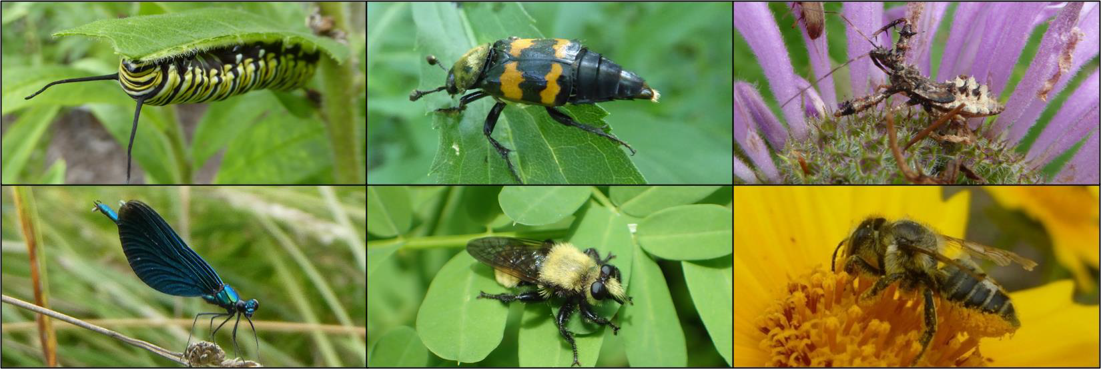
A collage of insects - clockwise from top left: monarch caterpillar (Lepidoptera), carrion beetle (Coleoptera), assassin bug (Hemiptera), leafcutter bee (Hymenoptera), robber fly (Diptera), and damselfly (Odonata).

Course Schedule

Week | Day | Date | Lecture topic | Class/lab activity | Textbook reading*
 |  |  | Unit 1 | Phylogeny & systematics
1 | T | 8-27 | Introduction to course, insects & their importance |  | Ch 1: 13-19, 34-39;  Ch 6: 317-321
1 | W | 8-28 | LAB: field trip - Arboretum and  other campus sites | Pinning, pointing, field  collection methods | FG Introduction: 1-  53
1 | R | 8-29 | Hexapods, Apterygotes,  Paleoptera |  | Ch 1: 20-25; Ch 2:  41-53
2 | T | 9-3 | Polyneoptera & Paraneoptera orders |  | Ch 1: 26-33
2 | W | 9-4 | LAB: field trip – Indian Fort | Collecting: forest, field, pond
2 | R | 9-5 | Holometabola orders
 |  |  | Unit 2 | Habitats, habits, & life history
3 | T | 9-10 | Aquatic insects – overview of  taxa, biological indicators |  | Ch 2: 94-99; Ch 5:  229-239
3 | W | 9-11 | LAB: field trip – Papermill Park | Stream sampling
3 | R | 9-12 | Ground-dwelling insects; library research |  | Ch 2: 54-57
4 | T | 9-17 | Mouthparts & digestive  system |  | Ch 2: 104-109
4 | W | 9-18 | LAB: order ID practice
4 | R | 9-19 | Reproduction & mating  behavior |  | Ch 2: 118-124
5 | T | 9-24 | Coleoptera ID (meet in lab) | Practice Coleoptera ID
5 | W | 9-25 | LAB: field trip – Research  Reserve, Island Preserve | Collecting aquatic and  terrestrial environments
5 | R | 9-26 | Insect life cycles, life history  variation | Fri, Sept 27 – Perspective  paper topic due | Ch 4: 171-179, 180-  195
 |  |  | Unit 3 | Evolutionary innovations
6 | T | 10-1 | Hemiptera ID (meet in lab) | Practice Hemiptera ID
6 | W | 10-2 | EXAM I (in lab) | Units 1 & 2; insect order ID
6 | R | 10-3 | How insects fly |  | Ch 3: 144-147, 160-  169

Week | Day | Date | Lecture topic | Class/lab activity | Textbook reading*
7 | T | 10-8 | Evolution of flight;  metamorphosis |  | Ch 3: 131-143; 152-  159
7 | W | 10-9 | LAB: ID practice; collection work | Practice Coleoptera & Hemiptera ID
7 | R | 10-10 | LAB ID EXAM | Coleoptera/Hemiptera ID;  Fri, Oct 11 – Perspective paper outline & annotated  bibliography due
8 | T | 10-15 | NO CLASS | Fall Break
8 | W | 10-16 | LAB: external anatomy, Orthoptera ID | Grasshopper external anatomy, Orthoptera family  ID; collection work
8 | R | 10-17 | Metamorphosis, hormones, evolution of holometaboly |  | Ch 4: 196-211, 212-  215, 216-221, 222-  225
9 | T | 10-22 | Hymenoptera ID (meet in lab) | Practice Hymenoptera ID
9 | W | 10-23 | LAB: internal morphology;  using dichotomous keys | Virtual dissection; collection  work
9 | R | 10-24 | Social insects I |  | Ch5: 262-290
10 | T | 10-29 | Diptera family ID (meet in lab) | Practice Diptera family ID
10 | W | 10-30 | LAB: ID practice, collection work | Practice Orthoptera/Hymenoptera/ Diptera family ID; turn in field  notebooks for natural history project
10 | R | 10-31 | Social insects II | Fri, Nov 1 – Perspective paper  draft due
 |  |  | Unit 4 | Insect senses & communication
11 | T | 11-5 | Nervous system, detecting  sound |  | Ch 2: 80-81, 86-93
11 | W | 11-6 | EXAM II (in lab) | Unit 3; Orthoptera/ Hymenoptera/Diptera family ID
11 | R | 11-7 | Chemoreception, pheromones
12 | T | 11-12 | Vision and navigation |  | Ch 2: 82-85
12 | W | 11-13 | LAB: Collection work | Work on collections
12 | R | 11-14 | Thermoregulation |  | Ch 2: 100-103

Week | Day | Date | Lecture topic | Class/lab activity | Textbook reading*
 |  |  | Unit 5 | Ecological roles of insects
13 | T | 11-19 | Insect herbivory | Mon, Nov 18 – collection  (physical & photographic) & ID slide show due | Ch 5: 294-304
13 | W | 11-20 | LAB: Digital collections | Natural history presentations  start
13 | R | 11-21 | Pollination & other  mutualisms |  | Ch 5: 305-315
14 | T | 11-26 | Medical entomology | Tues, Nov 26 – Perspective  paper final version due | Ch 6: 324-331
14 | W | 11-27 | NO LAB | Thanksgiving Break
14 | R | 11-28 | NO CLASS | Thanksgiving Break
15 | T | 12-3 | Predation, parasitism, defense |  | Ch 5: 240-261
15 | W | 12-4 | LAB: Insects & climate change
15 | R | 12-5 | Insect conservation |  | Ch 6: 349-351
 | W | 12-11 | FINAL EXAM (3:30 – 6:50 pm) | Units 4 & 5; plus cumulative  component

* Readings refer to chapters and pages in The Complete Insect, unless otherwise specified (FG = reading in the
Insects of North America Field Guide; additional online readings posted on Brightspace may be assigned
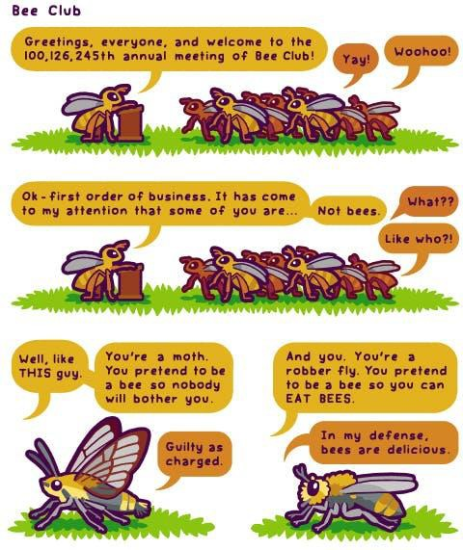
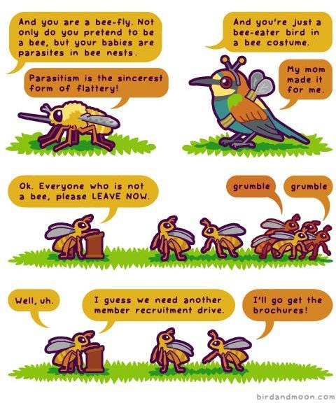
For more great natural history comics like this one by Rosemary Mosco, see Rosemary Mosco Comics

