Ecology 203, Exam III. April 19, 2002. Print name:_________________________________
Rules: Read carefully, work accurately and efficiently. There were no student-submitted questions.

Multiple guess. Circle the best answer (3 pts each, 30 pts total)

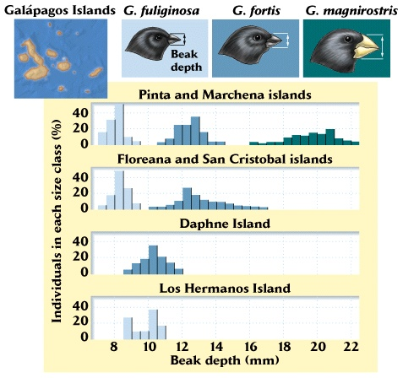
1. The figure to the right suggests
a. diversity increases with beak
depth.
b. competitive exclusion has
taken place.
c. character displacement has
taken place.
d. all of the above.
e. none of the above.
2. If you wanted to know whether two
species were competing you could
a. remove one species and see if
it grows faster.
b. remove one species and see if
the other grows faster.
c. add some individuals and see
if they grow faster.
d. all of the above.
e. none of the above.
3. The following equation depicts what type
of interaction?

dN₁/dt = r₁N₁(1 – N₁/K₁)

a. exponential growth.
b. intraspecific competition.
c. interspecific competition
d. predator-prey dynamics.
e. none of the above.
4. An exaptation, (for example, the placement by monarch butterflies of cardiac glycosides into their exoskeletons, effectively reducing predation rates), is
a. a trait that evolved for some other function.
b. a function that now serves no purpose.
c. a trait that came about by a means other than natural selection.
d. all of the above.
e. none of the above.
5. E. coli is a
a. mutualist
b. pathogen.
c. microbe.
d. all of the above.
e. none of the above.

6. Assuming that pathogens evolve toward the state of benign coexistence the relationship between virulence and time should be what type of function?
a. increasing
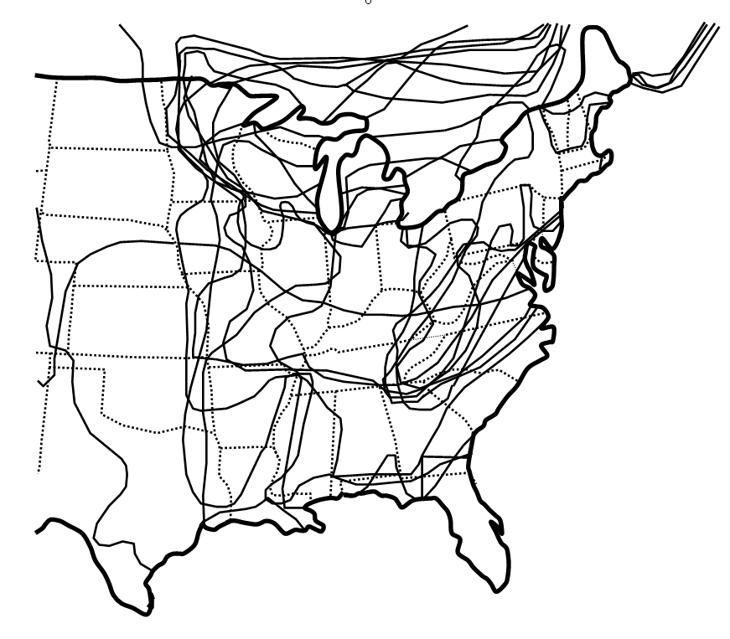
b. decreasing
c. increasing at first and then decreasing.
d. all of the above are consistent with this idea.
e. none of the above.
7. The figure shows the approximate ranges
of 11 species of woody plants that have
ranges that include Geneseo, NY. The
ranges are consistent with the concept that
a. species richness and area are
positively related.
b. rainfall is greater south of the
Mason-Dixon line.
c. communities are “open,” like
Gleason’s continuum concept.
d. communities are “closed,” like
Clements’ concept.
e. diversity decreases with increasing
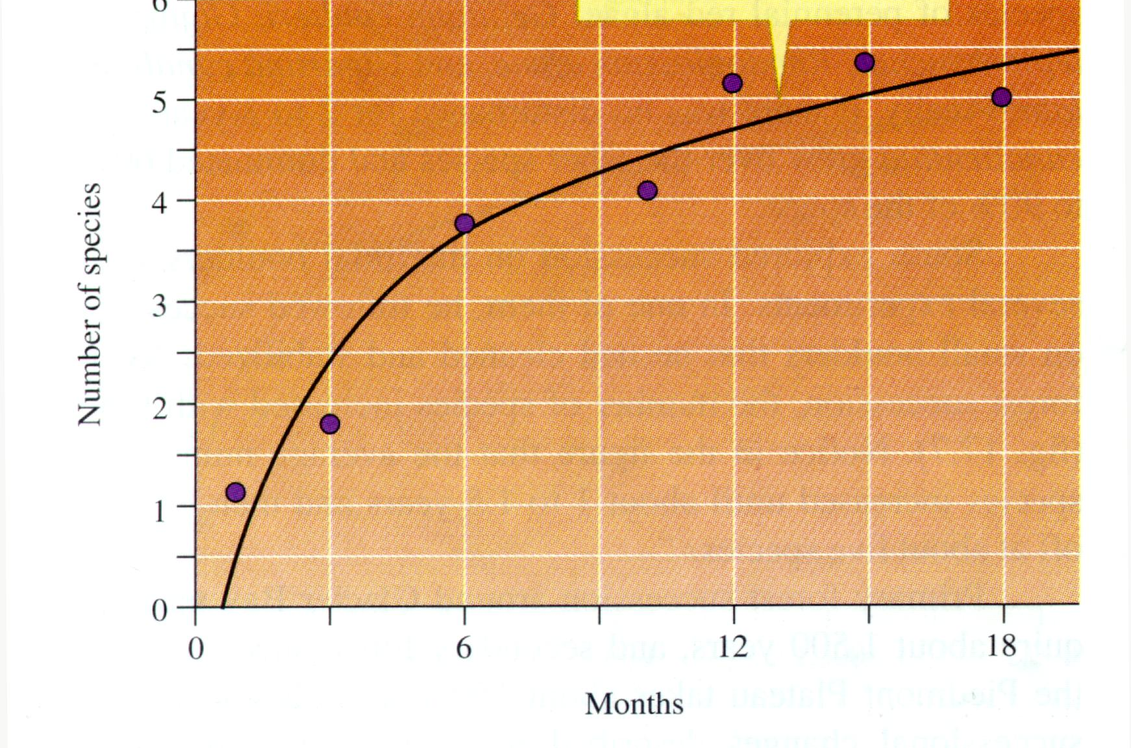
latitude.
8. The graph to the right relates the number
of species in an area as a function of
time since the last catastrophic
disturbance. It supports which theory?
a. Competitive exclusion
principle.
b. Species-area relationship.
c. Hartvigsen’s fractal geometry
model for community
development.
d. Clements’ “relay floristics”
model.
e. Egler’s “initial floristics
composition” model.

9. A community has three species with 25, 50, and 200 individuals. The species richness and Shannon-Weiner index (H’ = - Σ p_{i} log_{e} p_{i}), are respectively
a. 3 and 0.70.
b. 3 and 0.76.
c. 3 and 0.90.
d. 3 and 1.10.
e. 275 and 3.
10. Perennials, discussed in your field guide in the long section on succession,
a. live, reproduce, and die in one year.
b. live, reproduce, and die over two years.
c. live for many years.
d. live for many years and reproduce once, then die.
e. have showy, insect pollinated flowers
Short answer questions. Choose 5 of 6. (10 pts each, 50 pts total)

1. Fill in the table with “+” for positive, “-“ for negative, and “0” for no effect. Give a specific example for three types of interactions.

Species 1 Species 2 Example (just three)
-------------------------------------------------------------------------------------------------------------------------------------
Competition
-------------------------------------------------------------------------------------------------------------------------------------
Predation
-------------------------------------------------------------------------------------------------------------------------------------
Herbivory
-------------------------------------------------------------------------------------------------------------------------------------
Host-Pathogen
-------------------------------------------------------------------------------------------------------------------------------------
Mutualism
-------------------------------------------------------------------------------------------------------------------------------------
Amensalism
-------------------------------------------------------------------------------------------------------------------------------------
Commensalism
-------------------------------------------------------------------------------------------------------------------------------------

2. Explain the relevance of the figure
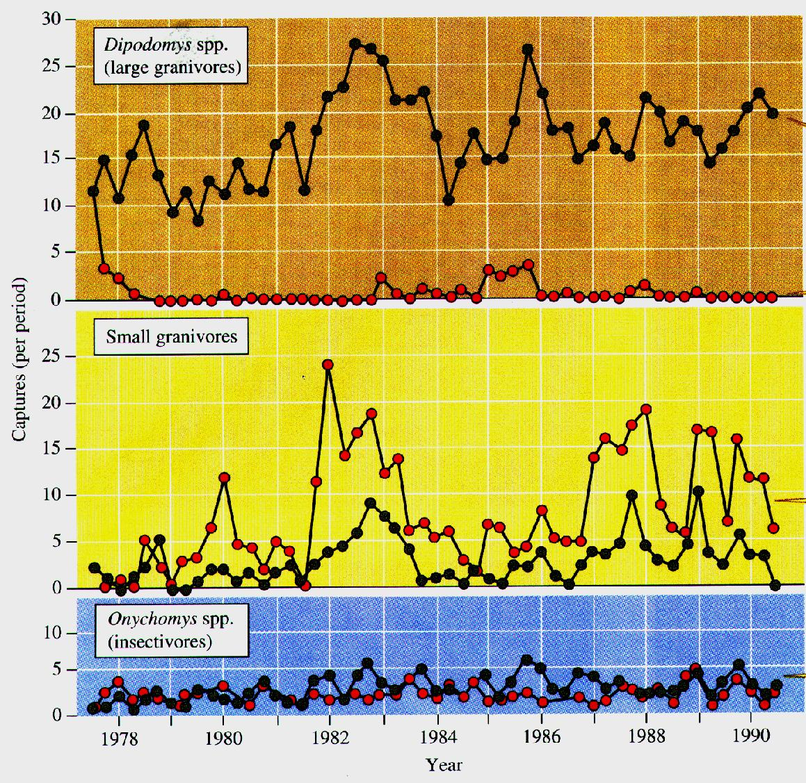
for competition. Label treatments on
the graph clearly.

3. Assume two species of plants compete for light and soil moisture (water). Set up a graph for these two resources, with the y-axis being light intensity and the x-axis being soil water concentration. Draw the realized and fundamental niches such that the fundamental niches overlap for both resources but the realized niches overlap for neither resource. Why do or don’t these species compete in nature?

4. Draw a graph of the intermediate disturbance hypothesis. Be very careful in deciding what the axes should be. Assume that the disturbance is fire intensity. briefly explain your relationship.

5. Draw the graph for the equilibrium number of species predicted by the theory of island biogeography. Do this for four islands (two small islands that are near and far, and two large islands that are near and far). Analyze the graph. Discuss one reason this theory is not realistic.

6. Summarize the article you read titled “Up for the count” or the article “Economic and environmental benefits of biodiversity.” [Please indicate which you are summarizing!]

Mandatory 20 point question.

Each of these parts (a - d) is worth 5 points.
a. Two species of cockroaches (C₁ and C₂) live in Bailey Hall. You decide to do an honors thesis with Dr. Hartvigsen studying the dynamics of these beasts. Design an experiment (use an annotated diagram, preferably) that would allow you to determine whether these species compete.
What is it you will measure? _________________________________________________

b. Provide a graph that would show that these species both exhibit a negative response to competition and that competition results in asymmetry (an asymmetric reduction in whatever you decide to measure).

c. Your project goes so well that your advisor suggests you develop a Lotka-Volterra competition model for the two cockroaches in Bailey. From your work you discover that the coexistence of the two species is stable. Draw the phase plane graph (C₁ on y-axis, C₂ on x-axis) consistent with your finding. Assume you conduct a single run of the real system in a large aquarium tank and start off with just 20 cockroaches of C₁ and 80 of C₂. If K₁ = 50 and K₂ = 50 draw where the system will eventually end up. You study the system long enough for death reproduction to take place. Analyze the graph.

d Based on this last experiment draw a graph of N (the number of individuals) vs. time for both species, assuming they follow the standard Lotka-Volterra dynamics.

Extra Credit (+3 points)

A recently discovered cluster of galaxies was determined to be 13 billion years old. It formed when the universe was just 10% of its current age. What is the age of the universe? Show your work for credit.

